Dear Families, 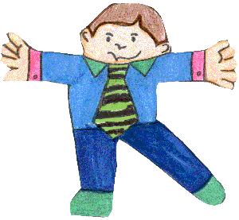

Our class is reading the book Flat Stanley by Jeff Brown. In the book, Stanley gets crushed with a bulletin board. He’s fine, but now he’s flat! Luckily for us, that means he can be folded into an envelope and sent anywhere in the world.
That leads us into a fun geography project with him! The children are coming home today with their own Flat Stanley. You are invited to send or bring Flat Stanley to anyone or anyplace you know for a little adventure. We’ll hoping you’ll record that adventure and send Flat Stanley back any pictures or notes by _____________________________.
I’ve included a letter you can send to your friend or relative with instructions on what they can do with Flat Stanley and when they can get him back to us so we can plot his adventures on our classroom map!
Thanks for helping out
_______________________________

