 | DATE Newsletter
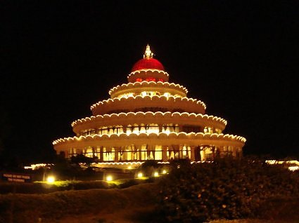
 | V a n c o u v e r
Weekly Follow-up Session | In This Issue
 | - Upcoming Courses
 | - Ayurvedic Massage
 | - Monthly Wisdom from Sri Sri
 | Upcoming Courses
 | Art of Living Basic Course
 | Date: NOVEMBER 19th - NOVEMBER 22nd
 | Venue: Surrey Hindu Temple
 | Contact: Ravi Virk
 | Phone No.: 604-781-2449
 | email: ravi.virk@gmail.com
 | Ayurvedic Massage - Marma
Contact : Bharati Strestha @ 604 628 6595
Olga Givaty @ 778 887 3011
 | Courses With Sri Sri at Montreal Ashram - November

T eachers in Vancouver | Monthly Wisdom from Sri Sri
MARCY JACKSON  radha108@direct.ca  604-228-8728  MANJIT JOHAL  munnyma2003@yahoo.ca  604-266-9452  RAJAN MONIE  SHASHI MONIE  shashi.monie@artofliving.ca  604-595-694  BANNANI CHAKARABORTY, PhD  SUBHINOY CHAKARABORTY, PhD  cbanani@gmail.com  604-345-9240  RAVI VIRK  ravi.virk@gmail.com  604-781-2449  BHARATI STRESHTA  bishre@hotmail.com  604-628-6595  PAYAL JHAVERI  RAGHUVIR JHAVERI  raghuvir.jhaveri@artofliving.ca  payal.jhaveri@artofliving.ca  604-657-6534  International AOL Websites  Art of Living center Website  Canada Art of Living Website  Art of Living Bookstore  Daily Sutra from Sri Sri | This fortnight is the period of the Divine and we do puja every day. Today is the concluding day and also Sharad Poornima/full moon. Each poornima (full moon) is associated with a very significant event in history.  Buddha Poornima, the full moon day in the month of Vaishakh (usually falls in April or May) is connected to the birth, enlightenment and attainment of Mahasamadhi by Gautama Buddha. The next Poornima is dedicated to Rishi Vyasa. Sage Vyasa was the master of both the realms – material as well as spiritual. He knew the ways of the world, and that of the spirit as well. Veda Vyasa organized the entire knowledge, and there was no knowledge about which he didn’t know. Guru Poornima is the day on which all the Masters of all the Traditions are venerated. The last full moon is dedicated to Anant or infinity. Celebrating infinity – no boundaries – no beginning or end.  This month’s full moon is called Sharad Poornima. The brightest and without any blemish, it is supposed to stay longer too, the full moon of Celebration. It is said that Divine dance happened on the day between Lord Krishna and the Gopies – symbolic of grateful devotees. It is said that Lord Krishna danced with all the Gopis under this moon so many thousands of years ago. Sharad Poornima is known for dance and celebration. It is the time when devotees feel the presence of the Divine in their life. This moon is also dedicated to beauty. The sky is clear and the largest moon shines brightly. Our mind and the moon are connected. When the moon is full, the mind is also full. The energy on the day is very high and celebration will keep it up. But this energy needs to be channelized.  With every full moon, we find an excuse to celebrate - Celebration with the spiritual flavor. The period of last fifteen days was a Divine period. We do all poojas and yagyas. What is pooja? Reciprocating what Divinity is doing to us. God makes Sun and Moon go around us, showers flowers, rain and fruits. Imitation of that Divine expression is called pooja. Pooja is the most natural way of showing one’s gratitude.  We conclude this beautiful period doing pooja with a playful heart and keeping this intention, “Let the light in my life, the enthusiasm and wisdom around me always be there. I take the light of life into me. I accept wisdom and love.”  Divinity is everywhere like the air. Yet you feel the air near the fan. Similarly, Divinity is everywhere but you feel it more near the fan. Knowledge, yagya and Guru are like the fan. Near these you feel the presence of Divinity. (Bangalore, India, Oct. 21)
Monthly Ayurvedic Recipe - ( Pina Coco Delight)
Ingredients:  Pineapple juice - 1 glass, Tender Coconut water – 1 glass, Scrapped Coconut – 1 tsp , Banana – 1 no. | Procedure:  Step 1: Grind banana and pineapple juice in a grinder.  Step 2: Now add tender coconut water in the above mixture and grind.  Step 3: Serve in a glass. Decorate it with scrapped coconut.

