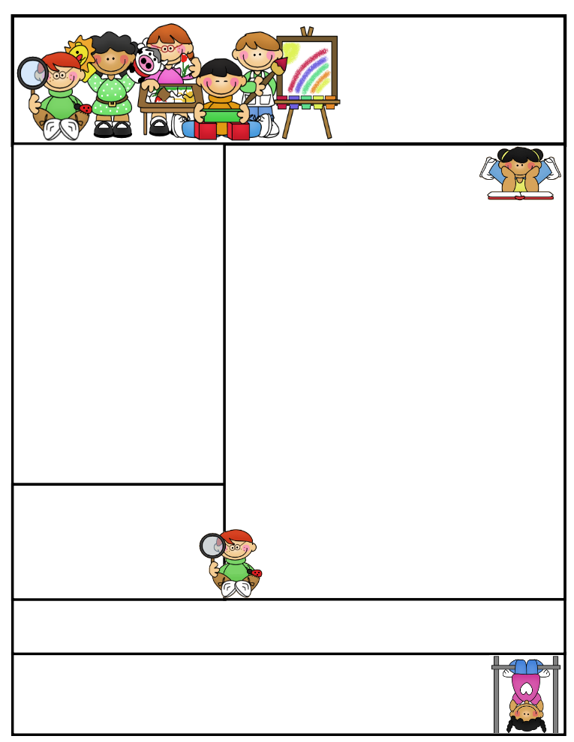

Ms. Teacher’s Name  
Newsletter

March, 25, 2011

Literacy Tip:

Math Tip:

Ms. Teacher’s Name Email address:  
Name of School Webpage:  
Address  
Phone Number

Birthdays

Important Dates

Classroom News

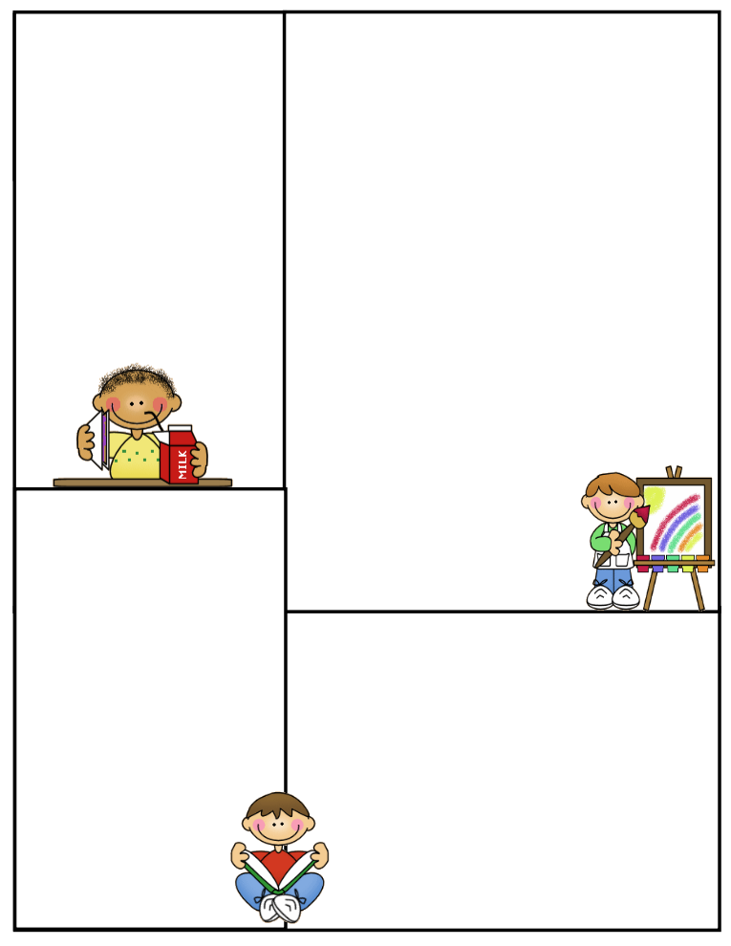

Other Information Here

Student of the Week

Lunch Menu

Monday:

Tuesday:

Wednesday:

Thursday:

Friday:

What We’re Learning

Reading:

Math:

Writing:

Science:

Social Studies: