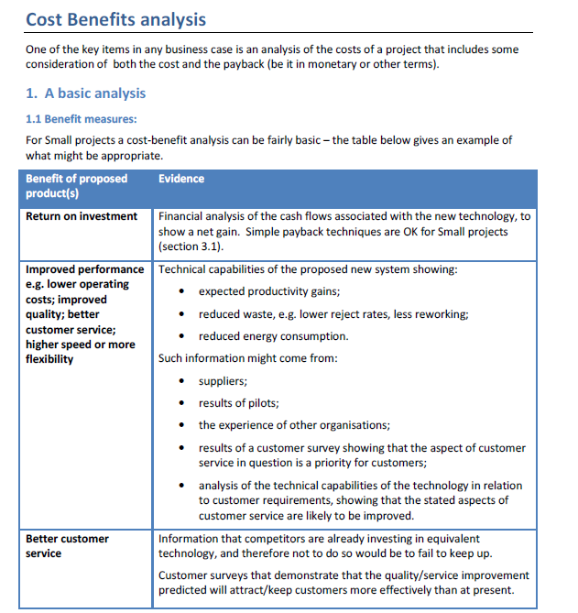
Engineering Solutions On-Line presents the
Sample Cost Benefit Analysis Template
(with Amortization Calculator)
 | A product of Engineering Solutions On-Line,
 | a division of Armitage Consulting
 | Copyright 2009, Armitage Consulting, all rights reserved
 | Author: | John Cesarone, Ph.D., P.E.
 | Date: | May 2009
 | Version: | 2.02.1
 | Contact Information:
 | e-mail: | jcesarone999@gmail.com
 | web: | http://EngineeringSolutions.homestead.com
 | phone: | 312.493.0839
 | fax: | 504.285.0687

Sample Cost Benefit Analysis
Part Number
Description
Total Requirements (Units)
20,000
Number of Vendors
5
Requirement per Vendor
4,000
PRICES AND DELIVERY COSTS IN UNITS
Vendor
Bid Price
Delivery
Total
1.
Vendor
$24
$1
$24
2.
Vendor
$21
$2
$23
3.
Vendor
$23
$2
$25
4.
Vendor
$22
$1
$23
5.
Vendor
$22
$1
23.45
Average Delivered Price Per Unit
$23.75
ALLOCATION OF ORDERS AND COSTS
Manual
Delivered
Price vs.
Actual
Amount
Vendor
Override
Price/Unit
Average
Order
of Order
1.
Vendor
3000
$24
103%
3000
$73,200
2.
Vendor
10000
$23
95%
10000
$226,500
3.
Vendor
0
$25
104%
0
$0
4.
Vendor
7000
$23
99%
7000
$164,150
5.
Vendor
0
$23
99%
0
0
Total Units
20000
SUMMARY
Total Cost of Orders
$463,850
Low Bidder Total
$453,000
Multiple Bid Premium and %
$10,850
2.40%

