[](https://templatelab.com/)



**Felix Armstrong**

CEO

GTX Construction



**Brandon Lee**

CFO

GTX Construction

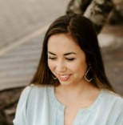

**Gina Dumars**

IT Specialist

Pearson Ltd

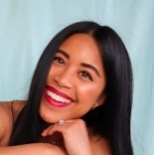

**Elie Redbrick**

Lawyer

Green & Sons



**Tanya Flowers**

Marketing Manager

Ello High



**Joe Darkwood**

Graphic Designer

LPG Monument



**Zoe Dixon**

Personal Assistant

GTX Construction

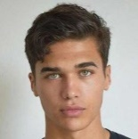

**Hercul Collins**

Maintenance Engineer

GTX Construction

ROUND TABLE

Seating Chart

[© TemplateLab.com](https://templatelab.com/)