Name:__________________

The Pythagorean Theorem

Find the length of the missing side in the following examples. Round answers to the nearest tenth, if necessary.

**1.** **2.**

6cm *c* *c* 5 cm

3 cm 12 cm

5m

**3.**

7m

4. A ladder is leaning against the side of a 10m house. If the base of the ladder is 3m away from the house, how tall is the ladder? **Please draw a diagram and show all work**.

S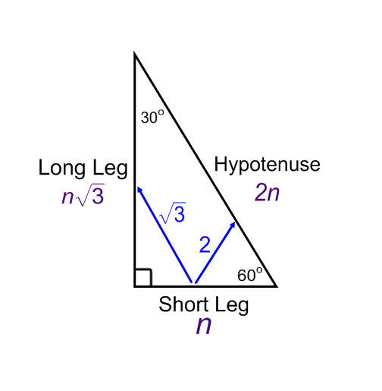pecial Right Triangles: 30º - 60º - 90º

Hypotenuse = 2 * Short Leg

Long Leg = Short Leg *

**F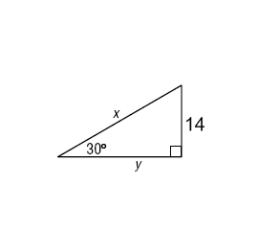ind the value of x and y in each triangle.**

**1. 2. 3.**

**Sketch the figure that is described. Then, find the requested measure.**

**4.** An equilateral triangle has a side length of 10 inches. Find the length of the triangles altitude.

**5.** The altitude of an equilateral triangle is 18 inches. Find the length of a side.

S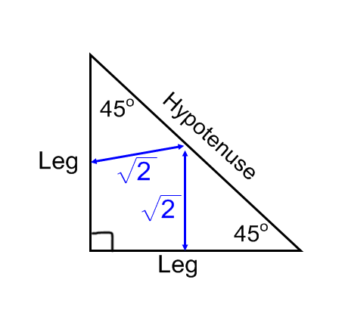pecial Right Triangles: 45º - 45º - 90º

Hypotenuse = Leg *

Leg =

**Find the value of x in each triangle.**

**1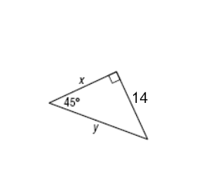. 2. 3.**

**Sketch the figure that is described. Find the requested measure.**

**4.** The perimeter of a square is 48 meters. Find the length of a diagonal.

**5.** The perimeter of a square is 20 cm. Find the length of a diagonal.