**A GOOD WEEK AT CAMP**

**TEACHERS**

**ACTIVITIES**

**STUDENTS**

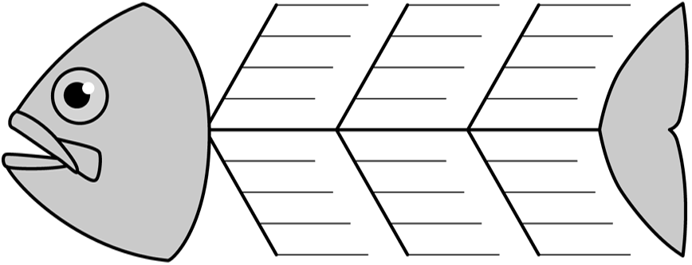

**CAMP FACILITIES**

**OUTDOORS CONDITIONS**

**OTHER**

**A GOOD WEEK AT CAMP**

**(effect)**

**CAUSE**