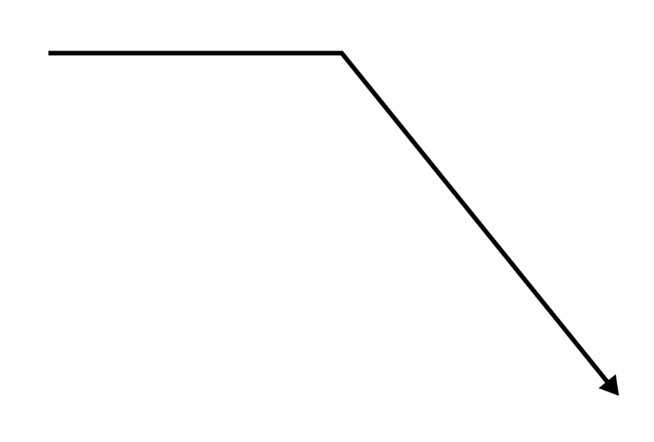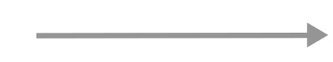

**Insert**

**Text**

**here**

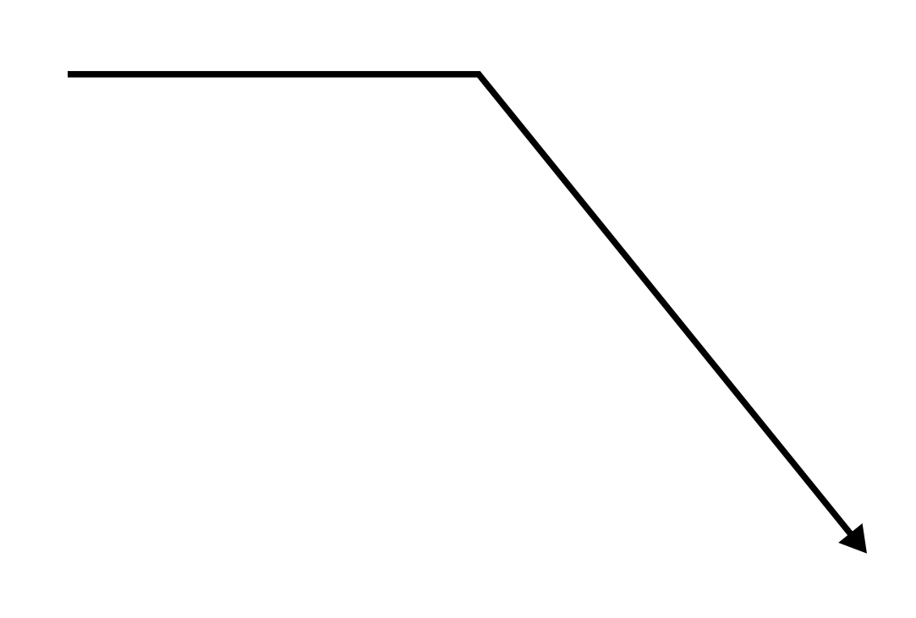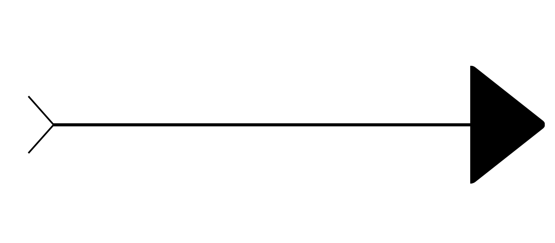

**Insert Text Here**

**Insert Text Here**

**Insert Text Here**

**Insert Text Here**

Insert text here

Insert text here

Insert text here

Insert text here

Insert text here

Insert text here

Insert text here

Insert text here



**FISHBONE DIAGRAM**