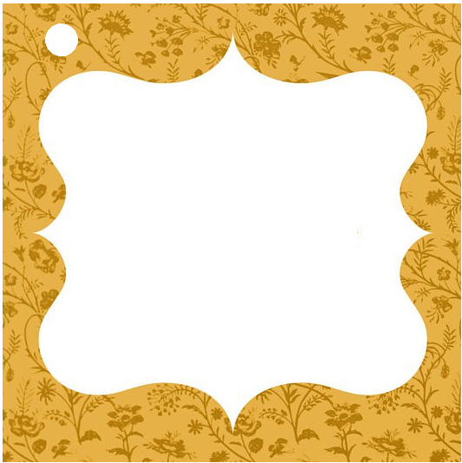

**Heartily Wrapped with a Smile**

**To**

**From**



**Heartily Wrapped with a Smile**

**To**

**From**