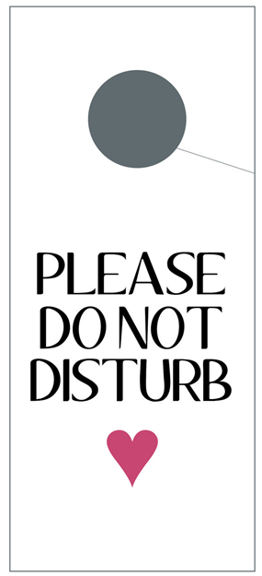

**We are recovering from**

**(state illness)**