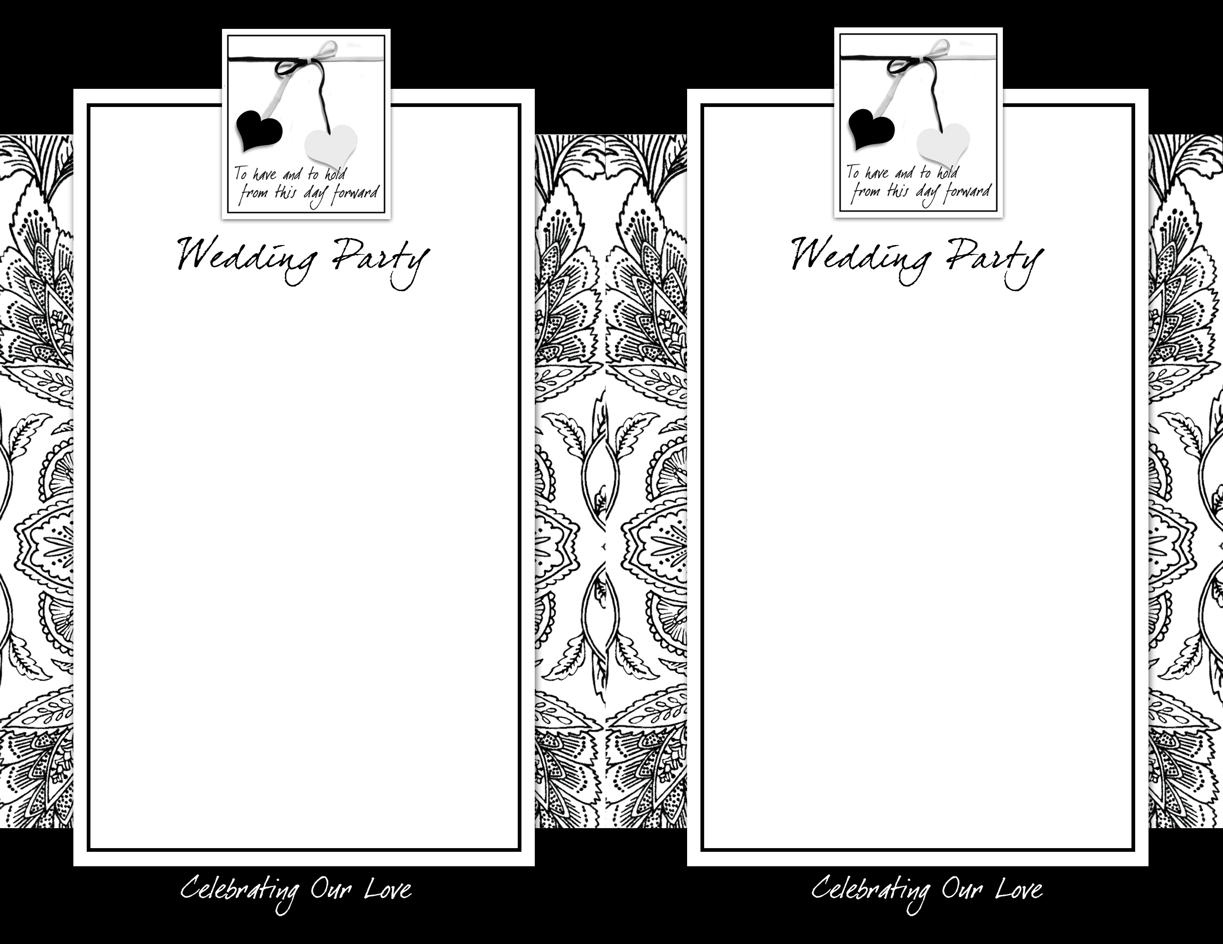
The Bride’s Parents
The Groom’s Parents
The Bride’s Grandparents
The Groom’s Grandparents
The Bride’s Great-Grandparents
The Groom’s Great-Grandparents
Minister
Maid of Honor
Bridesmaid
Bridesmaid
Bridesmaid
Bridesmaid
Flower Girl
Best Man
Groomsmen
Ring Bearer
Usher
Usher
Usher
Usher
Organist/Pianist/Soloists

The Bride’s Parents
The Groom’s Parents
The Bride’s Grandparents
The Groom’s Grandparents
The Bride’s Great-Grandparents
The Groom’s Great-Grandparents
Minister
Maid of Honor
Bridesmaid
Bridesmaid
Bridesmaid
Bridesmaid
Flower Girl
Best Man
Groomsmen
Ring Bearer
Usher
Usher
Usher
Usher
Organist/Pianist/Soloists

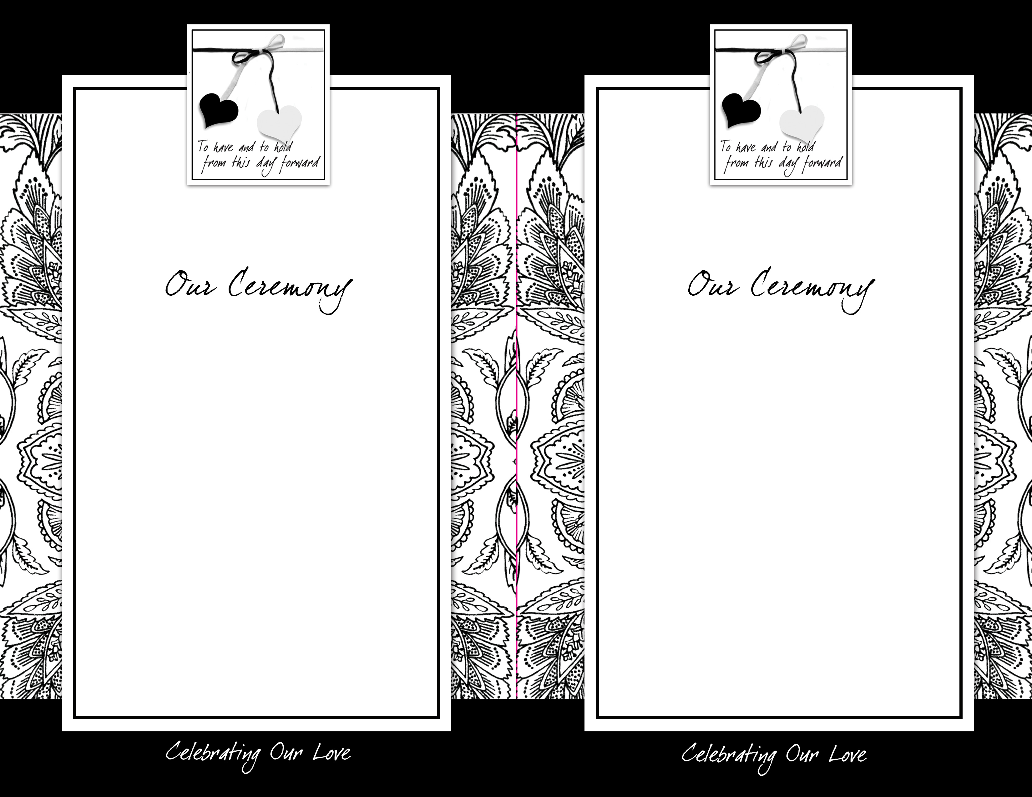
PRELUDE
SEATING OF THE GRANDPARENTS
SEATING OF THE PARENTS
PROCESSIONAL
GREETING MINISTER
READINGS
MARRIAGE VOWS
EXCHANGE OF RINGS
LIGHTING OF THE UNITY CANDLE
PRAYER
PRONOUNCEMENT
*RECESSIONAL

You are invited to the reception
immediately following ceremony.

Bride’s Name & Groom’s Name
Wedding Date
Brides Name & Grooms Name
Wedding Date
PRELUDE
SEATING OF THE GRANDPARENTS
SEATING OF THE PARENTS
PROCESSIONAL
GREETING MINISTER
READINGS
MARRIAGE VOWS
EXCHANGE OF RINGS
LIGHTING OF THE UNITY CANDLE
PRAYER
PRONOUNCEMENT
*RECESSIONAL

You are invited to the reception
immediately following ceremony.

