 |  |  |  | 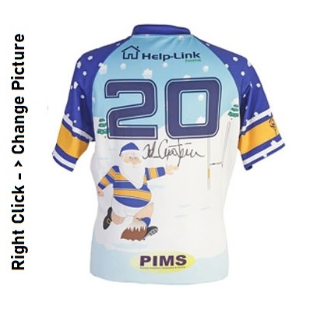
 |  | You are bidding on:
 |  | Rugby Christmas Jersey
 |  | Generously donated by:
 |  | Mr. Kyal Wicks
 |  | Valued at:
 |  | $100
 |  | BID AMOUNT | NAME | CONTACT PHONE INFO
 |  | $10 | Morris Green | (555) 12345 44586
All bids must be made in increments of 20$ or more!
The Silent Auction closes at 6pm
 |  | GOOD LUCK!
 |  |  |  | © TemplateLab.com

