HANDYMAN | 555-555-2222 | Your Address
 | info@yourmail.com | City, State
ESTIMATE | yourwebsite.com | ZIP CODE
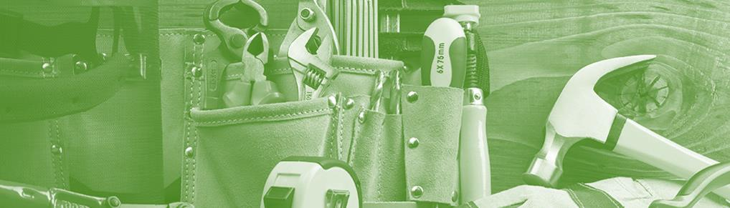

Qty | Parts/Materials | Price | Line Total
1 | Screws | $30.00 | $30.00
 | Box 100pcs 40x3mm
2 | Glue | $25.00 | $50.00
 | Tube 200ml
5 | Your Item Name | $10.00 | $50.00
 | Item description goes here
5 | Your Item Name | $10.00 | $50.00
 | Item description goes here
1 | Your Item Name | $20.00 | $20.00
 | Item description goes here
1 | Your Item Name | $20.00 | $20.00
 | Item description goes here
 | TOTAL PARTS/MATERIALS: |  | $220.00
Hours | Labour | Rate | Line Total
1 | Drain clog opening | $30.00 | $30.00
 | With automatic tool
2 | Door and window check | $25.00 | $50.00
 | Security Check
5 | Your Item Name | $10.00 | $50.00
 | Item description goes here
1 | Your Item Name | $10.00 | $10.00
 | Item description goes here
 |  | TOTAL LABOUR: | $140.00
 |  | SUBTOTAL: | $360.00
 |  | TAX RATE: | 10%
 |  | TAX: | $36.00
Notes:
Bank transfer details for example

Terms:
Please pay within 7 days

Total Amount
$396.00

Billed to:

CLIENT NAME
Street Address

City, State
ZIP Code

ESTIMATE NUMBER: 0001236

DATE OF ISSUE:
01/01/2020

DUE DATE:
01/08/2020

© templatelab.com

