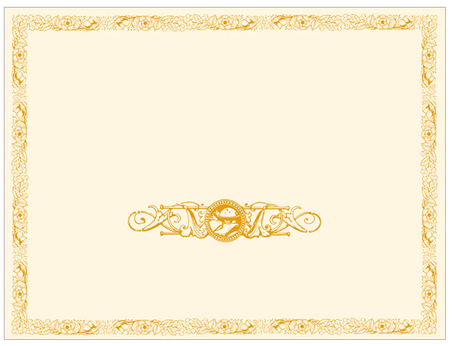

Signatures

Signatures

Scammers University

Upon the consideration and the fact that pour check cleared

We hereby bestow upon this piece of paper with the seal called

Diploma

To

________________________________