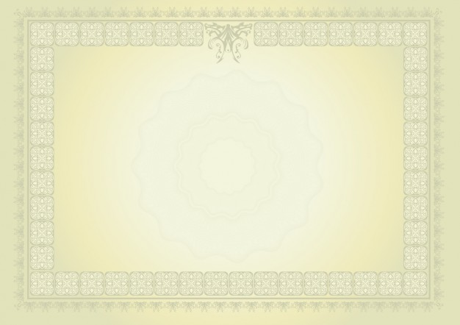

Guffaw College

To all whom these presents shall come, greeting Be it known that

JOHN DOE

Having honorably fulfilles all ther requirements imposed by the authorities Institution, The President and the trustees of the Guffaw College upon recommendation of the faculty, do therefore confer the degree of

________________

This day _______, 2017

President Signature