[](https://templatelab.com/)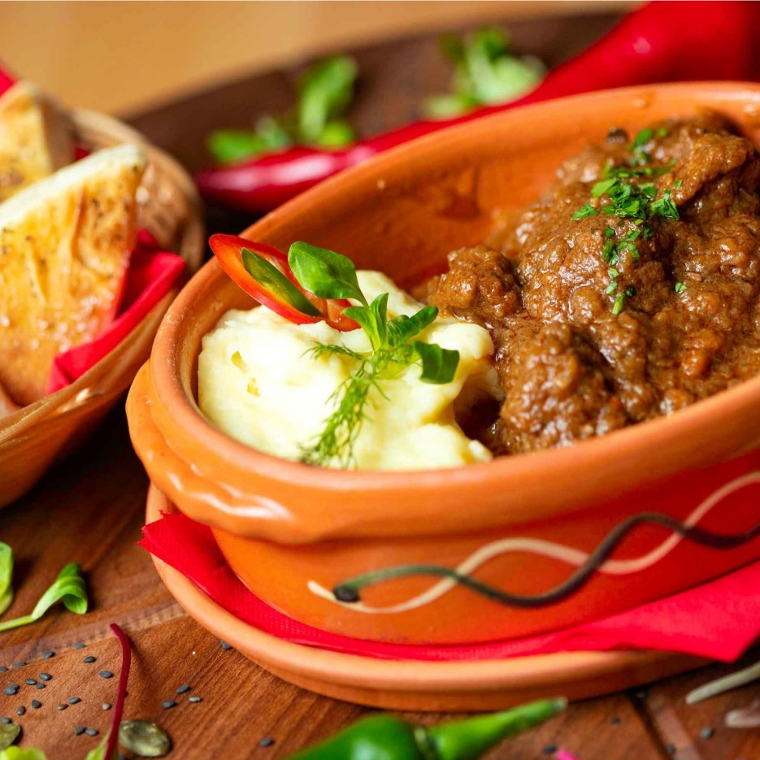

HUNGARIAN

4 SEASONS

GOULASH

CHEFF’S WORDS

NUTRITION FACTS



SERVES

8 PERSONS



PREPARATION

45 MINUTES

**Per Serving:** Protein 5.2g; fat 9.2g; carbohydrates 23.2g; cholesterol 27.1mg; sodium 46.1mg; lorem ipsum 50.0g; lorem ipsum 100.0g; lorem ipsum 10.0g.

Goulash (Hungarian: gulyás) is a soup or stew of meat and vegetables seasoned with paprika and other spices. ... At that time, the cooked and flavoured meat was dried with the help of the sun and packed into bags produced from sheep's stomachs, needing only water to make it into a meal. Lorem ipsum dolor sit amet, consectetuer adipiscing elit. Maecenas porttitor.

INGREDIENTS

DIRECTIONS

1kg good braising steak, preferably chuck steak

1 tbsp sunflower oil

3 medium onions, cut into 12 wedges

3 garlic cloves, crushed

2 tsp hot smoked paprika

1 tbsp paprika

1 lorem ipsum

500ml cold water

300g lorem ipsum

2 tbsp lorem ipsum

2 lorem ipsum

1 red lorem ipsum

1 green lorem ipsum

1 orange lorem ipsum

flaked sea salt

freshly ground black pepper

**Brown the meat** – In a large skillet heat the olive oil over high heat. When the oil is hot add the beef, season with salt and pepper and continue to sear till the meat begins to brown. We want the liquid that the beef releases as it cooks to evaporate off so be sure to keep the heat on high.

**Incorporate your flavours** – Add the onions and garlic to the dish and cook till the onions begin to soften and go translucent, be sure that your garlic doesn’t burn in this time, it shouldn’t though because there should be enough moisture in the pot. If need be, add the garlic right when the onions are soft. Add the paprika.

**Lorem Ipsum** - Lorem ipsum dolor sit amet, consectetuer adipiscing elit. Maecenas porttitor congue massa.

RECIPE BOOK NAME

- 25 -

[© TemplateLab.com](https://templatelab.com/)