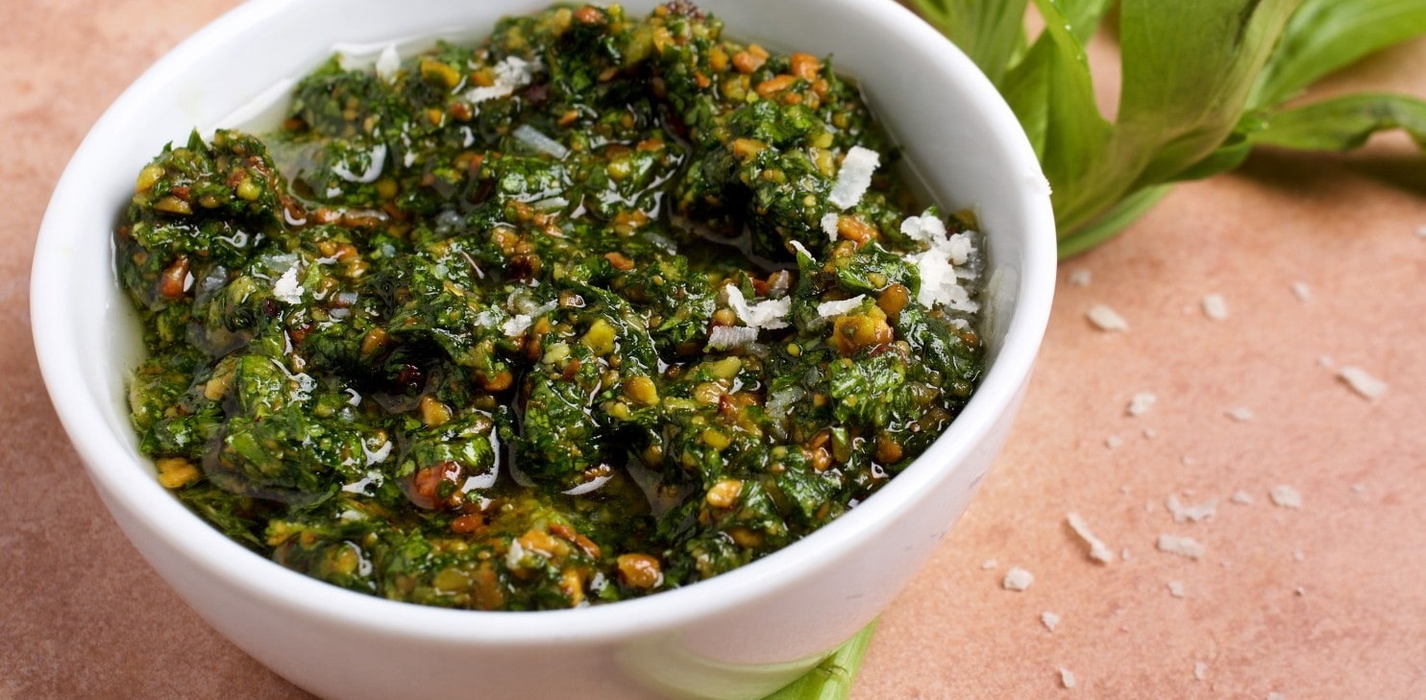[](https://templatelab.com/)

▪ 1 pound ground beef

▪ 1/2 cup water

▪ 1 envelope taco seasoning

▪ 2 tablespoons hot pepper sauce

▪ 2 tablespoons steak sauce

▪ 2 tablespoons olive oil

▪ 1 Lorem Ipsum

▪ 1 small lorem ipsum

▪ 1 medium lorem ipsum



INGREDIENTS LIST

PUTTANESCA

PASTA

I've loved PUTTANESCA PASTA since I can remember. In an attempt to give it a makeover, I thought of this idea, which was a big hit with my family, friends and co-workers!

45 MINUTES



DIRECTIONS

Page 25 ǀ Recipe Book

1. Start by heating up olive oil in large skillet. Add chopped onion and minced garlic and saute until fragrant and the onion is almost caramelized.

2. Stir in soy sauce and fresh spinach. Cook stirring often until the spinach is wilted. Remove from heat and serve immediately. Lorem ipsum dolorem sit.

3. Lorem ipsum dolor sit amet, consectetuer adipiscing elit. Maecenas porttitor congue massa. Fusce posuere, magna sed pulvinar.

4. Maecenas porttitor congue massa. Fusce posuere, magna sed pulvinar ultricies, purus lectus malesuada libero, sit amet commodo magna eros quis urna. Lorem ipsum dolor sit amet, consectetuer adipiscing elit.

[© TemplateLab.com](https://templatelab.com/)