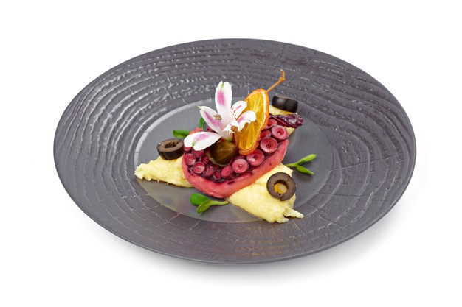[](https://templatelab.com/)

Page 14 ǀ Recipe Book

GALACTIC OCTOPUS

MASTER RECIPES

1 onion - coarsely chopped, 3 bay leaves, 1 pound octopus tentacles, 1/2 pound potatoes, 2 lorem ipsum, 3 lorem ipsum, 2 teaspoons lorem ipsum, 3 1/2 pounds lorem ipsum dolor sit, 5 ounces lorem ipsum - cut into 1/2-inch dice (optional),

VIRGIN ISLANDS

**STEP 1** - Bring a large saucepan of salted water to a boil with the onion and carrots. Using tongs, carefully dip the octopus into the boiling water 2-3 times, then leave it in the water.

**STEP 2 -** Cook the octopus over moderately low heat for 20-25 minutes. Remove from the heat and let the octopus stand in the water for 10 minutes, then drain. Lorem ipsum.

**STEP 3** – Lorem ipsum dolor sit amet, consectetuer adipiscing elit. Maecenas porttitor congue massa. Fusce posuere, magna sed pulvinar ultricies, purus lectus malesuada libe.

**STEP 4** - Lorem ipsum dolor sit amet, porttitor congue massa. Fusce posuere, magna sed ultri, purus lectus malesuada libero, sit amet commodo magna eros quis urna.

- One cannot think well, love well, sleep well, if one has not dined well -

Virginia Woolf, A Room of One's Own

[© TemplateLab.com](https://templatelab.com/)