[](https://templatelab.com/)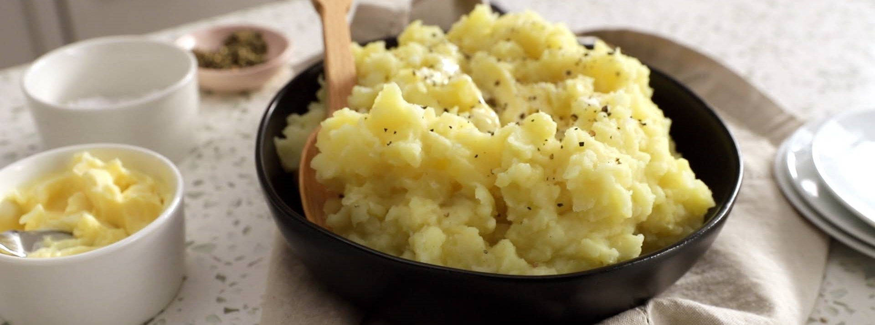

COOKBOOK NAME

BASIC MASHED POTATO

COOKBOOK SECTION



SERVES

DIFFICULTY

TIME

METHOD

CALORIES

6

LOW

40´

BOIL

125kcal

TIPS

With help of potato mashers you can make cooking your favourite recipes like this one much easier.

Lorem ipsum dolor sit amet, consectetuer adipiscing elit. Maecenas porttitor congue massa. Fusce posuere, magna sed pulvinar ultricies, purus lectus.

NUTRITION

FACTS

**Per Serving:** Protein 5.2g; fat 9.2g; carbohydrates 23.2g; cholesterol 27.1mg; sodium 46.1mg.

**2 pounds baking potatoes, peeled and quartered; 2 tablespoons butter; 1 cup of milk; lorem ipsum; 1/2 lorem ipsum; 3 lorem ipsum; 4 lorem ipsum; 1/4 Maecenas porttitor congue massa.**

Peel potatoes and cut them in pieces if they are very large. If you want the potatoes to be the smoothest possible, you can take the time to remove the little knots from the potatoes with a small spoon or the tip of a potatoes peeler. Place potatoes in a large pot. Lorem ipsum dolor sit amet, consectetuer adipiscing elit. Maecenas porttitor congue massa. Fusce posuere, magna sed pulvinar ultricies, purus lectus malesuada libero, sit amet commodo magna eros quis urna.

Nunc viverra imperdiet enim. Fusce est. Vivamus a tellus.

Pellentesque habitant morbi tristique senectus et netus et malesuada fames ac turpis egestas. Proin pharetra nonummy pede. Mauris et orci.

[© TemplateLab.com](https://templatelab.com/)