Insert your logo here

Accident/Incident/Early Reporting Form

Work Area / Department | Time of Incident hh:mm pm / am  Time started Shift hh:mm pm / am | Incident Date dd/mm/yyyy  Date of Report dd/mm/yyyy | Injured Employee Name : Enter here  Date of birth dd/mm/yyyy:
First Aider (write name clearly) | Witness | TREATMENT (Tick appropriate box) Nil First Aid Doctor Hospital
STATUS (tick appropriate box) Permanent Fixed Term Contractor Other (please state)
Severity:  - Sever pain  - Pain  - Mild pain  - Discomfort  Duration  - Discomfort/Pain is always present to some degree  - Discomfort/pain stays after work but improves after a night’s rest  - Only at work  - Occasional  Severity Scale  Enter here  Duration Scale  Enter here  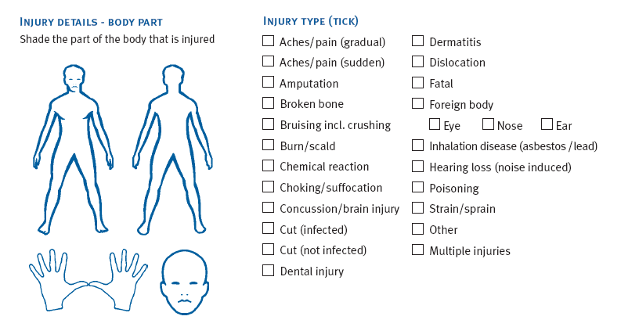  Discomfort/Injury Type (tick)  Discomfort/Injury Details – Body Part |  | - Description of Accident / Incident: (please describe your interpretation of events)  Enter here
- Information for Discomfort for Early Reporting:
- - When did you first notice discomfort / pain?
- - Is it getting worse, better or staying the same?
- - Have you had this discomfort/pain before?
- - What are you doing to help relieve the discomfort/pain?
- - Is there anything else you feel we should know? (note on reverse)
 |  | Root Cause(s) of Incident Initial Control/Corrective Action Suggested Action/s Person Responsible for completing Date Completed Review Completed
Is Further Investigation Required? Yes No (If no, please give reason):

Final Classification: Early Discomfort Incident (EDI) / Near Miss Incident (NMI) / First Aid Incident (FAI) Medical Treatment Incident (MTI) / Lost Time Incident (LTI)
Department Manager Sign off: Date:
Initiator Sign off: Date:
Other Sign off eg Health & Safety Committee:
Yes No Date:

