City of Galveston
Disaster Recovery Plan

Galveston Planning & Development Regulations

CITY COUNCIL REVIEW DRAFT

JUNE 24, 2013

TABLE OF CONTENTS

TABLE OF CONTENTS |  |  | 1
1. | INTRODUCTION |  | 1
 | 1.1. | Overview | 1
 | 1.2. | Focus on the Recovery Period | 1
 | 1.3. | Building on Existing Policies, Plans, & Assessments | 2
 | 1.4. | Annual Review | 4
 | 1.5. | Organization of the Plan | 4
2. | RECOVERY RESOURCES |  | 4
 | 2.1. | Staffing Levels | 4
 | 2.2. | Eligibility & Reimbursement Requirements | 5
 | 2.3. | City Service Levels | 5
3. | RECOVERY CENTER ESTABLISHMENT |  | 6
 | 3.1. | FEMA/TDEM Disaster Recovery Centers | 6
 | 3.2. | City Recovery Permitting Center | 7
 | 3.3. | GEDP/Chamber Business Recovery Center | 8
4. | DAMAGE ASSESSMENTS |  | 9
 | 4.1. | Assessments Processes | 9
 | 4.2. | Color-Coding System | 9
 | 4.3. | Assessment Communications | 11
5. | RECOVERY & REBUILDING ORDINANCES |  | 11
 | 5.1. | Post-Ike Ordinances | 11
 | 5.2. | Emergency Repair Authorization | 12
6. | RECOVERY PERMITTING & INSPECTIONS |  | 13
7. | EMERGENCY & TEMPORARY HOUSING |  | 14
 | 7.1. | Integrated Strategies for Disaster Housing | 14
 | 7.2. | Deployment of Emergency & Temporary Housing | 15
8. | DEBRIS REMOVAL & NUISANCE ABATEMENT |  | 16
 | 8.1. | Debris Staging & Sorting | 16
 | 8.2. | Communications to Commercial Owners | 16
 | 8.3. | Private Property Debris Removal | 16
 | 8.4. | Private Property Nuisance Abatement | 17
9. | RECOVERY PHASE COMMUNICATIONS |  | 17
 | 9.1. | Comprehensive Disaster Communications Plan | 17
 | 9.2. | Expended Communication Channels | 18
 | 9.3. | Availability of Assistance | 18
10. LONG-TERM COMMUNITY RECOVERY PLANS |  |  | 19
 | 10.1. | LTCRP Guidance | 19
 | 10.2. | Federal Assistance for Recovery Planning | 19
 | 10.3. | Galveston’s Post-Ike LTCRP | 19

DISASTER RECOVERY PLAN | 06.24.13 i

- INTRODUCTION

- Overview

The Disaster Recovery Plan, adopted [insert date] as an addendum to the 2011 Comprehensive Plan, offers guidance for City decision-makers as they plan for and undertake recovery activities following a disaster event. The Disaster Recovery Plan offers a review of current and recommended recovery actions focused on the following:

  - ensuring adequate resources are available to support assessment, permitting, and inspection services;
  - planning for the establishment and staffing of recovery centers to help residents, businesses, and institutions recover, rebuild, and reestablish social and economic activities;

  - completing and reporting the results of initial post-disaster assessments of damage to private property;
  - enacting recovery ordinances and expediting post-disaster permitting and inspection processes;
  - pre-planning for the provision of emergency and temporary housing;
  - planning for post-disaster debris management and nuisance abatement;
  - improving recovery phase communications; and
  - initiating disaster-specific, long-term community recovery planning processes.

- Focus on the Recovery Period

The Disaster Recovery Plan addresses actions the City will undertake during the post-disaster period extending from the emergency response phase immediately following a disaster to a point when all physical property, social, and economic processes return to stable and acceptable pre-disaster levels. In the aftermath of a minor event resulting in localized damage, the recovery phase may last several weeks, while following major events, like Hurricane Ike, the recovery phase can extend for many years.
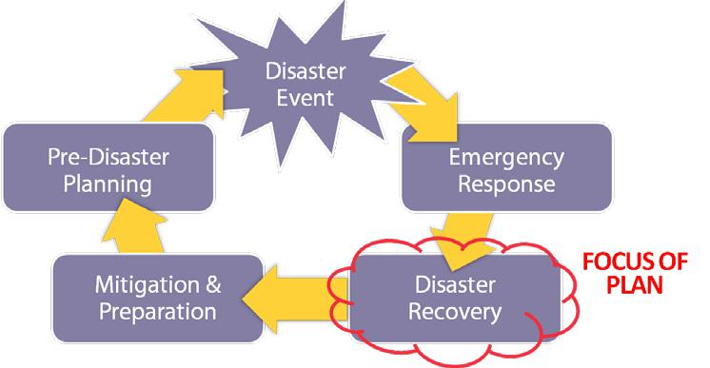

Figure 1: Phases of Disaster-Related Activities
DISASTER RECOVERY PLAN | 06.24.13 | 1

The Disaster Recovery Plan serves as a guide to local staff and decision-makers as they work to achieve the following broad recovery phase objectives:

  - restore public infrastructure, facilities, and services;
  - reestablish an adequate supply of housing;
  - restore and replace lost jobs; and
  - revive the economic base of affected areas and the community at-large.

- Building on Existing Policies, Plans, & Assessments

The Disaster Recovery Plan focuses on actions the City will take to accelerate the pace of rebuilding following a disaster event. The plan is designed to build on rather than repeat preparedness, mitigation, and emergency response recommendations in plans and reports prepared by the City and local stakeholder groups.

Recommendations in the plan do not directly address the City’s pre- or post-disaster emergency response operations, nor do they address on-going hazard mitigation or emergency preparedness planning efforts. Such matters are addressed in the following plans and reports:

  - 2011 Comprehensive Plan. Objective 5 of the Disaster Planning Element of the 2011 Comprehensive Plan provides recommendations for improving the City’s ability to accelerate the pace of recovery following major disaster events. Recommendations in the Comprehensive Plan address the importance of completing a Disaster Recovery Plan; improving assessment, permitting and inspection processes; planning for emergency and temporary housing; and improving recovery-phase communications.

  - Emergency Operations Plan. In accordance with Chapter 418 of the Texas Government Code and Title 37, Part 1, Chapter 7 of the Texas Administrative Code, the City has prepared an emergency operations plan that outlines the City’s approach to emergency operations and provides guidance for emergency management activities. The City’s Emergency Operations Plan provides broad policy and procedural guidance for response agencies to use in preparing detailed plans and procedures.

  - Hazard Mitigation Plan. Information presented in the City of Galveston Hazard Mitigation Plan offers an especially important foundation for the City’s recovery planning activities. The Hazard Mitigation Plan, completed in April 2011 following guidance published by the Federal Emergency Management Agency (FEMA) pursuant the Disaster Mitigation Act of 2000, defines actions to reduce the effects of natural hazards on the City and its’ population. Two sections of the plan offer important background information for disaster recovery planning—Section Six provides information regarding hazards potentially affecting the Island and Section Seven offers a detailed assessment of risks associated with the following types of hazards: coastal erosion, extreme wind, flooding, hazardous materials incidents (fixed site and transport), and fire.

DISASTER RECOVERY PLAN | 06.24.13 | 2

- Prepare-Protect-Preserve: the Disaster Response Plan for Historic Properties. The City’s Disaster Response Plan for Historic Properties, adopted in May 2007, provides important information for the owners of historic and older properties on the Island. The plan provides detailed recommendations for improving post-disaster damage assessment, recovery, and rebuilding activities.

- Disaster Recovery Guide. The Disaster Recovery Guide, prepared by the Galveston Economic Development Partnership (GEDP), provides recovery-related information for use by Galveston’s business owners and operators. The guidebook outlines actions business owners may take to minimize the disruptive effects of a disaster, offers information on the roles and responsibilities of government and business owners in private sector disaster recovery, and provides information needed to help individual businesses prepare comprehensive disaster continuity plans.
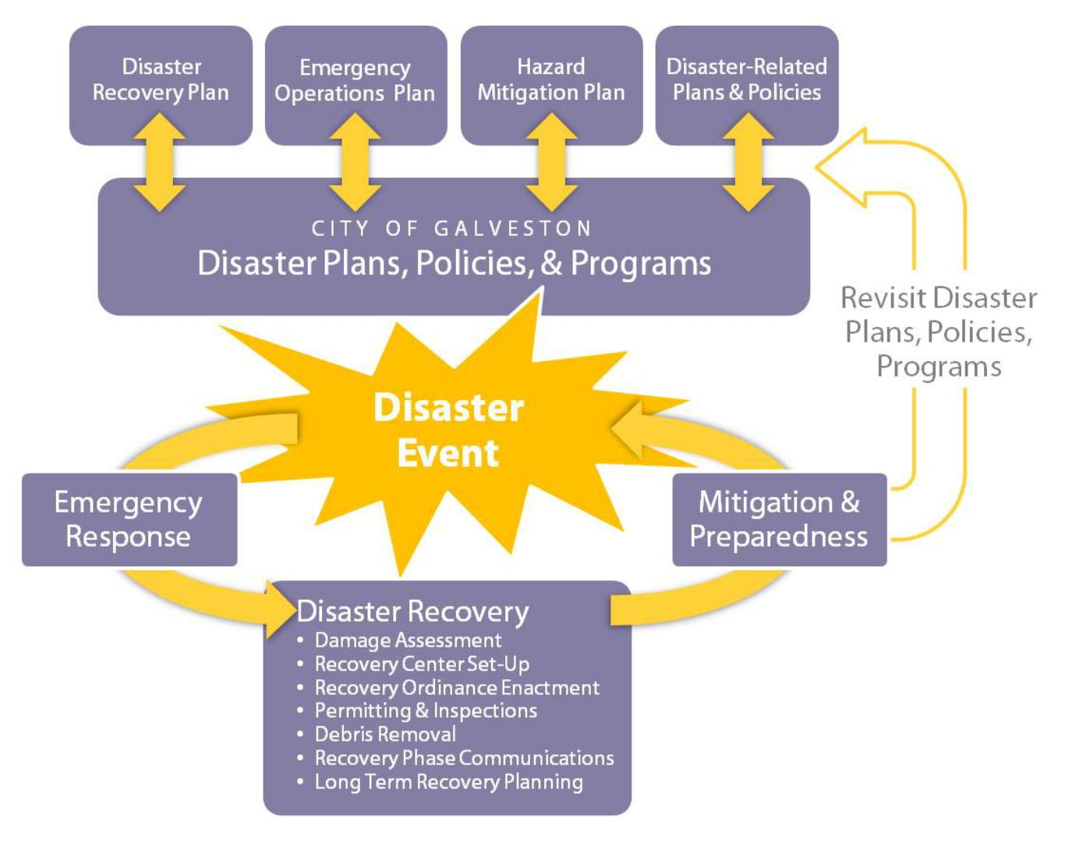

Figure 2. The Disaster Recovery Plan guides City recovery phase activities.

DISASTER RECOVERY PLAN | 06.24.13 | 3

- Annual Review

Recommendations in the Disaster Recovery Plan should be assessed on an annual basis, concurrent with the review of the Emergency Operations and Hazard Mitigation Plans, and revised as necessary to ensure the City is prepared for recovery activities in the aftermath of disaster events. The review should be completed by staff and documented in a report presented to the Planning Commission and City Council. Should the annual review result in the need to make substantive changes to the plan, a revised plan should be prepared and presented for formal review by the Planning Commission and approval by City Council.

- Organization of the Plan

Background information and recommendations regarding the City’s disaster recovery activities are provided in the following sections of the plan.

  - Recovery Resources
  - Recovery Center Establishment
  - Disaster Assessment
  - Recovery & Rebuilding Ordinances
  - Recovery Permitting & Inspections
  - Emergency & Temporary Housing
  - Debris Removal & Nuisance Abatement
  - Recovery Phase Communications
  - Long Range Community Recovery Plans

Recommendations are designed to set the stage for repair, reinvestment, and rebuilding in areas affected by disaster events.

- RECOVERY RESOURCES

Providing sufficient resources to support the City’s early recovery activities—initial assessments, permitting, and inspections—is an important early step in the process of supporting repair and rebuilding.

- Staffing Levels

To supplement existing staff resources in the aftermath of a large-scale disaster and provide adequate support for recovery-related data collection and mapping, damage assessment, permit review and processing, and property inspection services, the City should establish pre-positioned contracts with private companies, mutual aid agreements with local governments, or other forms of agreement with entities able to provide assistance. Although the City’s existing mutual aid agreements for first responder equipment and personnel are adequate to support emergency response activities, such agreements do not address long-term needs related to rebuilding. For

DISASTER RECOVERY PLAN | 06.24.13 | 4

larger-scale disaster events, the City will need to seek alternative staffing solutions for personnel required to support early recovery stage activities.

Pre-positioning contracts and mutual-aid agreements to support recovery activities should be designed to address the nature of services required; the skills and experiences of staff; requirements for training and certification to ensure readiness; performance benchmarks; time frames for service; and deployment logistics such as payment and time-keeping, equipment, housing, and transportation; and other factors affecting the successful provision of services. Working with communities across Texas, the City has the potential to play a leadership role in the establishment of mutual-aid agreements for the provision of post-disaster planning, permitting, and inspection assistance.

Pre-positioned contracts and emergency management plans should be reviewed to ensure both on-Island emergency housing and on-/off-Island transportation is arranged for City staff and contractors assigned to provide initial damage assessment, permit processing and review, and inspection services. The City’s existing agreements with Moody Gardens and the San Luis Resort should be evaluated to determine their adequacy to support sufficient personnel to staff the Recovery Permitting Center in the event of a major hurricane like Ike.

- Eligibility & Reimbursement Requirements

To ensure eligibility for reimbursement under existing disaster-related grant and funding programs, the City should review record-keeping and data requirements published and periodically updated by FEMA, the Texas Department of Emergency Management (TDEM), the U.S. Army Corps of Engineers (USACE), and other entities that provide funding for post-disaster recovery activities. Working with the local governments in the region, the City should ensure data collection and data management systems are designed to carefully document disaster and recovery related activities and expenditures.

- City Service Levels

As part of the City’s on-going emergency response and continuity of operations planning, the City will continue to evaluate the following: 1) potential sources of funding for long-term recovery, including lines of credit to provide cash flow for direct expenses and matches while waiting for federal funds; and 2) the adequacy of internal staff, or external resources, or both, to manage the financial side of recovery. In addition, the City will continue to develop plans and policies to accomplish the following:

  - provide disaster housing for essential first responder employees—police, fire, emergency operations center staff, shelter workers, and damage assessment and repair teams;

  - enable employees to participate in response and recovery by helping them meet family needs;

DISASTER RECOVERY PLAN | 06.24.13 | 5

  - maintain necessary financial relationships to ensure employees' paychecks are issued and backup plans are in place for delivery when direct deposit is not used;
  - ensure that employees and their families have guidance on developing a personal support kit and family disaster plan; and
  - establish clear communication methods for City employees—an 800 number, a radio station, an e-mail system, a meeting place for information, or other means— to provide up-to-date information about employer expectations and public service needs.

- RECOVERY CENTER ESTABLISHMENT

Depending on the severity of the disaster event and the extent of damage, assistance centers may be established by FEMA/TDEM, the City, or the GEDP and Chamber of Commerce. Planning for recovery assistance centers should include close consultation regarding locations and operations. Although co-location of centers may be appropriate, it’s important that the differing needs of constituents be considered. Individual residents seeking information on housing and financial assistance will have different needs than those discussing disaster assessments, applying for permits, or seeking different forms of recovery assistance. Plans should account for both the anticipated number of assistance seekers and the types of assistance being sought.

The following provides information regarding the establishment of FEMA/TDEM Disaster Recovery Centers and recommendations for the establishment of City Recovery Permitting Centers and GEDP/Chamber Business Recovery Centers.

- FEMA/TDEM Disaster Recovery Centers

If a federal disaster is declared, FEMA and TDEM will establish Disaster Recovery Centers to assist individual victims to understand the recovery process after they have registered for the assistance. The opening of a Disaster Recovery Center is a joint effort by the State and FEMA to provide technical assistance and provide the status of assistance that is being requested by the individuals affected by the disaster.

FEMA/TDEM centers are set up in or near areas that received the highest levels of damage. If damage is wide spread or a large number of people need assistance, several centers may be established. Centers are staffed by federal and state government agency representatives and volunteer organizations, which offer information on resources available to people in the affected community. Typically, assistance resources from different agencies and organizations are organized in one facility so applicants have the ability to check on the status and availability of assistance from multiple entities.

The City will be asked to assist in the identification of potential locations and provide logistic support for center establishment. Site selection is a joint state and local responsibility which may be accelerated with pre-disaster coordination. Currently,

DISASTER RECOVERY PLAN | 06.24.13 | 6

Figure 3. Makeshift work station used after Hurricane Ike.
potential locations are identified in coordination with TDEM and Galveston County, and reviewed annually.

- City Recovery Permitting Center

The City should complete detailed plans for the establishment of a Recovery Permitting Center. Plans should provide details for how the establishment of a city-staffed recovery permitting center should be set up and operated (e.g. by City staff or by contractor through a Memorandum of Understanding [MOU] to support post-disaster permitting for residential and commercial properties and provide a location where residents and business owners can seek general information regarding recovery activities, housing assistance, debris removal, and financial assistance). Plans should also address the potential to co-locate related services designed to support recovery.

The Recovery Permitting Center should be designed to offer planning and permitting services in the aftermath of a disaster the scale of Hurricane Ike. (Following large-scale disaster events such as Ike, which resulted in extensive and geographically-dispersed damage, the City’s existing permitting operations in City Hall will be overwhelmed with the volume and diversity of individuals seeking assistance.) Existing permitting
operations on the 4th floor will be inadequate to comfortably and safely serve high volumes of applicants and assistance seekers, create difficulties segregating applicants by type and level of need, and serve to limit the potential for the creation of a “one stop shop” for recovery information and assistance.
Establishment of a center at a site like the McGuire-Dent Recreation Center
would allow the City to effectively serve large numbers of individuals while also providing for the potential to co-locate disaster assistance programs offered by FEMA, GEDP, and others. To ensure adequate levels of service and effective operations, careful planning is required to ensure the Center is set up quickly and offers adequate, effectively organized space and equipment to support planned activities.

- a space plan showing the configuration of space, including the designation of entries and exits, definition of waiting and cueing areas, location of restroom facilities, arrangement of work stations and support equipment like copiers and fax machines, location and extent of temporary partitions, and the definition of small group or staff only work rooms;

DISASTER RECOVERY PLAN | 06.24.13 | 7

  - plans for the provision of emergency power and means of distribution to work stations, lighting, equipment, and publicly-available charging stations;
  - plans for the transportation and set up of furnishings and equipment to support operations;
  - plans for the transportation, setup, and maintenance of required communication and computer equipment, including phones, computers, printers and plotters, copiers and fax machines, and wired or wireless networks;

  - plans for provision of basic services such as restroom facilities and basic break room/kitchen facilities;
  - pre-printed and mounted signs to indicate entry locations and guide users to appropriate resources; and
  - arrangements for security.

- GEDP/Chamber Business Recovery Center

In the event of a major disaster affecting a significant number of businesses, institutions, and non-profit organizations, the City will work in partnership with GEDP, Galveston County, and the state to establish one or more Business Recovery Centers on the Island or on the Mainland. The purpose of the Business Recovery Center is to provide technical assistance, resources, and information to members of the local business community affected by the disaster or with the potential to support rebuilding efforts. By working through the Business Recovery Center, local employers may be able to communicate with former employees and coordinate re-employment issues. While businesses and employees may not be able to immediately return to impacted areas of the Island, the center can support relocation efforts, track information, and provide technical assistance and counseling for alternate employers or workers to fill human resource shortfalls and business gaps. Representatives at the center may include local, state, and federal public and private sector organizations.

Business Recovery Centers can be established to provide the following services:

  - assistance with federal disaster programs and loan applications;
  - assistance with local and/or state bridge loans;
  - information on available temporary office space;
  - basic office and communications equipment;
  - message boards for organizations and companies to assist small businesses;
  - locations of operational wireless internet hotspots; and
  - other expert advice on financial and business recovery issues.

DISASTER RECOVERY PLAN | 06.24.13 | 8

Figure 4. Initial damage assessments set the stage for rebuilding.
- DAMAGE ASSESSMENTS

The completion of timely, accurate, and coordinated damage assessments provides an important foundation for post-disaster permitting and inspections. Initial damage assessments, completed by a City-designated team as quickly as deemed safe, will result in a preliminary definition of damage for individual properties affected by a disaster event, thus allowing property owners to make preliminary plans for repair or replacement. The timely completion of initial assessments will also provide important data to estimate resource requirements for permitting and inspection operations.

- Assessments Processes

When notified to begin assessment operations, the City’s assessment teams will be notified and directed to report to a central meeting place. The primary meeting location will most likely be City Hall with an alternative location to be identified in case of damage. The assessment teams will assemble, review assigned area to cover, and review data collection methods and reporting protocols.

Depending on the type, severity, and geographic scope of damage, resources required to complete initial damage assessment may vary greatly. Although existing staff may handle assess-ments for minor events and those resulting in localized damage, addi-tional staff will be needed
to support events the scale of Hurricane Ike
which resulted in damage across the entire extent of the Island. As recommended in the Recovery Resources section above, the City should review rules and procedures for reimbursement of costs related to the use of outside resources in carrying out recovery activities.

- Color-Coding System

The City’s initial damage assessments will result in the initial coding of buildings to indicate extent of damage and inhabitability. The following color-coding system was used by the City following Hurricane Ike:

  - Red - Substantially Damaged. Properties identified as being substantially damaged based on a review of the extent of damage and structural condition.

DISASTER RECOVERY PLAN | 06.24.13 | 9

Figure 5. Detail of a post-Ike damage assessment map with color-coding of parcels to indicate level of damage.
Buildings coded ‘red’ are those completely destroyed, significantly flooded, collapsed or collapsing, or structurally unsound.

- Yellow - Potentially Repairable with Major Damage. Properties identified as structurally sound and repairable as well as those requiring further assessment before final determination of condition. Buildings coded ‘yellow’ include those with signs of fire, flood, wind, or other damage to non-structural building features or elements including windows, doors, and roofing material, porches and stairs, and exterior cladding and trim.

- Green - Repairable with Minor Damage. Properties identified as structurally sound with little or no damage. Buildings coded ‘green’ include those with little or no damage to non-structural building features or elements.

- Blue - Historic Exemption. Any property that is listed or determined eligible for listing on the National Register of Historic Places is coded ‘blue’ to indicate that the property is exempt from current flood-plain elevation requirements and therefore not subject to limits on the extent of reinvestment permitted.

For properties designated ‘yellow’ or ‘red’ during the initial damage assessment conducted by the City, FEMA staff will complete follow-up inspections which may result in a change in the initial designation. For all properties designated ‘red’, staff will notify

owners by letter that their properties were sub-stantially damaged and that City regulations may limit the extent of repair allowed and may require that the property be brought into compliance with the Flood Damage Prevention Ordinance and National Flood Insurance Program (NFIP) require-ments.
Depending on a final determination regarding
the extent of damage relative to the property’s value, compliance with existing regulations may involve elevating the structure to meet the minimum elevation requirements, relocating the structure to a property that conforms to floodplain regula-tions, or demolishing the structure and rebuilding in according to the current regulations. Before a final ‘red’ or ‘substantially damaged’ determination is made, owners have an opportunity to provide information regarding the extent of damage and cost-to -repair, and should there be a disagreement on the final determination, the owner may appeal to the Building Board of Adjustments and Appeals.

To assist in ensuring owners comply with requirements of the Flood Damage Prevention Ordinance, property owners are encouraged to have their elevation certificate on file

DISASTER RECOVERY PLAN | 06.24.13 | 10

with the City. For properties with certificates on file, the City may permit repair work even if the property is designated ‘red’ and sustained more than 50% damage.

- Assessment Communications

To supplement existing assessment and color-coding systems, the City should explore the feasibility of developing a placard system to inform owners of the results of the initial damage assessments. Assessment teams could carry a supply of placards during the initial assessments and post individual properties to indicate status or have other staff post properties following the completion of the initial assessments. Posting of placards would allow property owners the ability to learn of their property’s status and how to access information regarding procedures for emergency repair and permitting. The exploration of such a system should include an evaluation of resources, including staff time, required to support the production and placement of placards.

The City should also prepare plans to report the results of initial damage assessment on-line, using the City’s existing web-based mapping tools and through a searchable database with references to address and property record. Following major events, when large areas of the Island may be closed for public health and safety reasons, owners should be able to access basic information regarding their property’s condition, including photographs of the property, and follow links to information regarding recovery permitting options.

- RECOVERY & REBUILDING ORDINANCES

In the aftermath of Hurricane Ike, the City adopted a number of emergency ordinances to help expedite efforts to complete emergency repairs; place emergency housing and storage; and establish assistance centers. The emergency ordinances addressed provisions in the City’s land development regulations, flood ordinance, and other regulations affecting building and development activities. The emergency ordinances included time limits or automatic sunset provisions as well as specific conditions and standards affecting temporary buildings and land uses.

- Post-Ike Ordinances

A review of the emergency ordinances enacted following Hurricane Ike is provided below. These ordinances, unless noted otherwise, provide the basis for ordinances which may be enacted following future disaster events. Public communications regarding these ordinances is included in Exhibit A.

  - Allowance for Trailers and Recreational Vehicles on Individual Properties. This emergency ordinance passed within weeks of Ike landfall. It temporarily suspended regulations relating to the placement of trailers and recreational vehicles and established temporary regulations for trailers and recreational vehicles located on residential and commercial properties (Ordinance No. 08-062,

DISASTER RECOVERY PLAN | 06.24.13 | 11

10.09.08). The ordinance was extended by City Council to accommodate the period of rebuilding.

  - Allowance for Temporary Storage Units on Individual Properties. This emergency ordinance temporarily suspended regulations relating to the use and placement of temporary storage units and enforced regulations for temporary storage units located on residential and commercial properties (Ordinance No. 08-067, 10.16.08). The ordinance was also extended to accommodate the period of rebuilding.

  - Flood Elevation Variance for Manufactured Homes. The City granted a variance from the Flood Ordinance waiving flood elevation requirements for manufactured homes in flood-plains for the limited purpose to allow FEMA to provide temporary direct housing assistance in the form of manufactured homes and readily fabricated dwellings, primarily mobile homes and park model mobile homes (Ordinance No. 08-068, 10/23/08). The waiver was extended several times.

  - Waiver of Building Permitting Fees for Repair and Reconstruction. The City approved a temporarily waiver of all building permitting fees for the repair and reconstruction of residential and commercial properties damaged during the hurricane (Ordinance No. 08-069, 11.13.08).

  - Waiver for Temporary License to Use City Right-of-Way. The City temporarily waived regulations regarding permits for temporary use of the city right-of-way and the associated license fees for placement of temporary structures in the city right-of-way (Ordinance No. 08-069, 11.13.08).

  - Authorization for FEMA Emergency Housing at Community Sites. The City adopted an ordinance authorizing FEMA to locate and manage the occupancy of manufactured homes and readily fabricated dwellings, primarily mobile homes and park model mobile homes, at cluster and community sites (Ordinance No. 08-071, 11.13.08).

  - Allowance for Volunteer Agency Trailers and Recreational Vehicles. The City adopted and extended an emergency ordinance providing temporary regulations for trailers and recreational vehicles located on trailer parks temporarily created to support for volunteer organization assistance operations (Ordinance No. 09-005, 02.12.09).

- Emergency Repair Authorization

The City should consider developing a recovery-related ordinance authorizing emergency repairs without advanced approval. Under such a program, the use of placards or another mechanism may be used to identify buildings for which emergency repairs may be permitted. By authorizing specific kinds of work to be completed, the system could help owners prevent further damage to their structure and/or make their structure safe and habitable.

Should an emergency repair authorization program be implemented, the following safeguards should be in place and communicated to property owners and licensed contractors:

DISASTER RECOVERY PLAN | 06.24.13 | 12

  - emergency repair work may only be performed by the property owner and/or properly licensed contractor(s);
  - a permit and inspection will be required and must be obtained within a certain number of days of work being completed; and
  - all work shall comply with the applicable building codes.

- RECOVERY PERMITTING & INSPECTIONS

As the initial assessments are completed and recovery ordinances are enacted, staff’s focus will shift to the processing of building permit applications and completion of inspections for repair and reconstruction, restoration of electrical and plumbing services, and other work. During these early stages of recovery, it is critical that the City be positioned to quickly process applications and provide effective information and technical assistance to home owners, business owners, and private contractors. Section 3.2 discusses the need for a Recovery Permitting Center and focuses on the physical and staffing needs of such a Center. This section is intended to discuss the internal processes required to quickly and efficiently serve the City’s permitting and inspection needs after a disaster.

To prepare for recovery permitting and inspection activities, the City should augment its recently implemented on-line permitting system with the following enhancements and improvements:

- Recovery-related work flows in Accela, the City’s electronic permitting and inspections system, to provide for streamlined and expedited permitting. The goal of recovery permitting should be on-the-spot-permitting for eligible properties and pre-defined repair and rebuilding activities.

- Provisions for on-line permitting of pre-defined kinds of repair and rebuilding activities, which would allow citizens and contractors to apply for permits directly from the Internet, 24 hours a day, 7 days a week.

- Provisions for permitting in the field by staff using mobile devices and mobile applications.
- Provisions to accommodate the increase in contractor registration requests.
- Provisions for permitting in special areas such as historic districts and the beachfront.
- Coordination with the Public Works Department regarding the issuance of plumbing permits.
- Informational materials for internal use and for distribution to the public describing emergency and temporary regulations and recovery permitting processes and procedures.

- Electronic and print forms for use in post-disaster permitting. The standard forms can be lengthy and may be confusing to the public as they are designed to capture all information needed for complex projects. The forms should be simplified to include only the minimum information needed for typical post-disaster projects.

DISASTER RECOVERY PLAN | 06.24.13 | 13

Examples of recovery-phase permitting forms include simplified versions of the existing building permit and beachfront and dune protection permit applications.
- The physical layout of workstations at the Recovery Permitting Center. The layout should closely mimic the workflows of the permitting system to provide an efficient and intuitive path for the public.

As recommended in earlier sections of the plan, the City should enter into agreements with other local governments or private entities able to provide permit review, inspection, and supplemental administrative support to staff during peak phases of recovery. In the aftermath of large-scale events, the City will need to provide adequate staffing levels for the Recovery Permitting Center as well as properly trained and licensed inspection staff for operations in the field.

- EMERGENCY & TEMPORARY HOUSING

One of the most urgent needs during the recovery process is emergency shelter and housing for disaster victims. Although immediate shelter falls under the purview of emergency management, the City should address the need to provide emergency shelter and temporary housing through the development of a detailed Disaster Housing Strategy, pre-planning for the deployment of emergency and temporary housing units, and the completion of related revisions to the City’s planning policies and Land Development Regulations.

- Integrated Strategies for Disaster Housing

The City should develop an integrated local disaster housing strategy to provide policies and tactics designed to retain population, help dis-placed residents return and reestablish support networks, and help accelerate the pace of

economic recovery. Using Figure 6. Temporary housing with connection to City sewer system.
a template such as the
Local Disaster Housing Strategy Guide Template created by the Florida Division of Emergency Management, the City can address the full array of interim housing options available to support recovery. With strategies keyed to the severity and magnitude of impact, decision-makers will have the flexibility to select from a range of potential options, including placement of displaced residents within local hotels, vacant rental units, or within FEMA provided manufactured housing units. The strategy can also ensure that the needs of special populations are addressed.
DISASTER RECOVERY PLAN | 06.24.13 | 14

- Deployment of Emergency & Temporary Housing

The City should also initiate a dialogue with FEMA to explore opportunities to pre-plan for the deployment of emergency housing on the Island. Following Hurricanes Katrina, Rita, and Ike, FEMA’s Joint Housing Solutions Group (JHSG) has identified strategies to improve its ability to provide housing assistance to communities. JHSG has researched, evaluated, and documented alternatives to traditional disaster housing while also recommending improvements for conducting disaster housing operations. Among the group’s early actions was an effort to identify alternatives to the use of FEMA trailers, expand the range of disaster housing options, and provide flexibility in the selection of disaster housing in response to regional and community considerations. The JHSG team includes housing specialists from the U.S. Department of Housing and Urban Development (HUD); building science experts from the National Institute of Building Sciences (NIBS); and specialists from FEMA housing, policy, Individual Assistance, Long-Term Recovery and Public Assistance divisions.

Through a pre-planning effort with the JHSG, the City could identify appropriate emergency housing typologies and potential public and private sites for placement; prepare concept plans and cost-estimates for the provision of infrastructure, utility, and social service support; and clarify policies and strategies to limit tenure and repurpose sites and structures following a pre-defined period of emergency and temporary use. As part of this effort, the City should explore the potential to employ typologies with the potential for long-term use following the recovery phase. Examples like the cottages constructed following Hurricanes Katrina and Rita and the post-1900 storm Commissary Houses, several of which are still in use on the Island, may serve as examples of emergency housing designed to have long-term utility.

Information from the planning effort could be used to support negotiations with providers of emergency shelters and other forms of emergency housing when current MOUs expire. (Currently, the City has an MOU with Assett Group to provide temporary emergency mass care sheltering for citizens.)

DISASTER RECOVERY PLAN | 06.24.13 | 15

- DEBRIS REMOVAL & NUISANCE ABATEMENT

The City should conduct a careful evaluation of existing processes and procedures to guide debris removal efforts. Currently, the City has pre-positioned contracts with several companies, all with experience providing debris removal services to the City, post-Ike. The City should consider the following issues and opportunities in managing existing agreements and negotiating new agreements in the future.

- Debris Staging & Sorting

The City should evaluate staging and sorting areas used during Hurricane Ike, and determine if adjustments in locations or use should be made to ensure effective operations. Segregating debris generating from historic and non-historic areas is an important objective, as is the ability to separate debris by type—household hazardous waste, general construction debris, landscape debris, and boats and vehicles.

Figure 7. Clearance, staging, and removal of debris from Hurricane Ike presented significant challenges.

- Communications to Commercial Owners

The City should review communication plans and materials to ensure business owners and operators and advocacy organizations understand limits on what may be removed by the City or its contractors. Currently, businesses are responsible for the collection and removal of post-disaster debris generated from cleaning, repair, construction, and other activities. And although the City has permitted temporary placement of debris awaiting disposal in City rights-of-way, such temporary placement does not transfer ownership of such debris to the City (or the County if placed in County rights-of-way or state if placed in state rights-of-way). To assist in the clean-up of commercial districts, the City should work with GEDP and local business owners to plan for the coordinated removal of debris from commercial districts.

- Private Property Debris Removal

Following Hurricane Ike, the City worked with FEMA to establish a Private Property Debris Removal (PPDR) Program to remove storm-damaged materials. Under the program, FEMA funded the removal of hurricane generated debris from eligible private property located within the city limits. To qualify to participate, property owners were

DISASTER RECOVERY PLAN | 06.24.13 | 16

required to explain why they were unable to move storm debris to the right-of-way; establish that the debris created a health and safety hazard for the area; and provide proof of ownership and insurance coverage. Demolition of privately owned structures determined unsafe was considered for the program if specific terms and conditions were met. Commercial, unimproved, and vacant property was not eligible.

The City should continue to work with FEMA to plan for the establishment of PPDR programs following future disaster events and prepare communications designed to alert property owners of a program’s establishment as quickly as possible following a storm event.

- Private Property Nuisance Abatement

The City should continue working towards the adoption of a Private Property Nuisance Abatement ordinance allowing City or City contractors’ right of access to private property to remove disaster-related debris without owner consent. Given the high number of vacant and abandoned properties in the City and other challenges associated with absentee ownership, clear title, and current insurance, an effective nuisance abatement debris removal program could be used as a tool-of-last-resort, allowing the City to clear debris before it becomes a long-term nuisance or health and safety hazard.

- RECOVERY PHASE COMMUNICATIONS

The City will continue to review disaster communications plans and explore opportunities to improve recovery phase communications via on-line and traditional channels—local print and broadcast media; distribution of flyers and pamphlets; and posting of information at important gathering places.

- Comprehensive Disaster Communications Plan

As called for in the Comprehensive Plan, the City should prepare a comprehensive Disaster Communication Plan designed to provide the following:

  - Strategies for use of the City web site, including webstreaming of Channel 16 and social media channels like Facebook and Twitter, to disseminate preparedness, response, and recovery information.

  - Plans for use of website during recovery phase to provide information relating to building permits, businesses re-opening, City recovery activities, and programs for residential recovery.

  - Translators to provide preparedness, response, and recovery information in Spanish and Vietnamese.
  - Communication tools to support secure and consistent communication among City staff.
  - Methods to provide damage assessment, permitting, and inspection information to residents and business owners, including those without access to the Island.

DISASTER RECOVERY PLAN | 06.24.13 | 17

  - Planning for regular community meetings during recovery phase to provide updates. In the short-term, meetings may be weekly while longer-term, meetings may be held monthly or quarterly.

- Expended Communication Channels

Recognizing residents affected by a disaster may have limited access to all standard communication channels, the City’s Disaster Communication Plans should be designed to offer a variety of ways to access important information.

  - Emergency Notification. The City’s Emergency Notification System is designed to alert residents by voice or text message of important news in the immediate response and early recovery phases following a disaster.

  - City Web Site. Residents and business owners with on-line access can visit the City’s web site at www.cityofgalveston.org to learn about the status of recovery activities and access information regarding emergency ordinances; damage assessment information; procedures for permitting and inspections; and sources of assistance.

  - Social Media. The City is now using social media sites like Facebook and Twitter to supplement conventional channels for the distribution of emergency information.
  - Media Outlets. The City will continue to use the following media outlets to provide regular updates on activities: the City’s Comcast Municipal Channel 16; KTRH 740AM radio, and regional TV networks.

  - Print Materials. In addition, print material will be made available at all recovery and assistance centers, as well as distribution to community groups and organizations.

  - Direct Mailers and Water Bill Inserts. Assuming regular mail service is available, direct mail and water bill inserts will supplement emergency communication methods.

- Availability of Assistance

As part of its recovery phase communications, the City will work with providers of assistance to distribute information on available programs. Following large scale disaster events, numerous forms of individual assistance are available to families, individuals, or owners of small businesses. Much of the available assistance is offered to support those with special needs, including low-income, elderly, and disabled residents. As reported in the Texas Recovery Manual, the assistance programs listed in Exhibit B may be available to residents following a federal disaster declaration.

The City will also work with GEDP and the Chamber of Commerce to assist in the distribution of assistance information relevant to the Island’s businesses and institutions.

DISASTER RECOVERY PLAN | 06.24.13 | 18

10. LONG-TERM COMMUNITY RECOVERY PLANS

Following larger scale disasters, the City will prepare a Long-Term Community Recovery Plan (LTCRP) to document and communicate disaster-specific recovery goals, decisions, and priorities and set forth a detailed roadmap to guide decision-making. Whether locally-initiated or undertaken with federal assistance, future LTCRPs should be developed in a timely manner, provide clear goals for recovery, and include detailed information to facilitate implementation. With clear goals and specific objectives, the City can work with federal and state entities to prioritize projects, allocate resources, and establish a basis for subsequent evaluations of the recovery progress.

- LTCRP Guidance

FEMA’s publication, The Long Term Community Recovery Planning Process: A Self-Help Guide, offers detailed guidance for the preparation of disaster-specific, community-based recovery plans. Building the experience and expertise of planners, architects, and engineers engaged in community recovery planning efforts, the Self-Help Guide provides step-by-step guidance for implementing a LTCR planning program. The Self-Help Guide describes a 13-step planning process designed to help communities define appropriate planning, communication, and engagement processes; clarify recovery issues and opportunities; articulate recovery visions and goals; identify, evaluate, and prioritize long-term community recovery projects; identify funding; and define implementation steps.

- Federal Assistance for Recovery Planning

Following Presidentially-declared disasters, federal assistance may be available to the City to support long-term community recovery planning activities. Through FEMA’s Emergency Support Function (ESF) #14–Long-Term Community Recovery program, federal technical assistance is available to help ensure a coordinated Federal response to address significant long-term impacts and foster sustainable recovery. The level of ESF #14 support will vary depending on the magnitude and type of incident.

- Galveston’s Post-Ike LTCRP

The LTCRP prepared following Hurricane Ike was created through an extensive community engagement and outreach effort and resulted in the identification of 40 projects with the potential to improve the community’s livability, economic vitality, and resilience. As Hurricane Ike was defined as a large-scale disaster event, FEMA played a central role in the preparation of the LTCRP, providing technical support and assistance in evaluating the recovery value of recommended projects. For each project identified in the plan, a recovery value was assigned by FEMA to indicate its ability to help jump-start community recovery. Projects with the highest rankings were those designed to promote a functioning and healthy economy, support infrastructure optimization, offer housing opportunities, and support revitalization. The highest ranking projects received priority for federal funding through the disaster recovery grant program.

DISASTER RECOVERY PLAN | 06.24.13 | 19

EXHIBIT A: PUBLIC COMMUNICATIONS REGARDING REBUILDING ACTIVITIES
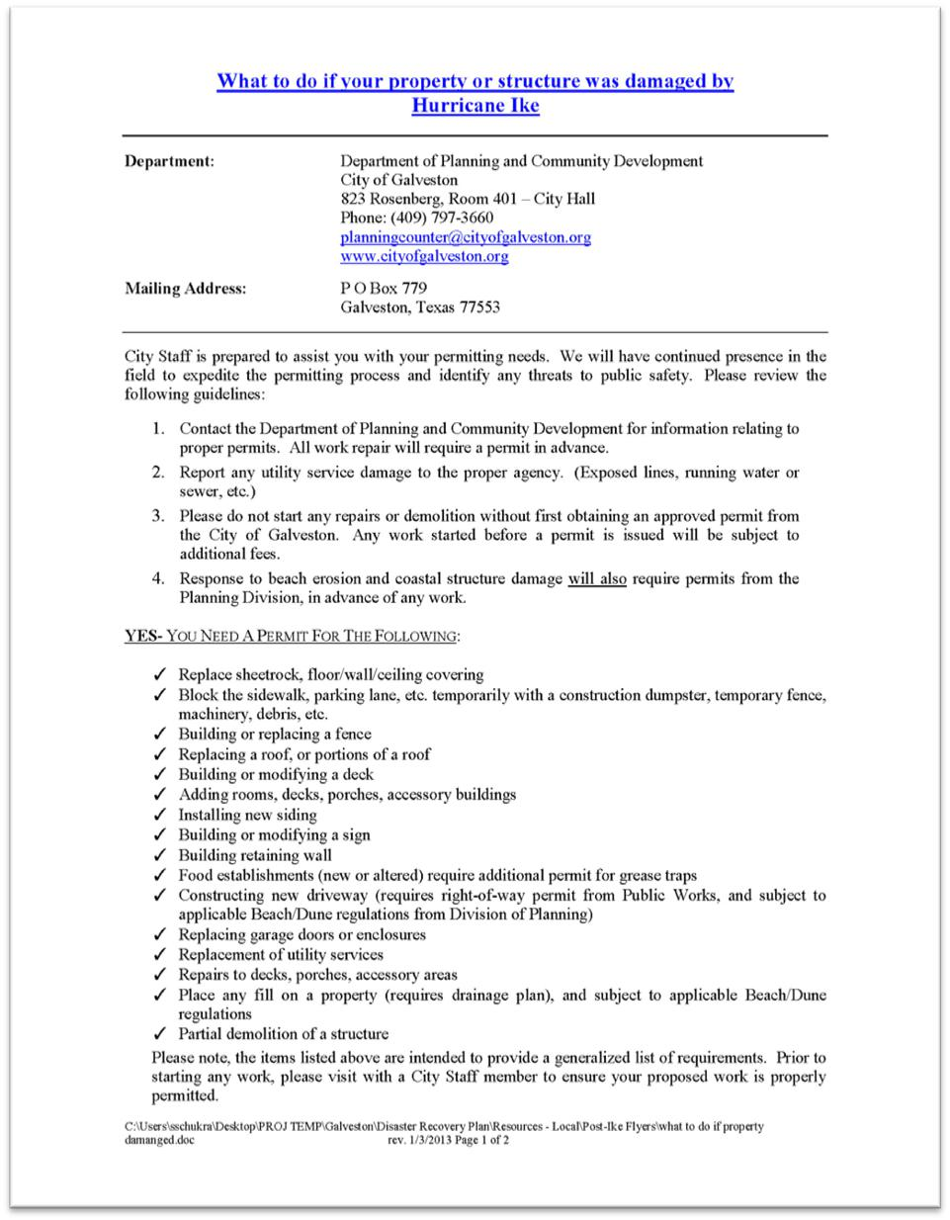

DISASTER RECOVERY PLAN | 06.24.13 EXHIBIT A | 1

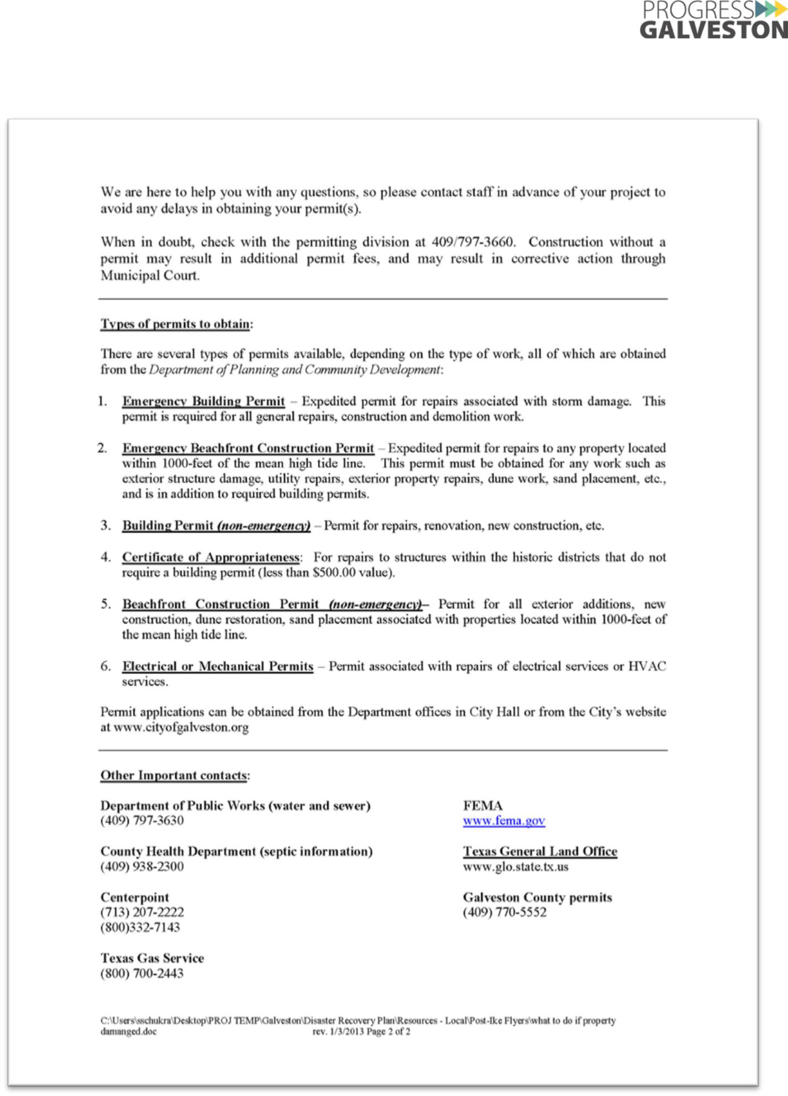

DISASTER RECOVERY PLAN | 06.24.13 EXHIBIT A | 2

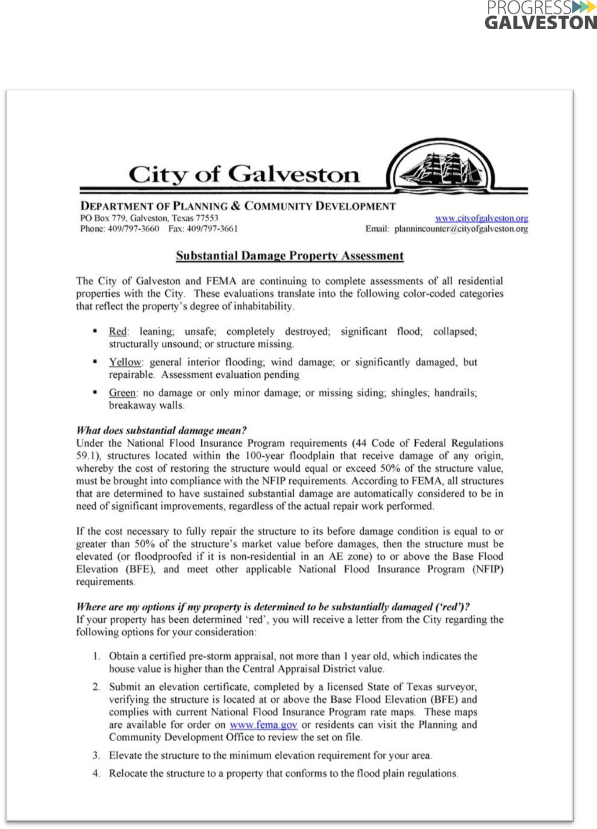

DISASTER RECOVERY PLAN | 06.24.13 EXHIBIT A | 3

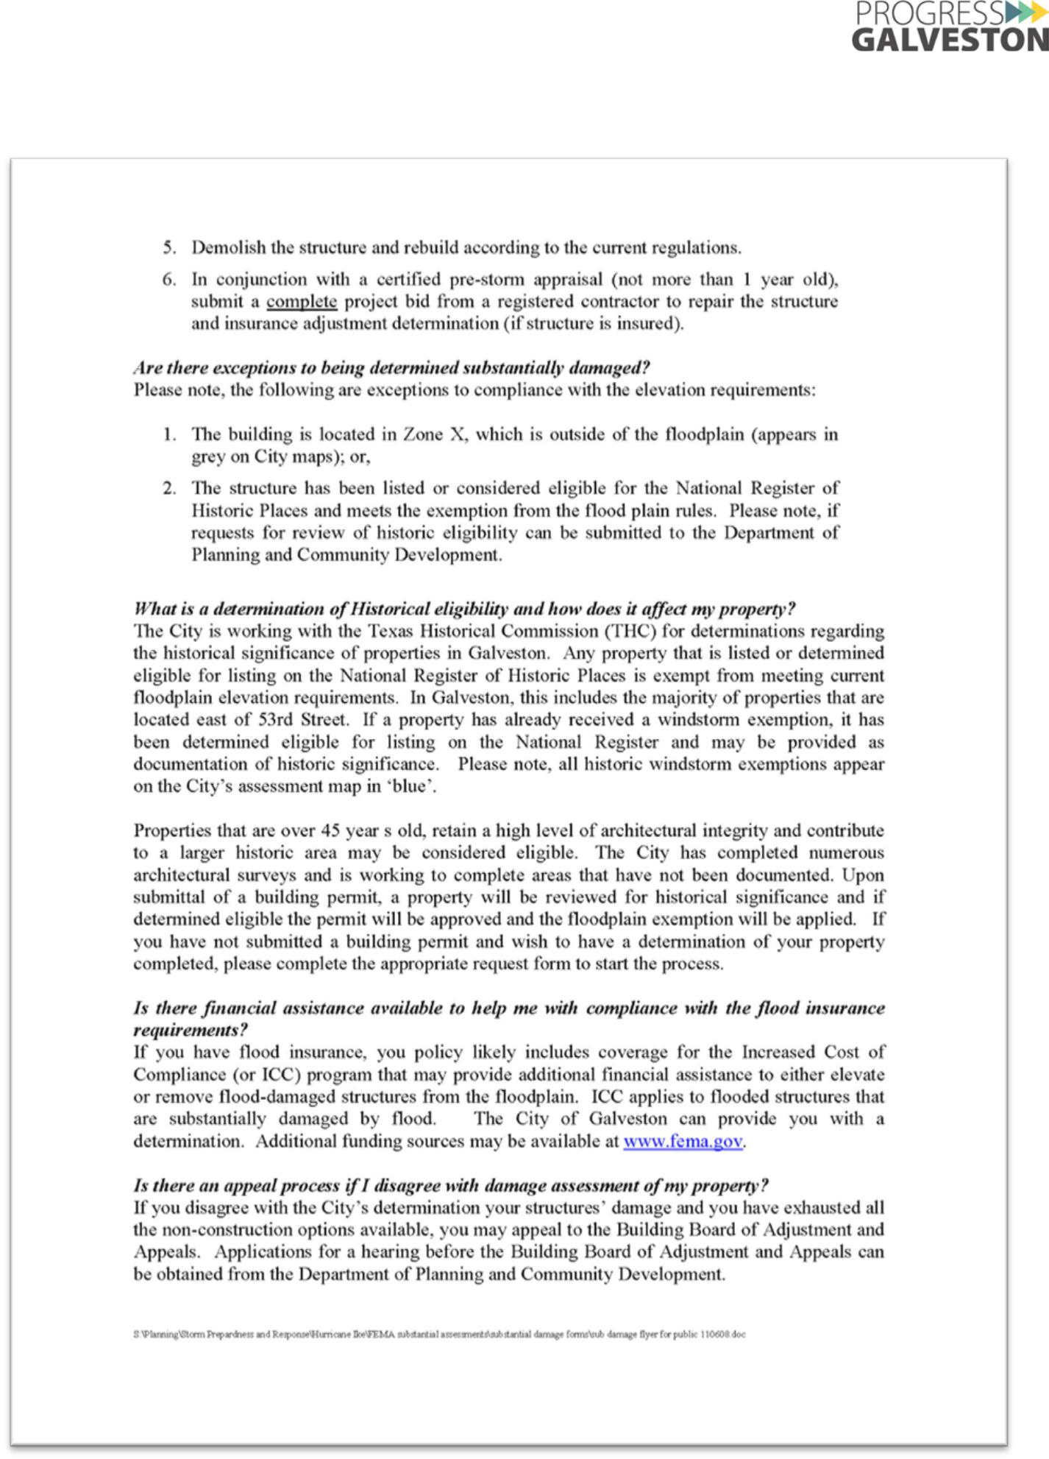

DISASTER RECOVERY PLAN | 06.24.13 EXHIBIT A | 4

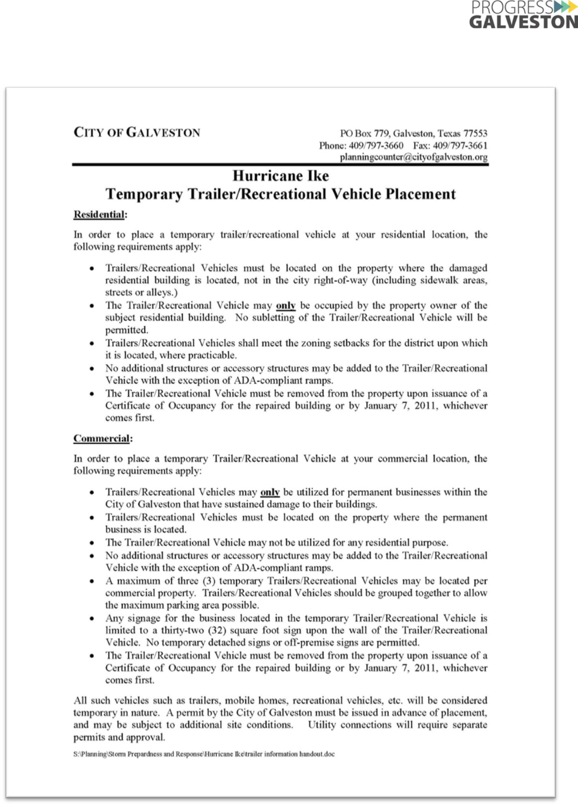

DISASTER RECOVERY PLAN | 06.24.13 EXHIBIT A | 5

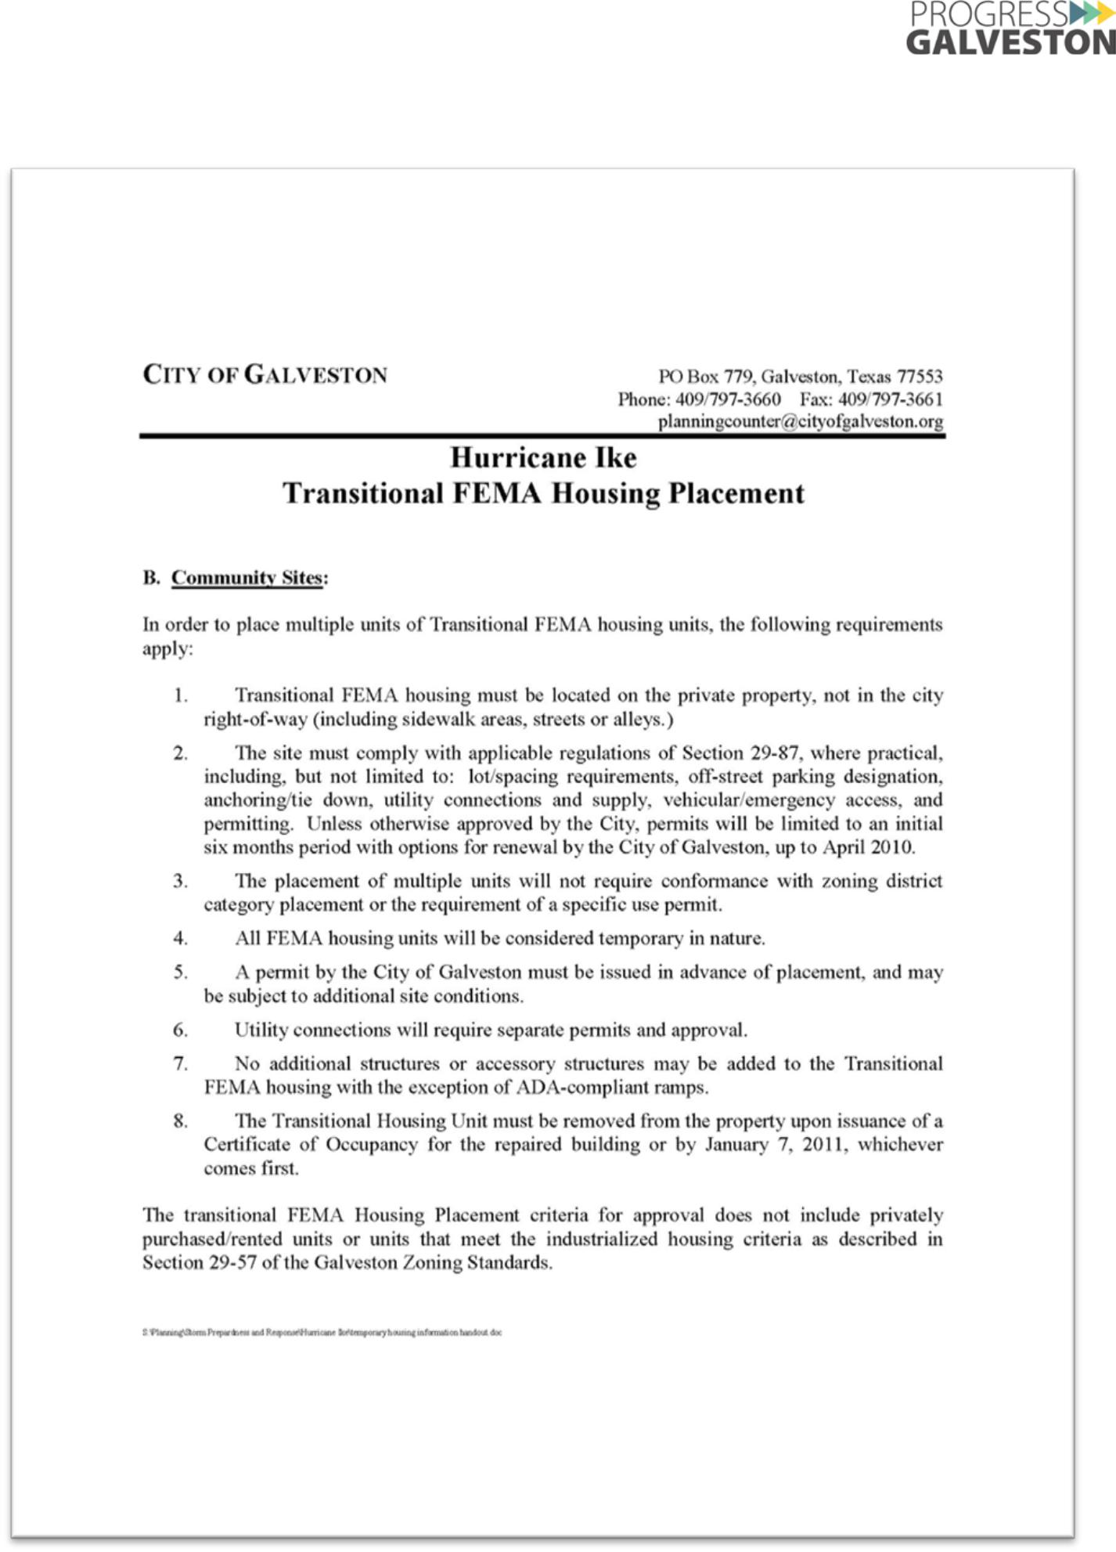

DISASTER RECOVERY PLAN | 06.24.13 EXHIBIT A | 6

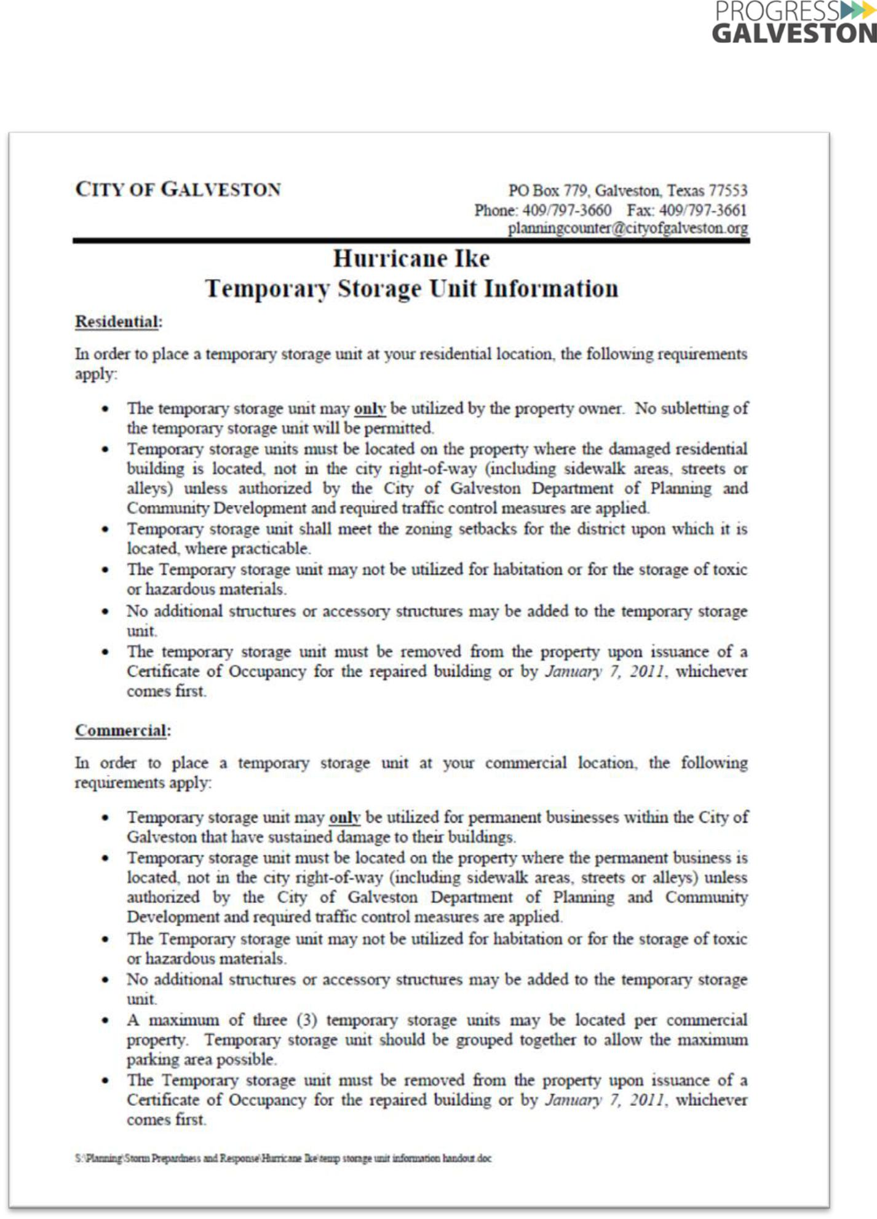

DISASTER RECOVERY PLAN | 06.24.13 EXHIBIT A | 7

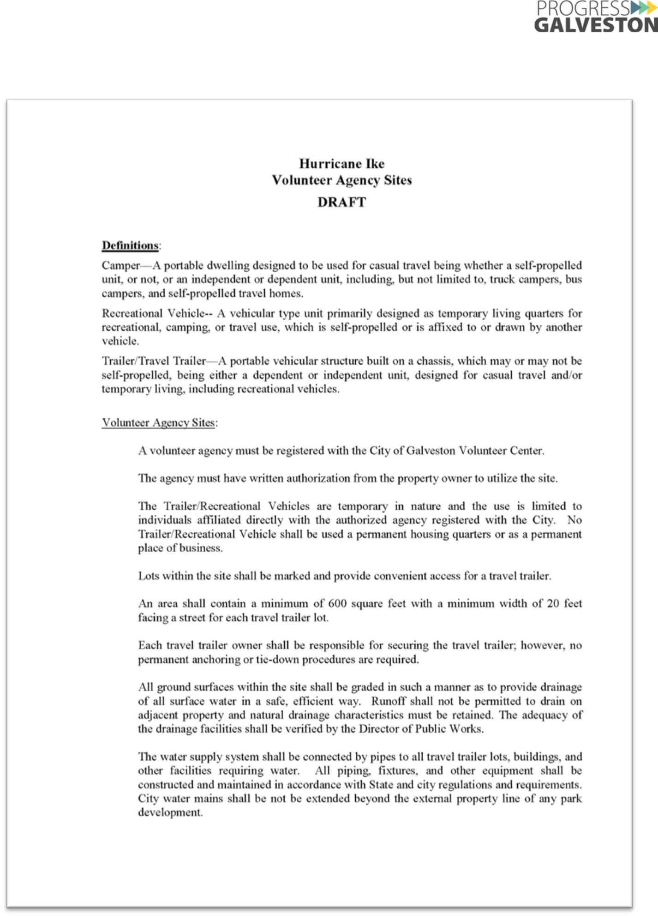

DISASTER RECOVERY PLAN | 06.24.13 EXHIBIT A | 8

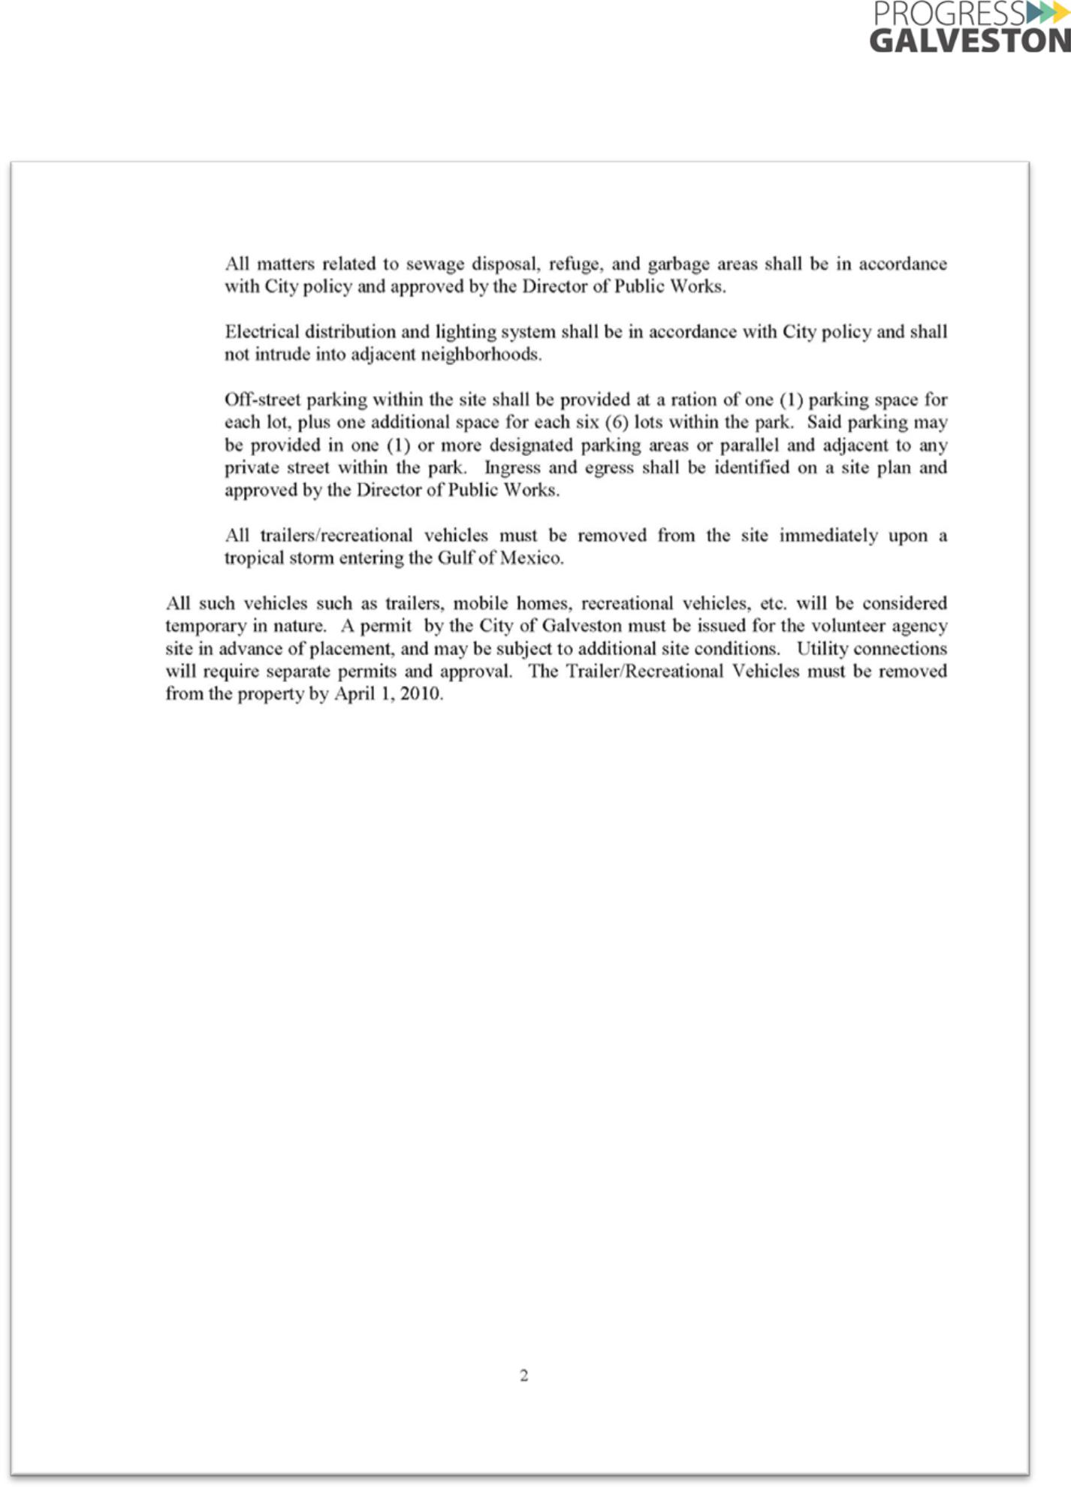

DISASTER RECOVERY PLAN | 06.24.13 EXHIBIT A | 9

EXHIBIT B: DESCRIPTION OF INDIVIDUAL ASSISTANCE PROGRAMS

Information on post- disaster assistance programs, drawn from the Texas Recovery Manual prepared by the Texas Division of Emergency Management, is provided below.

Description of Assistance Programs

Individuals and Households Program (IHP). The Individuals and Households Program is a combined FEMA and State program that provides money to help people whose property has been damaged or destroyed and whose losses are not covered by insurance. The IHP is divided into two parts—housing assistance and other needs assistance. Housing Assistance under the program is available for applicants displaced from their pre- disaster primary residences or whose pre-disaster residences are rendered uninhabitable, and who are under-insured or have no insurance to provide for their housing needs. Other Needs Assistance under the program provides assistance for necessary expenses and serious needs such as medical care for a disaster related illness or injury; funeral expenses for disaster related loss of life; repair or replacement of disaster damaged essential personal property items, like clothing, household items, furnishings, appliances, computers, etc,; funds to repair or replace damaged or destroyed personal; and vehicles; and assistance to move and store personal property to avoid additional disaster damage, including storing the property while disaster related repairs are made to the primary residence and returning the property back to the home.

SBA Disaster Loans. The following assistance is administered by the SBA and is available in a SBA only or major disaster declaration approved by the President:

- Home/Personal Property Physical Disaster Loans. Loans are available to homeowners and renters to repair or replace disaster-related damage to primaryresidences and personal property. Up to $200,000 may be loaned to repair or replace disaster damaged primary residences and up to $40,000 may be loaned for the repair or replacement of disaster damaged personal property. The loan amount is limited to the amount of the uninsured, SBA verified loss, but may be increased by up to twenty percent, but not exceeding the maximum loan amount for mitigating devices.

- Business Physical Disaster Loans. Loans are available to businesses and non-profit organizations of any size to repair or replace disaster damaged property owned by the business, including inventory, machinery, or equipment. Up to $1,500,000 may be loaned to repair or replace uninsured, SBA verifiedbusiness loss. Within this limit, the loan may be increased up to twenty percent for approved mitigation activities.

- Economic Injury Disaster Loans for Businesses (EIDL). Loans are available, to eligible small businesses and small non-farming agricultural cooperatives, for working capital to assist them through the disaster recovery period. A business need not have sustained physical loss as a result of the disaster. Loans are available only if the business or its owners cannot obtain this type of assistance from non-government sources. Up to $1,500,000 may be loaned for eligible economic needs. The total physical and economic injury loan to any one business entity, including affiliates, cannot exceed $1,500,000. In addition to those declarations listed above, EIDL loans are also available following an USDA Secretarial disaster declaration in both primary and contiguous counties.

DISASTER RECOVERY PLAN | 06.24.13 EXHIBIT B | 1

Interest rates and terms differ by type of loan. The SBA determines the interest rate based upon the individual applicant’s ability to recover from the disaster damages with their own resources or their ability to borrow through non-government sources. Loan terms may extend up to thirty years and are determined by the applicant’s ability to repay the loan. For more information, contact the SBA at 1-800-366-6303, 1-800-659-2955 or TDD 1-817-267-4688.

Emergency Services. Voluntary organizations (e.g. the ARC, TSA, and Mennonite Disaster Services) and local private sources provide disaster victims with assistance to meet their emergency needs. Whether declared or not, you may contact the State Voluntary Agency Liaison through the SOC at 512-424-2208, to receive additional resource contacts. Such assistance may include, but is not limited to providing immediate food, clothing, shelter, and medical attention; financial assistance for emergency home repair or replacement of essential household items; and skilled and unskilled labor for debris removal and/or home repair and rehabilitation.

Crisis Counseling. Local mental health centers can provide referral services and short-term counseling for mental health problems caused or aggravated by the disaster. This program, which is administered by the Texas Department of State Health Services (DSHS), is available only under a major disaster declaration approved by the President. In non-declared events, this assistance may be provided by volunteer disaster relief organizations.

Unemployment Assistance. Disaster Unemployment Assistance (DUA) is a program, which provides unemployment benefits and re-employment services to individuals who have become unemployed because of major disaster. Individuals, such as migrant workers, who reside in this state but whose employment opportunities have been adversely affected by a disaster in another state may also be eligible for this assistance. In either case, this program, which is administered by the Texas Workforce Commission, is available only under a major disaster declaration approved by the President. The application period is 30 days from the declaration, with the benefit period starting with the week following the disaster incident or the date that the individual became unemployed, whichever is later. An individual is eligible for up to 26 weeks (from the date of declaration) of benefits, or until the individual becomes reemployed, whichever comes first. The individual usually must have been employed for a minimum of one week to become eligible for benefit payments.

Tax Assistance. The Internal Revenue Service (IRS) provides counseling and assistance in the form of income tax refunds to disaster victims who filed income tax returns during the year of the disaster, by amendment to the previous year’s return or by providing copies of previous year’s returns. Uninsured losses are deductible only to the extent they exceed 10 percent of the adjusted gross income. Also, county assessors may provide information of possible property tax relief. For more information, contact the IRS at 1-800-829-1040 and your county tax assessor.

Insurance Services. Insurance information and assistance can be provided by the State Department of Insurance (TDI) and the NFIP. Such assistance includes counseling on insurance problems, answering insurance questions as well as help with filing claims, settling claims, and

DISASTER RECOVERY PLAN | 06.24.13 EXHIBIT B | 2

securing flood insurance. For more information, contact the TDI at 1-800-252-3439 or the National Flood Insurance Office at 1-800-638-6620 ext. 40730.

Legal Services. Free legal counseling is usually provided by the Young Lawyers Division (YLD) of the American Bar Association to low-income persons for disaster-related issues. Assistance may include replacing legal documents, transferring titles, addressing contract problems, will probates, and insurance matters, etc. Other attorneys may also be available to provide this service. For more information, contact the State Bar Association at 1-888-988-9996.

Social Security. The Social Security Administration assists annuitants in making address changes to expedite check delivery and Social Security insurance payments and in applying for disability, death and survivor benefits. For more information, contact the Social Security Administration at 1-800-772-1213.

Veterans Benefits. The Veterans Administration (VA) representatives will record any necessary changes or assist with VA death benefits, pensions, insurance settlements, and adjustments to VAinsured home mortgages. For more information, contact the Veterans Administration at 1-800-827-1000.

Food Stamp Program. Food coupons may be issued by the Texas Health & Human Service Commission (HHSC). This 30-day increment of food stamps is only administered when the ongoing food stamp program is unable to expeditiously handle the number of potentially eligible households who are affected by the disaster and are in need of emergency food assistance.

Consumer Services. The State Attorney General’s Office provides counseling on consumer related problems, such as non availability of products and services needed for reconstruction, price gouging, and disreputable business concerns and practices. This service may involve coordination with insurance and/other consumer protection organizations. For more information, contact the Attorney General’s Office at 1-800-337-3928.

Aging Services. Area Offices on Aging can provide transportation for the elderly to and from the Disaster Recovery Center as well as information to the elderly population about applying for the various types of assistance. For more information, contact the Texas Department of Aging and Disability Services at 1-800-582-5233.

Application Processes

Individuals seeking assistance have the option of applying for disaster assistance in person at a FEMA/TDEM Disaster Recovery Center or over the telephone by calling FEMA National Teleregistration Center (NTC) at 1-800-621-FEMA. That number also doubles as a helpline where individuals needing information on application status or other program information. Individuals applying for assistance should have the following information ready before calling: name of applicant, names of other persons living at the damaged address, address of damaged residence, social security number, total family income, name of insurance company, proof of ownership, and phone number where applicant can be reached.

DISASTER RECOVERY PLAN | 06.24.13 EXHIBIT B | 3

EXHIBIT C: RECOVERY PLANNING RESOURCES

GALVESTON & TEXAS RECOVERY RESOURCES

Comprehensive Plan, City of Galveston, 2011.

Disaster Recovery Guide, Galveston Economic Development Partnership, 2012.

Hazard Mitigation Plan, City of Galveston, 2011.

Long-Term Community Recovery Plan, City of Galveston, April 9, 2009.

Texas Recovery Manual, Texas Division of Emergency Management, 2006

FEMA RECOVERY RESOURCES

Disaster Assistance: A Guide to Recovery Programs, FEMA, September 2005.

FEMA Long Term Community Recovery Resources, http://www.fema.gov/rrr/ltcr)

Long-Term Community Recovery Planning Process: A Self-Help Guide, FEMA, December 2005.

GENERAL RECOVERY PLANNING RESOURCES

The following publications, drawn from a list prepared by the American Planning Association available on-line at www.planning.org/research/postdisaster/bibliography.htm, provide information regarding a wide range of recovery-related topics.

General Post-Disaster Recovery

Alesch, Daniel, Lucy A. Arendt, and James M. Nolly. 2009. Managing for Long-Term Community Recovery in the Aftermath of Disaster. Fairfax, Va.: P.E.R.I. Press. This book highlights the challenges in restoring the social, political, and economic elements of a community after a disaster. The intended audience is both local officials and leaders as it bridges the gap between government's emergency response and long-term community recovery necessary after a disaster. Based on years of cumulative research and case studies, it teaches readers how to adapt to new realities and the new norm.

Birch, Eugenie L., and Susan M. Wachter. 2006. Rebuilding Urban Places after Disaster: Lessons from Hurricane Katrina. Philadelphia: University of Pennsylvania Press. The book describes the hefty and inevitable prevalence of disasters in our modern world, especially the disproportionate effect on cities due to their high density. Using Hurricane Katrina as a case study, the authors focus on four main points: making cities less vulnerable, strengthening

DISASTER RECOVERY PLAN | 06.24.13 EXHIBIT C | 1

economic vitality, responding to the needs of the homeless and displaced in an emergency, and recreating a sense of security and home. Written immediately after the hurricane, this work serves as a write-up of lessons learned and best practices.

Comerio, Mary C. 1998. Disaster Hits Home: New Policy for Urban Housing Recovery. Berkeley: University of California Press. This book focuses on what happens after the disaster rather than before or during it; the author is concerned with urban residents and the recovery of damaged housing. Using case studies of six major international disasters, she points out fundamental differences regarding recovery periods throughout history until today. Population growth, technology, and governmental changes all contribute to the future of disasters, and existing recovery systems are still inadequate. Intended audience is policy makers and property owners.

Olshansky, Robert B., and Stephanie E. Chang. 2009. "Planning for Disaster Recovery: Emerging Research Needs and Challenges." Progress in Planning 72: 195-250. This is one of two special issues of Progress in Planning about new research and paradigms in the planning field. Bringing together multiple authors (two main are noted) from different schools of planning, the chapters discuss disaster recovery and mitigation, climate change, and urbanization in terms of relevance to today's research agendas. Also discusses how these topics can influence the assessment of current academic planning programs in the United States.

Smith, Gavin. 2010. Planning for Post-Disaster Recovery: A Review of the United States Disaster Assistance Framework. Fairfax, VA: P.E.R.I. Press. In a general review of the federal framework, Smith argues that the typical government response to disasters is narrowly defined and not nearly as helpful as it could be; recovery is therefore full of too many stakeholders — fragmented and somewhat ineffective. The author states that assistance comes in three forms: financial, policy-based, and technical. All must be used together.

Tierney, K.J., Michael K. Lindell, and R.W. Perry. 2001. Facing the Unexpected: Disaster Preparedness and Response in the United States. Washington, D.C.: Joseph Henry Press. Deriving information from the past 25 years of study, the authors attempt to answer questions about how these past disasters can improve our disaster mitigation and recovery. Using a wide lens they also consider the position of the government, its professionalism in dire times, and its effectiveness with its people. They compare different types of disasters and how technology plays a role in them and in our ever-growing, technology-dependent society. Lastly, they discuss sustainable redevelopment after a disaster.

Vale, Lawrence J., and Thomas J. Campanella. 2005. The Resilient City: How Modern Cities Recover from Disaster. New York: Oxford University Press. In a book focused on historical facts, the authors begin with the 1871 Great Fire of Chicago, then travel throughout international history. They present their findings to readers about the rebuilding of these cities, post-disaster, from the ground up. They find disaster recovery to be symbolic and cathartic, showcasing not only the strength of the city but also the strength of the human spirit.

Baker, Earl J., Robert E. Deyle, Timothy S. Chapin, et al. 2008. "Are We Any Safer? Comprehensive Plan Impacts on Hurricane Evacuation and Shelter Demand in Florida." Coastal

DISASTER RECOVERY PLAN | 06.24.13 EXHIBIT C | 2

Management Journal 36: 294-317. A study that covers five coastal communities throughout Florida and their state-mandated comprehensive plan policies for hurricanes from 2002 forward. Different models were used to calculate evacuation times and shelter demand. The authors recommend that a concurrent management strategy be implemented for all southern states that follow Florida requirements.

Beatley, Timothy. 2009. Planning for Coastal Resilience: Best Practices for Calamitous Times.

Washington, D.C.: Island Press. Hailed as a staple for any library in the coastal region (more than 50 percent of Americans live near some sort of coast), this book of best practices preaches resilience in coastal infrastructure. Beatley states that the primary planning principle for new developments should be resilience. He studies five coastal areas in the United States and supplies six "resilience profiles" from other communities and key solutions.

Berke, Philip, and Thomas Campanella. 2006. "Planning for Post-Disaster Resiliency." The ANNALS of the American Academy of Social and Political Sciences 604(5): 192-208. This article takes into account the story of Hurricanes Katrina and Rita when teaching how to plan for resilience after a disaster. The authors use their wealth of prior research to discuss resilient planning for both federal and state government officials. Using this knowledge, they recommend policy and law changes that foster pre-disaster long-term community recovery, along with what to do to build resilience in an area after a catastrophe.

Burby, Raymond, Robert E. Deyle, David R. Godschalk, and Robert Olshansky. 2000. "Creating Hazard Resilient Communities through Land-Use Planning." Natural Hazards Review 1(2). Defining land-use planning as the single most important aspect of sustainable hazard mitigation, this article describes steps to successful land-use planning. Combining more than 20 years of research, the authors apply their knowledge of planning processes and hazard assessments. This article is useful for emergency planners as a guide for considering how comprehensive plans and development regulations can help communities avoid natural hazards.

Florida Department of Community Affairs and Florida Division of Emergency Management. 2010. Post-Disaster Redevelopment Planning: A Guide for Florida Communities. This guidebook is the culmination of Florida's Statewide Post-Disaster Redevelopment Planning Initiative to assist counties by providing best practice examples of post-disaster redevelopment. Six Florida communities were selected as pilots and are documented as case studies. Recommendations are ranked either minimum, recommended, or advanced. The guide focuses on Florida-specific planning standards and hazards, but the planning process and topic areas are applicable to many U.S. communities. The document was prepared by consulting agency C.S.A. International.

Meyer, Sandy, Eugene Henry, Roy E. Wright, and Cynthia A. Palmer. 2010."Post-Disaster Redevelopment Planning: Local Capacity Building through Pre-Event Planning." Journal of Disaster Research 5(5): 552-564. Drawing upon the lessons learned from the impacts of the 2004 and 2005 hurricane seasons, local governments and the State of Florida sought a way to change behavior toward creating greater community resilience. This paper highlights key outcomes yielded by the post-disaster redevelopment planning initiative, including

DISASTER RECOVERY PLAN | 06.24.13 EXHIBIT C | 3

methodologies for integrating risk-based decision making within existing community processes and a best practice example of merging recovery, mitigation, response, and preparedness principles.

Olshansky, Robert B., Laurie A. Johnson, Jedidiah Horne, et al. 2008. "Planning for the Rebuilding of New Orleans." Journal of the American Planning Association 74(3): 273-287. An article that summarizes the key planning challenges during the aftermath of Hurricane Katrina. Written as a case study with interviews featuring current leaders in New Orleans, this paper aims to identify lessons for planners faced with future disasters. It concludes that the most important factors regarding post-disaster recovery are previous plans, citizen involvement, information infrastructure, and external resources. It also discusses the framework of the Louisiana Recovery Authority.

Olshansky, Robert B., Laurie A. Johnson, and Kenneth C. Topping. 2006. "Rebuilding Communities Following Disaster: Lessons from Kobe and Los Angeles." Built Environment 32(4): 354-374. This article begins by discussing the similarities and differences between the 1994 Northridge earthquake and the Kobe earthquake in 1995. Comparing both regional and national policies for disasters, the authors comment on seven urban districts within each municipality of study. The paper aims to turn post-disaster planning into a "fast, effective, and equitable" process. It suggests that the post-disaster recovery area should eventually improve on the previous conditions.

Olshansky, Robert B., and Laurie A. Johnson. 2010. Clear as Mud: Planning for the Redevelopment of New Orleans. Chicago: APA Planners Press. Covering the first 22 months of recovery after Hurricane Katrina, hands-on planners Olshansky and Johnson describe their experiences. Their insight from working with community leaders in New Orleans gives a unique approach to the disaster period, and they document their own thoughts and those of the community leaders and policymakers that they interviewed. Their aim is to have this book used by still unharmed locations in time of disaster.

Olshansky, Robert B. 2006. "Planning after Hurricane Katrina." Journal of the American Planning Association 72(2): 147-153. The author considers the aftermath of Hurricane Katrina the greatest planning problem he has ever seen and offers his insights on how it can be approached. To enable continued success, one must follow planning precedent while applying new knowledge in the disaster field. Readers are encouraged to learn about the funding and public participation needed for full recovery.

DISASTER RECOVERY PLAN | 06.24.13 EXHIBIT C | 4

