WHAT’S IN A BUSINESS CONTINUITY/

DISASTER RECOVERY PLAN TEMPLATE?

White Paper Series

2 What’s in a BC/DR Plan Template?

SUMMARY

Although business continuity (BC)/disaster recovery (DR) plans vary from company to company, industry to industry, and even from department to department, most BC/DR plans will conform to a logical template.

Some plans are hundreds of pages long, while others are only tens of pages; however, they contain the same basic building blocks that you can use

as a framework for your own BC/DR plan.

So if you’ve been tasked with creating a BC/DR plan for your team, function, business unit, or company, you can likely get yourself 80% of the way there by taking an existing disaster recovery plan template and customizing it to your specific situation. The goal of this white paper, therefore, is to share insights into effective disaster recovery plan templates that we at SunGard AS have gained over the last 30 years, as well as to provide a sample template that you can follow when writing your own BC/DR plan.

3 What’s in a BC/DR Plan Template?

PLAN SECTION:

Introduction

The plan introduction usually consists of general information about a plan, such as the information about the entity creating the plan (i.e., the particular company, business unit, or functional area), maintenance history of the plan (i.e., when the plan was last revised and

tested), the purpose of the plan, the scenarios being targeted, and any assumptions underlying the plan. Some sections that we commonly see included in the introductory section include:

- Plan purpose: for example, to allow company personnel to quickly and effectively restore critical business operations after a disruption.

- Plan objective: for example, to identify the processes or steps involved in resuming normal business operations.

- Plan scope: for example, the work locations or departments addressed.

- Plan scenarios addressed: for example, loss of a primary work area, loss of IT services for a prolonged period of time, loss of workforce, etc.

- Plan assumptions: for example, you may want to call out the number of work locations impacted at any given time, that key personnel are available for any recovery efforts, or any assumptions you may have made about vendor or utility service availability.

PLAN SECTION:

Recovery Strategies and Activities

After the initial introductory section, there are usually a number of modules about the strategies outlined in the plan, as well as the specific personnel undertaking the recovery and the recovery activities. Examples of sections that you may want to consider for your own BC/DR plan include:

- Recovery Strategy Summary: In this section, a plan will typically outline the broad strategies to be followed in each of the scenarios identified in the plan Introduction section. As an example, if “loss of work area” is identified as a possible failure scenario, a potential recovery strategy could be to relocate to a previously agreed-upon or contracted alternate work location, such as a SunGard work area recovery center.

- Recovery Tasks: This section of the plan will usually provide a list of the specific recovery activities and sub-activities that will be required to support each of the strategies outlined in the previous section. For example, if the strategy is to relocate to an alternate work location, the tasks necessary to support that relocation effort could include identifying any equipment needs, providing replacement equipment, re-issuing VPN tokens, declaration of disaster, and so on.

- Recovery Personnel: Typically, a BC/DR plan will also identify the specific people involved in the business continuity efforts, for example, naming a team lead and an alternate team lead, as well as the team members associated with any recovery efforts. This section of the plan will also include their contact information, including work phone, cellphone, and email addresses. Obviously, because of any potential changes in personnel, the plan will need to be a “living” document that is updated as personnel/workforce changes are made.

4 What’s in a BC/DR Plan Template?

- Plan Timeline: Many plans also include a section in the main body that lays out the steps for activating a plan (usually in the form of a flow chart). For example, a typical plan timeline might start from the incident detection, then flow into the activation of the response team, the establishment of an incident command center, the notification of the recovery team, followed by a decision point around whether or not to declare a disaster. A plan timeline may also assign the recovery durations or recovery time objectives required by the business for each activity in the timeline. Figure 1 provides an example timeline for an IT disaster recovery organization is given below for critical Tier 1 systems and the resumption of business operations.

Figure 1: Example plan timeline

Incident detection

Activate initial response team

Establish incident command center
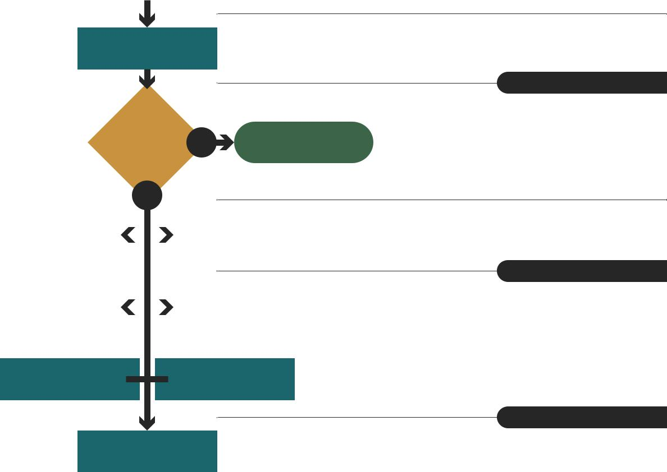

Notify recovery team and make recommendations

 | Declare |  |  |  | NO |  | Terminate
a disaster?
 | YES
Request/Obtain |  |  |  | Mobilize/Prepare
offsite tapes |  |  |  |  | recovery team
Restore network/ |  |  |  |  | Restore SAN
telecom

Restore VMs ^{Restore AS}

400

Validate data integrity

Validate user connectivity

Resume normal operations

OFFSET RECOVERY DURATION

HOUR 0 1 HOUR

HOUR 1 1 HOUR

HOUR 2 1 HOUR

HOUR 3 1 HOUR

4 hours past incident

HOUR 4 —

HOUR 4 4 HOURS

8 hours past incident

HOUR 8 16 HOURS

24 hours past incident

HOUR 24 10 HOURS

HOUR 34 1 HOUR

35 hours past incident

HOUR 35

- What’s in a BC/DR Plan Template?

  - Critical Vendors and their RTOs: In this section, a plan may also list the vendors critical to day-to-day operations and recovery strategies, as well as any required recovery time objectives that the vendors must meet in order for the plan to be successful.

  - Critical Equipment/Resource Requirements: A plan may also detail the quantity requirements for resources that must be in place within specified timeframes after plan activation. Examples of resources listed might include workstations, laptops (both with and without VPN access), phones, conference rooms, etc.

PLAN SECTION:

Appendices

Every plan contains appendices unique to the entity for which the plan was created,

so there is not a great deal of standardization in the appendices. In general, a plan’s appendix is an excellent place to include the details specific to the successful recovery of the specific entity for which the plan is being created. Below we have provided examples of the types

of information included in plan appendices, which you can customize according to the needs and functions of your specific group, department, business unit, or company.

- Business Continuity Site Information: If your plan calls for “failing over” to an alternate work location, it may be a good idea to include information about that alternate work site in the plan’s appendix. The details of the site might include:

  - Commencement Date (including last contract renewal date)

  - Location of the facility

  - Details about the office environment, such as number of workstations, servers, telephony, printers, internet access, and other equipment provided

  - Site contact details

  - How the site is invoked and the personnel authorized to invoke it

- Maps of meeting points: For those plans specifying a meeting location for employees, maps of the routes and alternate routes to those locations are useful.

- Vendor Contact Information: Many plans
include the details of how to reach the | Recovery Status Report Form
vendors listed as critical to normal operations | After the Plan has been activated, you are required to submit periodic Recovery Status Reports.
or recovery operations. | NAME:
 | DEPT:
• Forms: If there are forms required by the
 | DATE: |  | TIME:
plan, such as an incident report form, injury
 | COMMENTS:
summary form, disaster-related expense
tracking forms, consolidated status report
forms, manual purchase order forms, etc.,
the plan appendix is a useful place to locate
them. Figure 2 provides an example of a | CONCLUSIONS:
Recovery Status Report Form.

Figure 2: Example recovery status report form

- What’s in a BC/DR Plan Template?

  - Communication Plans: Successful plans will include the individuals responsible for communications during the time in which the plan is invoked, as well as the groups or constituents with which they are responsible for communicating. For example, it would be desirable to specify both internal and external communicators. For internal

communicators, you will need to identify the person communicating with the command team and with employees, as an example. For external communicators, best practices include identifying the individual in charge of communications with the media, with customers, with partners, and with vendors, etc.

  - Disaster Declaration Procedures: If there are business continuity or disaster recovery vendors contracted, the plan appendix may be a good place to include any relevant disaster recovery procedures, such as SunGard Recovery Services.

  - Employee Contact Information: Instead of inserting the contact details of the employees in the Recovery Strategies and Activities section of the plan (which can often take up many pages and become unwieldy), you can also leverage the plan’s Appendices as an alternate location for this information, as well as any phone tree procedures or call lists.

  - Process Flows: During plan activation, employees must often follow alternative processes or procedures (because primary processes are down or unavailable). Therefore, the plan appendices is a good place to list any out-of-process flows or procedures. For example, how to create manual purchase orders, how to take use corporate credit cards, how to access fuel/cash access cards.

  - Checklists: Checklists that provide useful reminders of “what to do” are often found in plan appendices. During an unexpected outage, human beings are often operating under higher levels of stress and anxiety, so offering them an easy-to-access checklist of to-dos can smooth and even automate the recovery process towards a successful result. Examples of checklists might be the steps involved in accessing an application via the Internet, or how to redirect call volumes in a call center.

BEYOND BC/DR PLAN TEMPLATES: BUSINESS CONTINUITY ASSURANCE

Templates are a good jumping-off point for business continuity and disaster recovery planning. However, in order to scale your program, you will need more than just a single completed plan document. Chances are that you’ll have multiple plans, and that you’ll need engagement from business and technical stakeholders to ensure that those plans help you get the right outcomes.

Ideally, business continuity should be about going beyond the latest compliance requirements to deliver what matters most for your business: better outcomes and increased confidence. It’s about engaging all of the stakeholders to find the vulnerabilities that matter, guide the next best action, expect change and accommodate it often, and to take what you learn back into the planning cycle and share it across the company.

This is how confidence in plans is created and better outcomes are delivered. To learn more about the new era of Business Continuity Assurance,
visit SunGard Availability Services or call 1-888-270-3657.

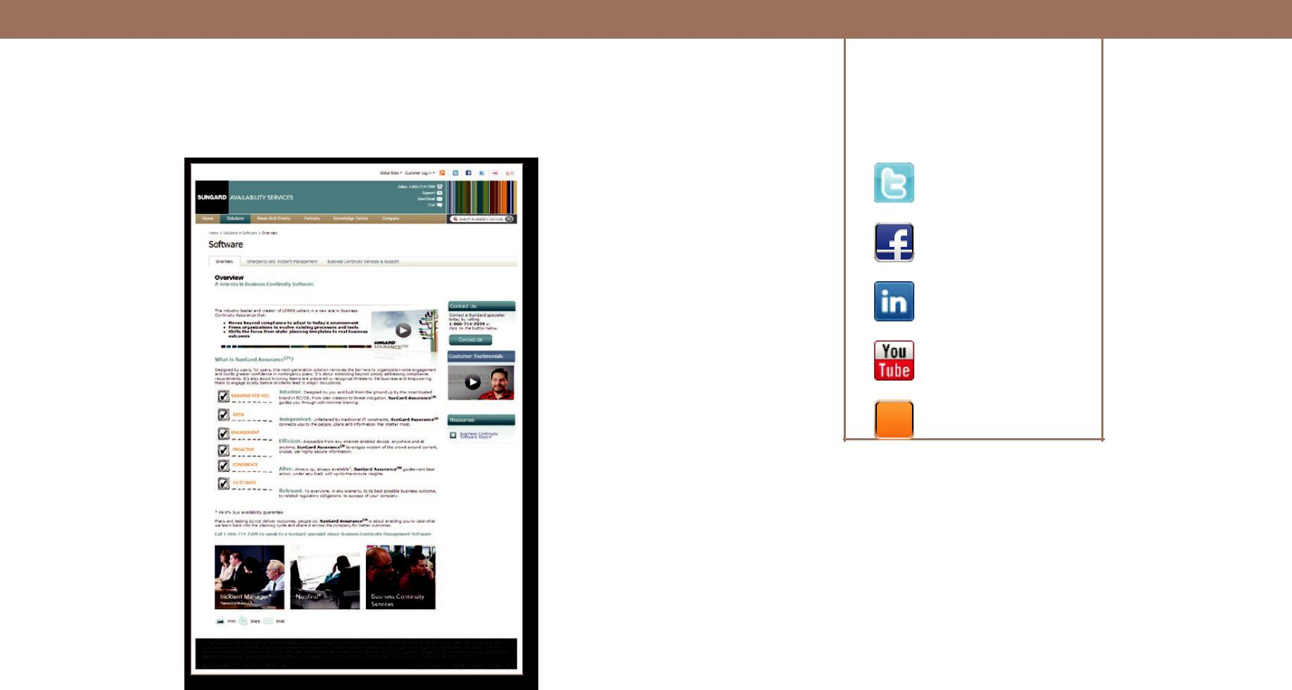
7 What’s in a BC/DR Plan Template?

FOR ADDITIONAL INFORMATION | CONNECT WITH US

on Twitter

on Facebook

on LinkedIn

on YouTube

on Our Blog

SunGard Software Solutions

ABOUT SUNGARD AVAILABILITY SERVICES

SunGard Availability Services provides disaster recovery services, managed IT services, information availability consulting services and business continuity management software. With approximately five million square feet of datacenter and operations space, SunGard Availability Services helps customers improve the resilience of their mission critical systems by designing, implementing and managing cost-effective solutions using people, process and technology to address enterprise IT availability needs. Through direct sales and channel partners, we help organizations ensure their people and customers have uninterrupted access to the information systems they need in order to do business.

To learn more, visit www.sungardas.com or call 1-888-270-3657.

www.sungardas.com

SunGard Availability Services

680 East Swedesford Road Wayne, PA 19087 1-888-270-3657

©2013 SunGard. WPS-086 313

Trademark information: SunGard and the SunGard logo are trademarks or registered trademarks of SunGard Data Systems Inc. or its subsidiaries in the U.S. and other countries. All other trade names are trademarks or registered trademarks of their respective holders.

