IT Disaster Recovery Plan

September, 2013

Prepared by The Cavan Group

Revision History

VERSION | DATE APPROVED | MODIFIED BY | DESCRIPTION OF CHANGES
 |  |  | MADE
Original 1.0 |  | Wim Bood | First release
Version 1.1 |  | Wim Bood | Updated after review with the
 |  |  | team
Version 1.2 |  | Wim Bood | Third Pass
Version 1.3 |  | Wim Bood | Updated Call Tree
Version 1.4 |  | Wim Bood, Paul | Final Review
 |  | Lawton

Prepared by The Cavan Group Page 2 of 37 Last Updated: September, 2013

Table of Contents
I. INTRODUCTION 4

A. Definition of a Disaster 4

B. Purpose of DRP 4

C. Definitions 4

D. Scope of DRP 5

II. ASSUMPTIONS 6

A. Policy Assumptions 6

B. Technology Assumptions 6

C. Exemptions 7

III. DR TEAMS & RESPONSABILITIES 8

A. Emergency Response Team (ERT) 8

B. IT Disaster Recovery Executive Management Team (REMT) 8

i. REMT Members 8

ii. Roles & Responsibilities 8

C. Disaster Recovery Team (DRT) 9

i. Roles & Responsibilities 9

ii. Disaster Recovery Team Members 10

iii. Application Expert Team Members 11

D. Disaster Recovery Call Tree 12

i. Key Personnel Contact Information 13

E. Vendor Contact List 13

IV. STATE OF MAINE - FACILITIES 16

A. Sewall DC - Production Site 16

B. CMCC DC – Production/ DR Site 16

V. COMMUNICATION DURING A DISASTER 18

A. Communication with Employees 18

B. Communication with Vendors 19

VI. DEALING WITH A DISASTER 20

A. Overall Workflow 20

VII. DISASTER ACTIVATION PHASE 21

A. Disaster Identification 21

B. Severity Level Assessment 21

C. Disaster Impact Assessment 22

D. Emergency Alert, Escalation and DRP Activation 23

VIII. DISASTER EXECUTION PHASE 24

A. Disaster Recovery Process Flow 24

B. Tier 0 Validation – Disaster Procedure 25
C. Tape Recovery 26

D. Data Storage & Backup Strategy 28

E. Tier 1 Application Restore Priorities 29

F. Application Run-book Template 30

IX. DISASTER RECONSTRUCTION PHASE 31

X. PLAN TESTING & MAINTENANCE 31

A. DRP Maintenance 31

B. DRP Change Log 32

C. DRP Documentation Storage 32

APPENDIX A - KEY PERSONNEL CONTACT INFORMATION 35

APPENDIX B - KEY DEPARTMENT CONTACT INFORMATION 35

Prepared by The Cavan Group Page 3 of 37 Last Updated: September, 2013

- INTRODUCTION

- Definition of a Disaster

For the purposes of this contracted work, a disaster is defined as a significant data center event that disables the functioning of the SSDC Data Center or CMCC Data Center or significant portions of either data center for a time estimated to exceed the operational RTO target of Tier 1 services housed at these data centers.

- Purpose of DRP

This document details State of Maine’s policies and procedures for technology disaster recovery, as well as process-level plans and recommended procedures for recovering critical technology platforms and the telecommunications infrastructure. After the event of an actual emergency situation, this document will need to be updated accordingly to ensure system uptime information accuracy, data integrity and availability, and business continuity.

- Definitions

  - DRP – Disaster Recovery Plan is a set of well defined procedures established to help the IT department get an organization’s IT infrastructure back to business as usual in the event of a disaster.

  - RTO – Recovery Time Objective (downtime) defines the length of time it will take to recover all the infrastructure carrying the target RTO attribute; RTO is typically expressed in seconds, minutes, hours, days.

  - RPO – Recovery Point Objective (data loss) defines the point in time to which data can be recovered for the entire infrastructure in that RPO attribute; RPO effectively defines tolerance for data loss and is typically expressed in minutes, hours or days of data loss.

Prepared by The Cavan Group Page 4 of 37 Last Updated: September, 2013

- Scope of DRP
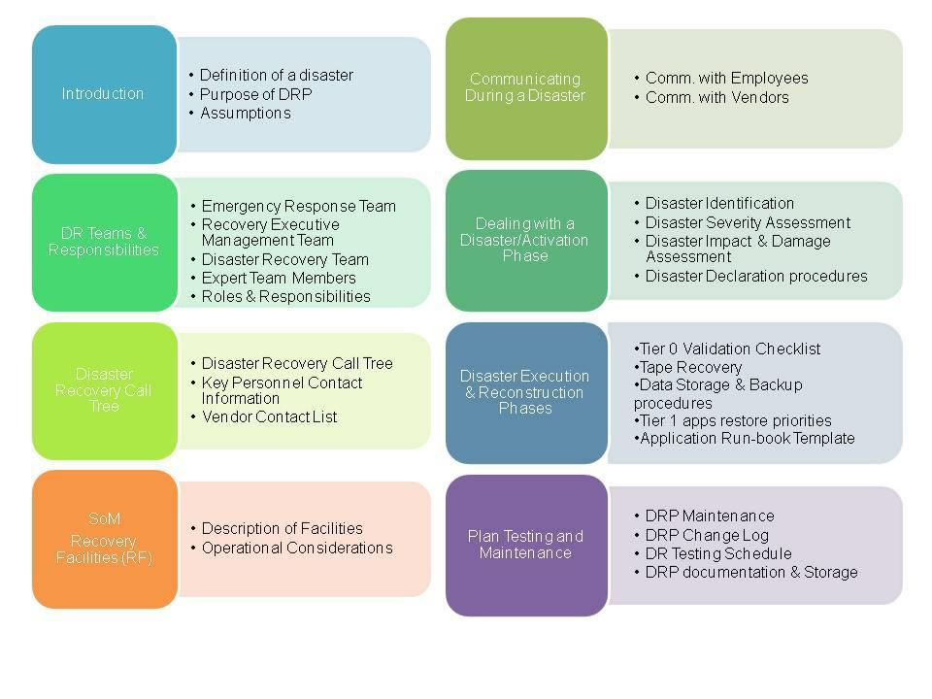

Prepared by The Cavan Group Page 5 of 37 Last Updated: September, 2013

- ASSUMPTIONS

A. Policy Assumptions

The following DRP has been developed based on the following explicit assumptions:

  - The expectation is that applications that must not have an interruption will be identified for failover/HA between the primary facility and the secondary facility.

  - For the purpose of the work for this contract, we will be able to identify the equipment in the SSDC and the CMCC facilities and can rank the applications on that equipment in criticality recovery order.

  - Recovery order will be able to be identified for particular timeframes of criticality: Weekday, Weekend, EOW, EOM, seasonal, etc.

  - For any applications that are needed to be recovered ASAP, State of Maine will have the ability to identify the applications running on the servers in any given facility and can rank them according to the most important of those applications to recover first to last.

  - State of Maine will not recover support environments until there are recovered Production environments. Support environments (Dev, Test, Stage, Training, etc.) will be recovered in the order specified in the

“playbook” or in the order of the Production recovery.

  - State of Maine will look to cloud situations for recovery rather than to repurpose what we have for development or test environments unless the “playbook” specifically designates the repurposing.

  - Sufficient operating staff will be available to implement the recovery plan.

  - DRP and application run-books are stored in a safe location and accessible during a disaster. “Team needs to identify the safe location”

  - The incident will not result in situations where employees get injured or hospitalized.

  - All staff listed in the hereunder documentation must be made aware of the Disaster Recovery Plan and their own respective roles.

  - The Disaster Recovery Plan is to be kept up to date to take into account changes in data recovery and backup procedures.

- Technology Assumptions

  - The DR site will provide foundation infrastructure (Tier Zero) insulated from disaster events and/or capable of quick recovery.

Prepared by The Cavan Group Page 6 of 37 Last Updated: September, 2013

- Tier Zero functions are configured for near zero RPO/RTO. To be validated and requires management decision to remediate the GAPS!

- Tier 1 Mission critical applications may experience significant decrease in response times until the infrastructure can be built out.

- Recovery tapes will be physically retrievable in target time frames.

  - Business agrees to target already agreed upon RPO’s and RTO’s.

  - Network of sufficient bandwidth is in place between State of Maine sites..

C. Exemptions

The following legacy applications will not be included in the DRP as they are subject to be retired. Recovery of these applications in the mean time will be best effort.

List of legacy applications:

- IBM Mainframe

- Externally hosted Applications and websites that will be covered under separate BCDR planning efforts

- There are apps with internal & external components with networks. These external sites are not included.

o Advantage

o MOLINA

Prepared by The Cavan Group Page 7 of 37 Last Updated: September, 2013

- DR TEAMS & RESPONSABILITIES

The DR plan will rely principally on key members of management and staff who will provide the technical and management skills necessary to achieve a smooth technology and business recovery.

A. Emergency Response Team (ERT)

In case of a disaster, the person identifying the incident must contact the Customer Support Staff (Help Desk and describe the incident. The Help Desk will then call the resources on call for each one of the following IT disciplines:

- Operations Management

- Site Facilities

- Site Security

- Systems
- Network services

The ERT at any time of a disaster consists of the resources scheduled to be on call. These have the responsibility of informing the IT Disaster Recovery Executive Management Team (REMT) defined below.

  - IT Disaster Recovery Executive Management Team (REMT)

- REMT Members

The State of Maine directors listed below represent the IT Disaster Recovery Executive Management Team (REMT) and have the authority and responsibility to execute the specific processes within this plan.

 | MANAGER/DIRECTOR |  |  | AREA OF |  |  | CONTACT INFO
 |  |  |  | RESPONSIBILITY
 |  |  |  |  |  |  | Cell: 215-2939
 | Jim Smith |  |  | Chief Information Officer |  |  | Office: 624-7568
 |  |  |  |  |  |  | Email: jim.smith@maine.gov
 |  |  |  |  |  |  | Cell: 649-7849
 | Greg McNeal |  |  | Chief Technology Officer |  |  | Office: 624-9471
 |  |  |  |  |  |  | Email: greg.mcneal@maine.gov
 |  |  |  | Associate CIO |  |  | Cell: 619-2244
 | Paul Sandlin |  |  |  |  |  | Office: 624-9427
 |  |  |  | Applications
 |  |  |  |  |  |  | Email:paul.sandlin@maine.gov
 | Vacant (Greg McNeal |  |  | Associate CIO |  |  | Cell: 649-7849
 |  |  |  |  |  |  | Office: 624-9471
 | Acting) |  |  | Infrastructure
 |  |  |  |  |  |  | Email: greg.mcneal@maine.gov
 |  |  |  | Manager Application |  |  | Cell: 899-8289
 | Mary Silva |  |  |  |  |  | Office: 624-7574
 |  |  |  | Hosting
 |  |  |  |  |  |  | Email:mary.silva@maine.gov
 |  |  |  | Manager Client |  |  | Cell: 441-8676
 | Jon Richard |  |  | Technologies and |  |  | Office: 441-8676
 |  |  |  | Enterprise Operations& |  |  | Email: jon.richard@maine.gov
 |  |  |  | Monitoring

- Roles & Responsibilities

The IT Disaster Executive Management Team (REMT) will be responsible for performing the following:

Prepared by The Cavan Group Page 8 of 37 Last Updated: September, 2013

- Final decision on structural integrity and space occupancy;

- Deciding whether to activate the plan based on presented damage assessment;

- Alerting and mobilizing all Disaster Recovery Team leaders (DRT);

- Making an initial report to senior management;

- Alerting the internal business;

- Calling a first meeting with the DRT leaders which has for mission to:

o define the causing problem, the extent of the disruption, its consequences and the probable implications for the foreseeable future;

o review each team's objectives for the next [x number of hours] hours; o set up a second meeting for [x number of hours] hours later;
  - report to senior management on the content of the meeting and the actions being taken;

- Calling follow up meetings accordingly with the DRT leaders and keeping senior management informed of the actions being taken;

- Identify key technical personnel who may be required to travel to the recovery site or be called to assist in the recovery.

  - Disaster Recovery Team (DRT)

- Roles & Responsibilities

The Disaster Recovery Team consists of each IT discipline’s team manager and their respective expert members.

The DRT has for responsibility to:
- Assess the extent of the disaster and its impact on the business, data center, etc.;

- Notifying Iron Mountain for media retrieval;

- Ensure employees are notified and allocate responsibilities and activities as required;

- Activate restoration functions as required;

- Contact vendors and request an on-site representative;

- Restore key services within RTO defined for each one of the critical business applications;

- Document and log recovery efforts for future disasters;

- Coordinate move of salvageable equipment to backup facility;

- Determine need to order equipment and make request through REMT;

- Coordinate installation and testing of equipment;

- Decide which elements of the DR Plan should be activated;

Prepared by The Cavan Group Page 9 of 37 Last Updated: September, 2013

- Disaster Recovery Team Members

 |  |  |  | MANAGER |  |  | GROUP LEAD |  |  | IT EXPERT
 | Unix/Linux |  |  | Sharon Horne |  |  | Dave Johnson |  |  | Resource on Call
 | Data Center |  |  | Jon Richard |  |  | Bill Hart |  |  | Resource on Call
 | Windows |  |  | Dawnna Pease |  |  | Bill Barreto |  |  | Resource on Call
 | Storage |  |  | Sharon Horne |  |  | Peter Bouchard |  |  | Resource on Call
 | Virtualization |  |  | Dawnna Pease |  |  | Bill Barreto |  |  | Resource on Call
 | Network |  |  | Dave Rodrigue |  |  | Jeff Welsh |  |  | Resource on Call
 | Network Security |  |  | Dave Rodrigue |  |  | Chad Perkins |  |  | Resource on Call
 | File and Print Servers |  |  | Dawnna Pease |  |  | Terry Kenniston |  |  | Resource on Call
 | Radio Operations |  |  | Craig Hitchhings |  |  | John Covert |  |  | Resource on Call
 | Oracle Platform |  |  | Sharon Horne |  |  | John Hawkes |  |  | Resource on Call
 | Client Technologies & |  |  | Nick Marquis |  |  | Sue Donovan |  |  | Resource on Call
 | Desktop Support
 | Backup & Recovery |  |  | Jon Richard |  |  | Ed Lincoln |  |  | Resource on Call

Prepared by The Cavan Group Page 10 of 37 Last Updated: September, 2013

- Application Expert Team Members
 |  |  | TIER 1 APPLICATIONS | MANAGER | IT EXPERT
 | Agency/Group | Dept. | Application System
 |  | DOC | Corrections Information System (CORIS) (hosted at Corrections data center) | Martin Murphy
 |  |  | Criminal History Records Information System (CHRIS) | Henry Quintal
 |  |  | Computer Aided Dispatch (CAD) | Henry Quintal
 | Public Safety | DPS | Sex Offender Registry | Henry Quintal
 |  |  | Crash Reporting System (CRS) | Henry Quintal
 |  |  | NetMotion | Henry Quintal
 |  | DOT | DOT systems - road repairs (hosted at DOT data center) | Tom Lynch
 |  |  | IMMPACT2 - Maine CDC Systems | Ray Venzel
 | Public Health | DHHS
 |  |  | Child Welfare Case Worker Database | Rick Hayward
 |  | DEP | Environmental Facility Information System (EFIS) and other DEP systems | Karen Curtis/ vacant
 |  | DAFS | Advantage - central accounting system (externally hosted) | Cathy Harrison
 |  |  | Automated Client Eligibility System (ACES) - screening for MaineCare, Food | Rick Hayward
 |  |  | Stamps, etc.
 |  |  | * Medicaid Payments (Molina) (externally hosted) | Hazel Stevenson
 | Financial Services to | DHHS | DHHS DataHub | Hazel Stevenson
 | Citizens |  | Child Support Enforcement for Maine (CSEME) | Dale Irish
 |  |  | Women, Infants & Children (WIC) subsidies | Dale Irish
 |  | DOL | Unemployment Insurance (UIPROD) | David Poulin
 |  | DOL | Benefits - unemployment compensation | David Poulin
 |  | DOL | DOL Interactive Voice Response (IVR) | David Poulin
 |  | DAFS | Advantage - central accounting system (externally hosted) - also listed above | Cathy Harrison
 | Financial Services to
 | Providers and Internal
 | Financial Management
 |  | DAFS | Budget and Financial Management System (BFMS) | Cathy Harrison
 |  |  | Maine Revenue IntegratedTax System (MERITS) | Karin Peterson
 |  | MRS
 |  |  | On-line Tax Filing (I-File and E-File) | Karin Peterson
 | Revenue Generating | MRS | Tax and Revenue Image Processing System (TRIPS) | Karin Peterson
 |  | MRS | MRS Interactive Voice Response (IVR) | Karin Peterson
 |  | IF&W | Maine Online Sportsman Enterprise System (MOSES) - hunting and fishing | Karen Curtis/ vacant
 |  |  | Licenses
 |  | DECD | Business One-Stop (web-based) - Governor's focus | Cathy Harrison
 | Regulatory | ACF, IFW, | Natural Resources Agencies - key systems for them | Karen Curtis/ vacant
 |  | DMR
 |  | DOE | Infinite Campus (externally hosted) | Charlotte Ellis
 | Other | DOE | Maine Education Data Mangement Systems (MEDMS) - financial tracking | Charlotte Ellis
 |  | PFR | Agency License Management System (ALMS) | Dorene Gerrish

1. Methodology to be determined which Apps should be failed over to which DC

Prepared by The Cavan Group Page 11 of 37 Last Updated: September, 2013

D. Disaster Recovery Call Tree

The resource observing the disaster has the responsibility of informing the on-call engineer(s) immediately. The incident will then be assessed and escalated accordingly to the appropriate manager and director depending on the incident criticality level.
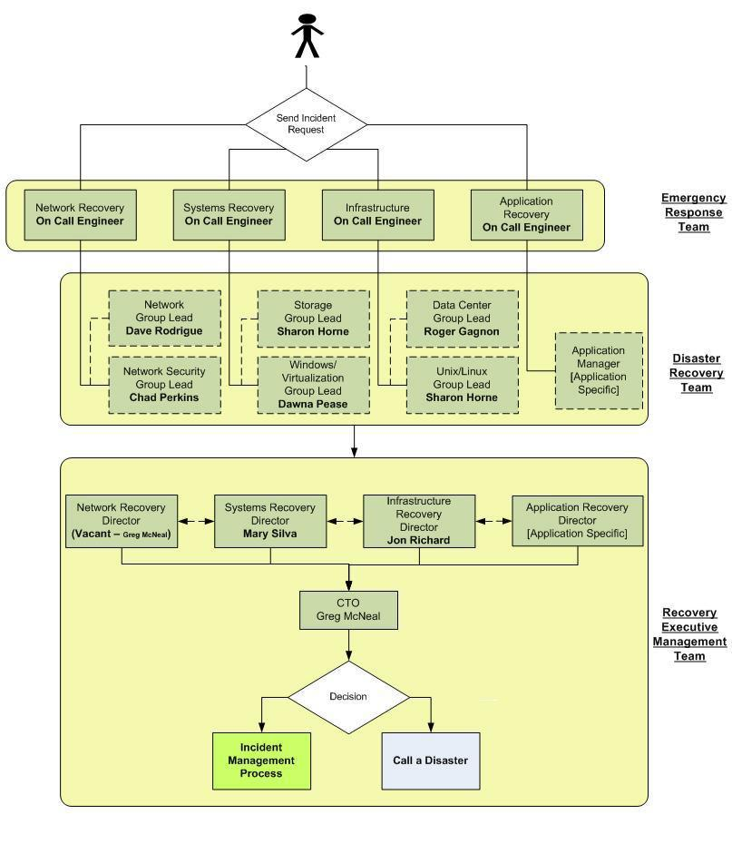

Prepared by The Cavan Group Page 12 of 37 Last Updated: September, 2013

- Key Personnel Contact Information

Please refer to Appendix A for a list of key personnel contact information. All contact information must be kept up to date in the above mentioned appendix.

E. Vendor Contact List

This section lists all key IT vendors who may need to be contacted following a disaster. Each team has responsibility to review and update this list [timeframe].

- Server and Computer Equipment Suppliers

  - Unix Team

 | Solution Name |  |  | Contact Option |  |  | Contact Name |  |  | Phone Number |  |  | Account Number |  |  | Web\email Contact
 | HP
 | SUN
 | IBM
 | Oracle

- Windows/Virtualization Team

 | Solution Name |  |  | Contact Option |  |  | Contact Name |  |  | Phone Number |  |  | Account Number |  |  | Web\email Contact
 | VMWare
 | SQL Server

- Data Storage Equipment Suppliers

 | Solution Name |  |  | Contact Option |  |  | Contact Name |  |  | Phone Number |  |  |  | Account Number |  |  | Web\email contact
 | Ironmountain
 | NetApp
 | Brocade
 | CommVault
 | Quantom
 | EMC

- Network & Security Hardware Vendors & Resellers

 | Solution
 |  |  |  | Contact Option |  |  | Contact Name |  |  | Phone Number |  |  | Account Number |  |  | Web\email Contact
 | Name
 | Nortel (IPC)
 | Juniper (JunOS)
 | Cisco (Presidio)
 | Fujitsu
 | Infoblox
 | Akibia
 | Elteon
 | Radware

Prepared by The Cavan Group Page 13 of 37 Last Updated: September, 2013

- Network Carriers

 | Company |  |  | Contact Option |  |  | Contact Name |  |  | Phone Number |  |  | Account |  |  | Web\email Contact
 | Name |  |  |  |  |  |  |  |  |  |  |  | Number
 | Verizon
 | Oxford
 | Fairpoint

iv. | Data Center
▪ Vendors
 | Company Name |  |  | Primary Support |  |  | Secondary Support |  |  | Contact Name |  |  | Web\email Contact
 |  |  |  | Number |  |  | Number
SCS (Structured cabling) |  |  |  | (207) 458-9190 |  |  |  |  |  | Dana Saunders |  |  | scsinc@fairpoint.net
 | MS Electric (Electrical) |  |  | (207) 582- 6223 |  |  | (207) 462-2115 |  |  | Ben Sirois |  |  | ben@mselectricinc.ocm
 | Southworth Miller |  |  | (207) 883-9586 |  |  | (207) 885-8035 |  |  | Kyle Morgan |  |  | kyle_morgan@miltoncat.com
 | (Generators)
 | BGS (Facility) |  |  | (207) 287-4154 |  |  | (207) 287-4153 |  |  | Gary Lafreniere |  |  | Building.control@maine.gov

Prepared by The Cavan Group Page 14 of 37 Last Updated: September, 2013

- In-Scope Applications Vendor’s Contact Information

This section will be completed when executing the DR test for each one of the applications below.
 |  | TIER 1 APPLICATIONS | Vendor Name | Contact Name | Support Number
Agency/Group | Dept. | Application System
 | DOC | Corrections Information System (CORIS) (hosted at Corrections data center)
 |  | Criminal History Records Information System (CHRIS)
 |  | Computer Aided Dispatch (CAD)
Public Safety | DPS | Sex Offender Registry
 |  | Crash Reporting System (CRS)
 |  | NetMotion
 | DOT | DOT systems - road repairs (hosted at DOT data center)
 |  | IMMPACT2 - Maine CDC Systems
Public Health | DHHS | Child Welfare Case Worker Database
 | DEP | Environmental Facility Information System (EFIS) and other DEP systems
 | DAFS | Advantage - central accounting system (externally hosted)
 |  | Automated Client Eligibility System (ACES) - screening for MaineCare, Food
 |  | Stamps, etc.
 |  | * Medicaid Payments (Molina) (externally hosted)
 | DHHS | DHHS DataHub
Financial Services to |  | Child Support Enforcement for Maine (CSEME)
Citizens |  | Women, Infants & Children (WIC) subsidies
 | DOL | Unemployment Insurance (UIPROD)
 | DOL | Benefits - unemployment compensation
 | DOL | DOL Interactive Voice Response (IVR)
Financial Services to | DAFS | Advantage - central accounting system (externally hosted) - also listed above
Providers and Internal
Financial Management | DAFS | Budget and Financial Management System (BFMS)
 | MRS | Maine Revenue IntegratedTax System (MERITS)
 |  | On-line Tax Filing (I-File and E-File)
 | MRS | Tax and Revenue Image Processing System (TRIPS)
Revenue Generating
 | MRS | MRS Interactive Voice Response (IVR)
 | IF&W | Maine Online Sportsman Enterprise System (MOSES) - hunting and fishing
 |  | Licenses
 | DECD | Business One-Stop (web-based) - Governor's focus
Regulatory | ACF, IFW, | Natural Resources Agencies - key systems for them
 | DMR
 | DOE | Infinite Campus (externally hosted)
Other | DOE | Maine Education Data Mangement Systems (MEDMS) - financial tracking
 | PFR | Agency License Management System (ALMS)

Prepared by The Cavan Group Page 15 of 37 Last Updated: September, 2013

IV. STATE OF MAINE - FACILITIES

A. Sewall DC - Production Site

 | Location |  | 28 Sewall Street, Augusta, ME
 | Key contact person |  | Jon Richard
 |  |  | Jon.Richard@maine.gov
 | Contact info
 | Alternative contact 1 |  | Bill Hart
 |  |  | Bill.Hart@maine.gov
 | Contact info
 | Alternative contact 2 |  | Roger Gagnon
 |  |  | Roger.Gagnon@maine.gov
 | Contact info
 | BGS Security |  | Building Control main # : 207 287 4154
 |  |  | Bill Black, Bill.Black@maine.gov, 287-6502

- Operational Considerations

Only employees and vendors with appropriate access privileges are allowed into the building. State of Maine will continue relying on the same policies currently in place during a disaster.

  - Assembly Points

Where the premises need to be evacuated, the DRP invocation plan identifies two assembly points:
    - Primary – t.b.d.

    - Alternate – t.b.d.

B. CMCC DC – Production/ DR Site

 |  | Location |  | 45 Commerce Drive, Augusta ME, 04330
 |  | Key contact person |  | Jon Richard
 |  | Contact info |  | Jon.Richard@maine.gov
 |  | Alternative contact 1 |  | Bill Hart
Prepared by The Cavan Group |  |  |  | Page 16 of 37 | Last Updated: September, 2013

 | Contact info |  | Bill.Hart@maine.gov
 | Alternative contact 2 |  | Roger Gagnon
 | Contact info |  | Roger.Gagnon@maine.gov
 | BGS Security |  | Building Control main # : 207 287 4154
 |  |  | Bill Black, Bill.Black@maine.gov, 287-6502

Prepared by The Cavan Group Page 17 of 37 Last Updated: September, 2013

- COMMUNICATION DURING A DISASTER

Procedures have been established to ensure that in the event of a disaster or crisis, personnel will have a clear understanding of who should be contacted and that communications can be quickly established.

A. Communication within OIT

While managers will serve as the focal points for their own departments, assigned resources will be responsible for contacting all resources in their call list to discuss the disaster level and plan for any immediate measures. Members of the management team must make sure to keep a hard copy of the names and contact numbers of each employee in their departments.

The Technology Business Consultants (TBC) are the communications liaisons to the State agencies. An overview of the TBCs can be found in Appendix A.

- Conference Bridge

A conference bridge number bellow will be reserved specifically for the disaster in order to have conference calls with employees, key contacts and vendors to evaluate disaster damage and to make recovery decisions.

 | DR Bridge Number |  | Conference ID |  | Host Code
877-455-0244 |  | 244239863# |  | *7016

- Text Messaging

Resources are encouraged to use text messaging as a primary means of communication during a disaster.

- Notification

The Helpdesk will update the OIT Customer Support Status page at:
http://inet.state.me.us/oit/customer_service/dailystatus/index.html

Notices should cover:

- What is the Major Incident or Disaster (plain English, from a user perspective)

- What is the impact on agency, operations or citizen services

- What actions will be taken

- When is the service expected to be restored

During a disaster the updates should be every 2 hours.

- Backup Staff

If a manager or staff member designated to contact other staff members is unavailable, s/he is advised to call the second person on call.

Prepared by The Cavan Group Page 18 of 37 Last Updated: September, 2013

B. Communication outside OIT

Generally, the following key groups will be notified about a Major Incident or Disaster, as soon as possible after awareness of the disaster. The communication will be handled by the CIO or CTO.

- Commissioner and Deputy Commissioner of the Department of Administrative and Financial Services (DAFS)
- Selected State Agency Commissioners and key agency contacts

- Governor’s Office (for every Disaster and selective for Major Incidents)

- Press release through the Governor’s Office (if impacting citizen services on a long-term basis)

C. Communication with Vendors

Vendors will be informed of the disasters on a per need basis.

Prepared by The Cavan Group Page 19 of 37 Last Updated: September, 2013

VI. DEALING WITH A DISASTER

A. Overall Workflow
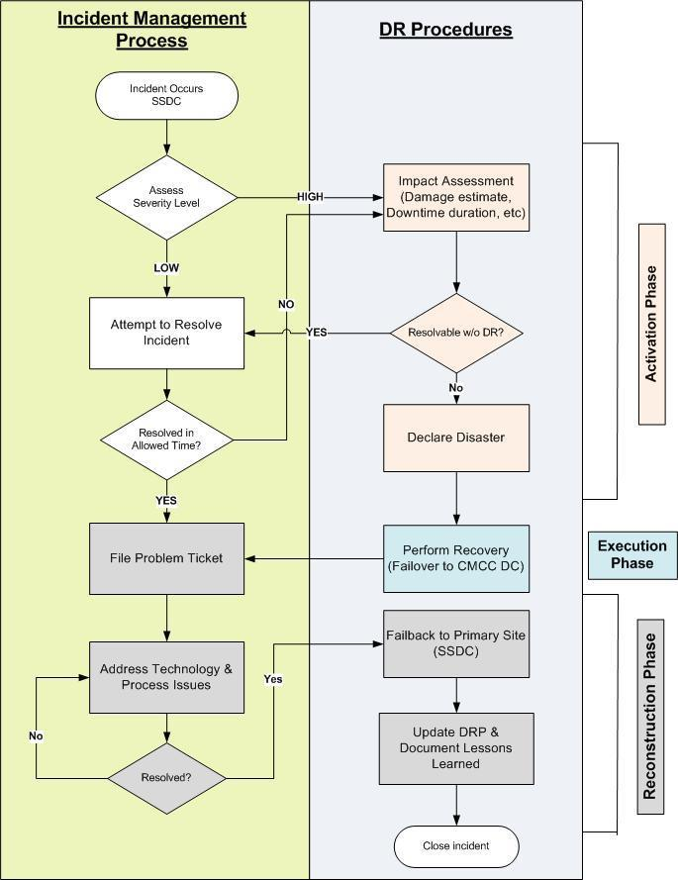

Prepared by The Cavan Group Page 20 of 37 Last Updated: September, 2013

VII. DISASTER ACTIVATION PHASE

A. Disaster Identification

Many potential disruptive threats could occur at any time and could affect State of Maine’s normal business operations. A wide range of potential threats taking place at either the SSDC or CMCC data centers that would lead to the activation of this DRP are:

  - Total loss of all communications

  - Total loss of power

  - Flooding of the premises

  - Loss of the building

  - Environment Disaster

  - Organized and / or Deliberate Disruption

  - Equipment or System Failure

  - Serious Information Security Incident

  - Other events that could cause the building to be uninhabitable.

B. Severity Level Assessment

Each potential environmental disaster or emergency situation has been considered. The table below presents a breakdown of each one of the disasters, its probability rate as well as the level of business disruption which could arise from each disaster. The impact rating represents the disruption level and therefore severity level.

The severity level of each one of the disasters has been assessed as follow:

Note: To be assed with the State of Maine Security Team

 | Potential Disaster |  |  | Probability |  |  | Impact Rating |  |  | Brief Description Of Potential
 |  |  |  | Rating |  |  |  |  |  | Consequences & Remedial Actions
 | Flood |  |  | 2 |  |  | 2
 | Fire |  |  | 3 |  |  | 1 |  |  | .
 | Tornado |  |  | 5 |  |  | 1
 | Organized and/or Deliberate
 | Disruption |  |  | 3 |  |  | 2
 | Data center infrastructure |  |  | 4 |  |  | 2
 | failure
 | Network Infrastructure Failure |  |  | 2 |  |  | 2
 | Probability: 1=Very High, 5=Very Low |  |  |  | Impact: 1=Total destruction, 5=Minor annoyance

Prepared by The Cavan Group Page 21 of 37 Last Updated: September, 2013

C. Disaster Impact Assessment

The following describes damage assessment procedures for the different Disaster Recovery Teams. These procedures will help measure the damage level and predict the time of system outage.

- Data Center Team Equipment

 | # |  |  |  |  |  |  |  |  |  |  | Equipment |  |  | Condition |  |  | Salvage |  |  | Comments
 | 1 |  |  |  |  | Building |  |  |  |  |  | Interior
 | 2 |  |  |  |  |  |  |  |  |  |  | Exterior
 | 3 |  |  |  |  |  |  |  |  |  |  | Flooring
 | 4 |  |  |  |  |  |  |  |  |  |  | Lighting
 | 5 |  |  |  |  |  |  |  |  |  |  | UPS
 | 6 |  |  |  | Electrical |  | Systems |  |  |  |  | Power panel breakers
 | 7 |  |  |  |  |  |  |  |  |  |  | Automatic transfer switches
 | 8 |  |  |  |  |  |  |  |  |  |  | Generator
 | 9 |  |  |  |  |  |  |  |  |  |  | Power distribution Unit
 | 10 |  |  |  |  |  |  |  |  |  |  | Air Handler
 | 11 |  |  |  | HVAC |  | System |  |  |  |  | Glycol piping
 | 12 |  |  |  |  |  |  |  |  |  |  | Glycol pumps
 | 13 |  |  |  |  |  |  |  |  |  |  | Dry coolers
 | 14 |  |  |  |  | Control |  | Systems |  |  |  | Sprinkler
 | 15 |  |  | Fire |  |  |  |  |  |  |  | Local and remote alarms
 | 16 |  |  |  |  |  |  |  |  |  |  | Fire extinguishers
 | 17 |  |  |  |  | Other |  |  |  |  |  | Telephone Service
 | 18
 | 19

- Platform Team

 |  | # |  |  | Equipment |  |  | Condition |  |  | Salvage |  |  | Comments
 |  | 1 |  |  | Servers
 |  | 2 |  |  | Storage
 |  | 3 |  |  | Tape Library
 |  | 4 |  |  | Appliances
 |  | 5 |  |  | Other
Prepared by The Cavan Group |  |  |  |  |  |  |  | Page 22 of 37 |  |  |  |  |  | Last Updated: September, 2013

- Network Team

 | # |  |  | Equipment |  |  | Condition |  |  | Salvage |  |  | Comments
 | 1 |  |  | Communication circuits
 | 2 |  |  | Firewalls/Load balancers
 | 3 |  |  | Routers
 | 4 |  |  | Switches
 | 5 |  |  | Critical system products
 | 6 |  |  | Appliances
 | 7 |  |  | Telephone Service
 | 8 |  |  | Other

D. Emergency Alert, Escalation and DRP Activation

After a complete severity and damage assessment, the Disaster REMT will either activate the DRP or report an incident management process. In case of an incident management process, the team will follow the already defined processes to address the specific incident. In case of disaster invocation, all recovery teams will be activated. The DRT will decide the extent to which the DRP must be invoked.

Prepared by The Cavan Group Page 23 of 37 Last Updated: September, 2013

VIII. DISASTER EXECUTION PHASE

A. Disaster Recovery Process Flow
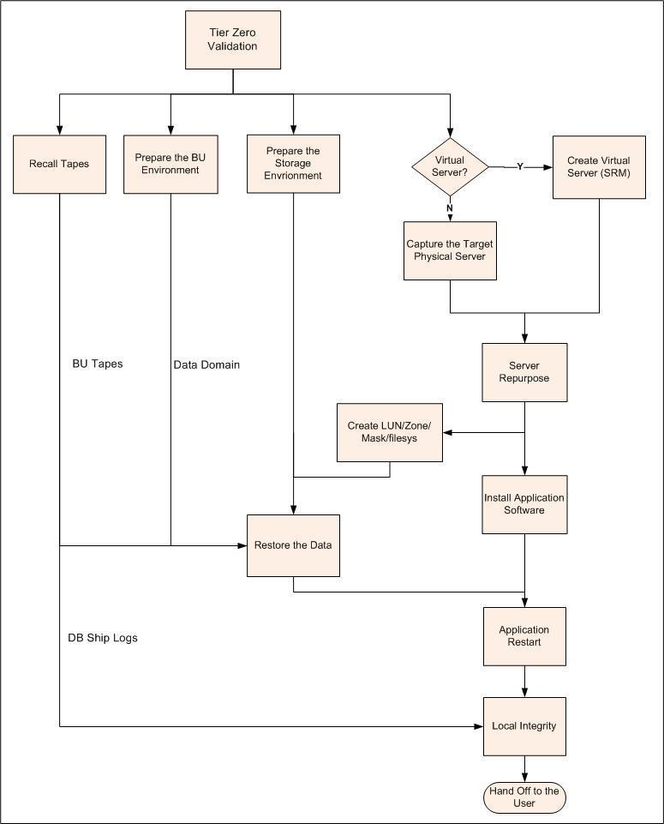

Prepared by The Cavan Group Page 24 of 37 Last Updated: September, 2013

B. Tier 0 Validation – Disaster Procedure

Tier Zero contains the necessary baseline infrastructure to support any recovery effort. The availability of Tier Zero should be validated before any recovery effort. Because the validation of Tier Zero is one time effort, the validation process is maintained in a separate document titled "SoM Guide to the MSDC".

i. Key Procedural Information

Before servers and applications can be recovered after a disaster, a member of the operations team must validate that all components of Tier Zero are up and running by following the Disaster Procedure.

Storage: | Validation/Availability Test
SAN | Connect through SAN storage utility software
NAS | Connect through SAN storage utility software
WAN:
NOC Software and server | Login and map network nodes
Firewall | Successful trial logins
Switches & Routers | Successful ping test
ISP | Ping alternate site server
VPN | Log in from remote host
Data Recovery:
NetBackup sw, server, catalog | Run a test restore
Tape libraries and drives | Backup Application device configuration is
 | successful
Operations:
Active Directory | Network login test
Password Portal | Service account passwords are provided
Domain Name Service | Ping test
Load Balancer Configurations | Login to LB and verify virtual IPs and health check
 | status of real servers and Apps
Job Scheduler (Autosys) | Autosys services are enabled
Virtualization environment | Connect to vSphere interface
Repository:
Key Management Environment (Quantum) | Access Key Manager software to validate key sets
DR Plans and documentation | Login and locate directories
Software license keys
Re-start scripts
Re-sync scripts

Prepared by The Cavan Group Page 25 of 37 Last Updated: September, 2013

C. Tape Recovery

Tapes needed for data recovery are stored at the Iron Mountain storage facility located in xxxx, ME. Once the BU Catalog has been recovered, relevant tapes can then be identified and ordered by phone from the offsite facility by following:

SOP Number: Data Center Operations PS042
SOP Name: Retrieving Media from Off-Site

- Task Description Summary

When a file(s) need to be restored after a disaster, a member of the Storage team will request the tape(s) to be retrieved from off-site.

- Key Procedural Information

A VOLSER number for the requested tapes and an IM SecureSync user ID is required. Use the https://www3.securesync.com website.
  - Production tapes are in account

  - Non production tapes are in account

- Disaster Procedure

Emergency Tape Retrievals (Urgent/Rush 2-hour)

  - A member of the Storage Team will request a tape to be called back from off-site storage within two-hours. He/she should provide you with the completed request form containing:

    - The VOLSER number on the tape

    - The approximate date of the data on the tape
    - The request form found in the Forms folder in the network OPER folder.

Note: An emergency request may come in overnight via email or phone call to the Data Center. If it is by phone, ask the person to please send a follow up email with the appropriate form filled out.

  - Call the Iron Mountain Customer Service number 781-273-9500 and order a two-hour delivery of the requested tapes. If a tape needs to go to a different location than what is established for that particular account, mention this as part of the request (ex. A production tape that needs to go to the non-production Data Center).

  - When the tape arrives, notify the Storage Team member who requested this retrieval.

  - When the tape is ready to be returned to off-site storage, follow SOP P041, but use the same information from the original deposit slip. The Storage Team member does not need to submit another request form.

- Emergency Tape Retrieval - Resources

Name of resources who can request emergency tape retrievals:

 | Contact Person |  | Contact Information
 |  |  | (Refer to Appendix A)
 |  |  | (Refer to Appendix A)

Prepared by The Cavan Group Page 26 of 37 Last Updated: September, 2013

(Refer to Appendix A)

(Refer to Appendix A)

(Refer to Appendix A)

(Refer to Appendix A)

- Tape Recovery Site Information

Company Name | Address | Contact Name | Phone Number
Iron Mountain

Prepared by The Cavan Group Page 27 of 37 Last Updated: September, 2013

D. Data Storage & Backup Strategy

This table documents the backup strategy for each one of the Tier 1 applications. Applications which are fully mirrored at a second site make the recovery instantaneous by switching from the live site to the backup site.

 |  | TIER 1 APPLICATIONS | Location | Backup Strategy | Replication
Agency/Group | Dept. | Application System |  |  | Strategy
 | DOC | Corrections Information System (CORIS) (hosted at Corrections data center)
 |  | Criminal History Records Information System (CHRIS)
 |  | Computer Aided Dispatch (CAD)
Public Safety | DPS | Sex Offender Registry
 |  | Crash Reporting System (CRS)
 |  | NetMotion
 | DOT | DOT systems - road repairs (hosted at DOT data center)
 |  | IMMPACT2 - Maine CDC Systems
Public Health | DHHS
 |  | Child Welfare Case Worker Database
 | DEP | Environmental Facility Information System (EFIS) and other DEP systems
 | DAFS | Advantage - central accounting system (externally hosted)
 |  | Automated Client Eligibility System (ACES) - screening for MaineCare, Food
 |  | Stamps, etc.
 |  | * Medicaid Payments (Molina) (externally hosted)
 | DHHS
 |  | DHHS DataHub
Financial Services to |  | Child Support Enforcement for Maine (CSEME)
Citizens |  | Women, Infants & Children (WIC) subsidies
 | DOL | Unemployment Insurance (UIPROD)
 | DOL | Benefits - unemployment compensation
 | DOL | DOL Interactive Voice Response (IVR)
Financial Services to | DAFS | Advantage - central accounting system (externally hosted) - also listed above
Providers and Internal
Financial Management | DAFS | Budget and Financial Management System (BFMS)
 | MRS | Maine Revenue IntegratedTax System (MERITS)
 |  | On-line Tax Filing (I-File and E-File)
 | MRS | Tax and Revenue Image Processing System (TRIPS)
Revenue Generating
 | MRS | MRS Interactive Voice Response (IVR)
 | IF&W | Maine Online Sportsman Enterprise System (MOSES) - hunting and fishing
 |  | Licenses
 | DECD | Business One-Stop (web-based) - Governor's focus
Regulatory | ACF, IFW, | Natural Resources Agencies - key systems for them
 | DMR
 | DOE | Infinite Campus (externally hosted)
Other | DOE | Maine Education Data Mangement Systems (MEDMS) - financial tracking
 | PFR | Agency License Management System (ALMS)

Prepared by The Cavan Group Page 28 of 37 Last Updated: September, 2013

E. Tier 1 Application Restore Priorities

In the event of a disaster, each Tier 1 applications will need to be recovered within the agreed on RTOs.

Below is the sequence of recovery events in case of a disaster. The RTOs and RPOs for each one of the Tier 1 applications is also documented and should remain up to date:
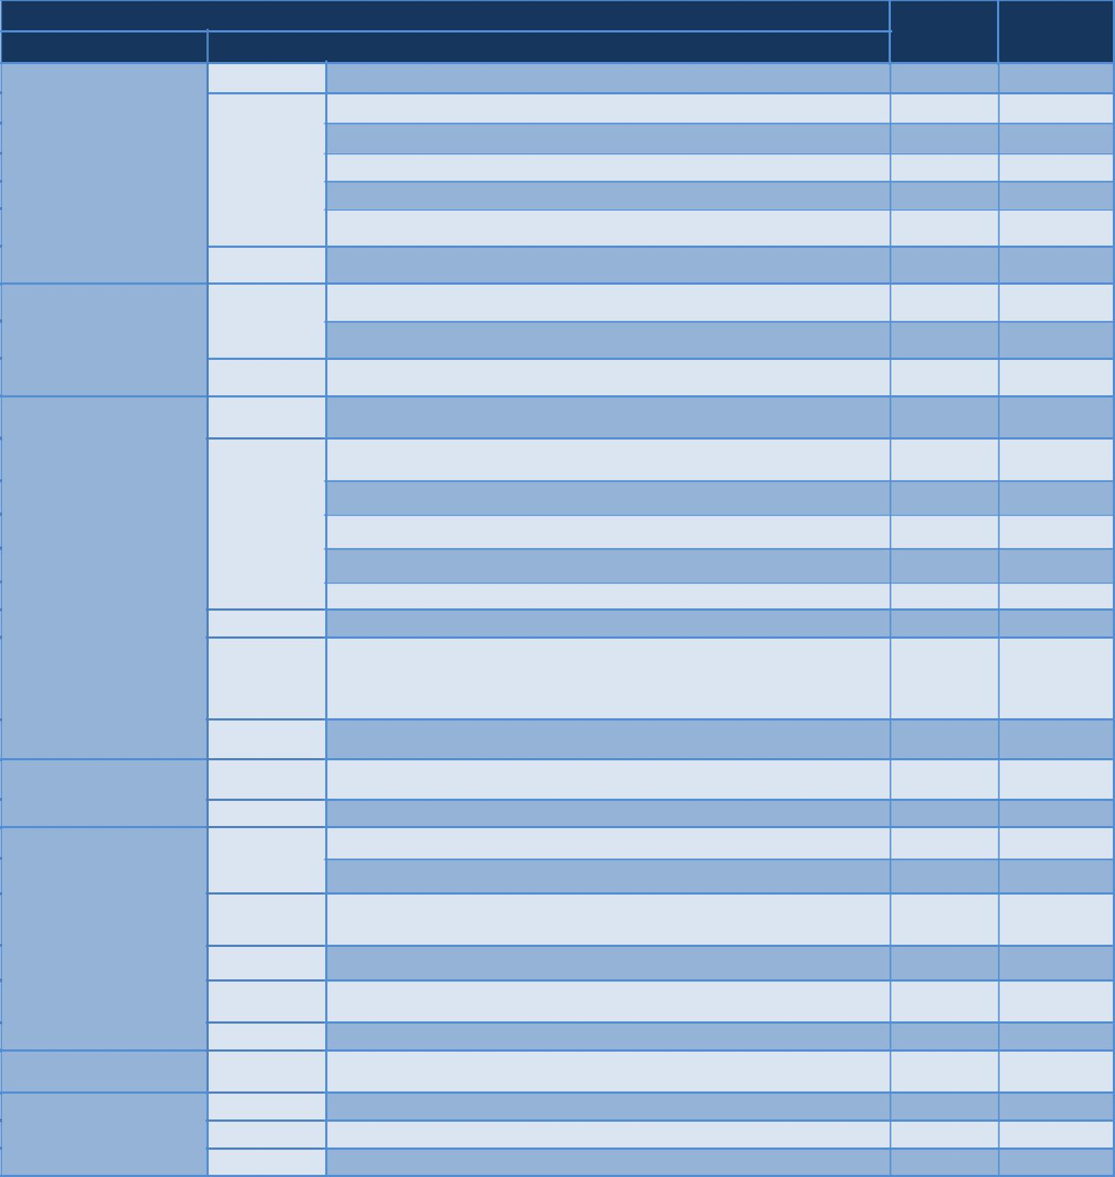
 |  | TIER 1 APPLICATIONS | RTO | RPO
Agency/Group | Dept. | Application System
 | DOC | Corrections Information System (CORIS) (hosted at Corrections data center) | TBD | TBD
 |  | Criminal History Records Information System (CHRIS) | TBD | TBD
 |  | Computer Aided Dispatch (CAD) | TBD | TBD
Public Safety | DPS | Sex Offender Registry | TBD | TBD
 |  | Crash Reporting System (CRS) | TBD | TBD
 |  | NetMotion | TBD | TBD
 | DOT | DOT systems - road repairs (hosted at DOT data center) | TBD | TBD
 |  | IMMPACT2 - Maine CDC Systems | TBD | TBD
 | DHHS
Public Health |  | Child Welfare Case Worker Database | TBD | TBD
 | DEP | Environmental Facility Information System (EFIS) and other DEP systems | TBD | TBD
 | DAFS | Advantage - central accounting system (externally hosted) | TBD | TBD
 |  | Automated Client Eligibility System (ACES) - screening for MaineCare, Food | TBD | TBD
 |  | Stamps, etc.
 |  | * Medicaid Payments (Molina) (externally hosted) | TBD | TBD
 | DHHS | DHHS DataHub | TBD | TBD
Financial Services to |  | Child Support Enforcement for Maine (CSEME) | TBD | TBD
Citizens |  | Women, Infants & Children (WIC) subsidies | TBD | TBD
 | DOL | Unemployment Insurance (UIPROD) | TBD | TBD
 | DOL | Benefits - unemployment compensation | TBD | TBD
 | DOL | DOL Interactive Voice Response (IVR) | TBD | TBD
Financial Services to | DAFS | Advantage - central accounting system (externally hosted) - also listed above | TBD | TBD
Providers and Internal
Financial Management | DAFS | Budget and Financial Management System (BFMS) | TBD | TBD
 | MRS | Maine Revenue IntegratedTax System (MERITS) | TBD | TBD
 |  | On-line Tax Filing (I-File and E-File) | TBD | TBD
 | MRS | Tax and Revenue Image Processing System (TRIPS) | TBD | TBD
Revenue Generating
 | MRS | MRS Interactive Voice Response (IVR) | TBD | TBD
 | IF&W | Maine Online Sportsman Enterprise System (MOSES) - hunting and fishing | TBD | TBD
 |  | Licenses
 | DECD | Business One-Stop (web-based) - Governor's focus | TBD | TBD
Regulatory | ACF, IFW, | Natural Resources Agencies - key systems for them | TBD | TBD
 | DMR
 | DOE | Infinite Campus (externally hosted) | TBD | TBD
Other | DOE | Maine Education Data Mangement Systems (MEDMS) - financial tracking | TBD | TBD
 | PFR | Agency License Management System (ALMS) | TBD | TBD

Prepared by The Cavan Group Page 29 of 37 Last Updated: September, 2013

F. Application Run-book Template

Refer to the disaster recovery run-book per application

Prepared by The Cavan Group Page 30 of 37 Last Updated: September, 2013

IX. DISASTER RECONSTRUCTION PHASE

Part of the reconstruction phase is to ensure that all operations are transferred back to the original site SSDC and that the CMCC DC is fulfilling its day to day operations. Depending on the disaster and the damage level, the reconstruction phase can last from one to multiple days.

The following are activities that must occur before falling back to the original production site:

- Continuously monitor the site or facility’s health for reoccupation

- Ensure that there are no further threats and that the site is clear from all disaster aftereffects

- Provision and install all needed systems and hardware to ensure operational environment

- Ensure that all infrastructure services are fully functional (power, telecommunication, security, …)

- Ensure all business applications are fully functional

- PLAN TESTING & MAINTENANCE

The DRP document must be kept up to date with the organization environment. It must be revised periodically [timeframe] and executed in a simulated environment on an [timeframe] basis. Testing will ensure that it can be implemented in emergency situations and that the staff and management clearly understand their roles and responsibilities in the event of a disaster.

A. DRP Maintenance

Modification to this plan will be based on both scheduled and unscheduled events:

- Periodic Maintenance

System Updates: The information covered by the plan will change over time. Changes to the core infrastructure, systems, facilities, business applications, resource information must be captured in the plan to ensure accuracy. For this reasons, the DRP document must be revised periodically [timeframe/quarterly]. A meeting should be scheduled by the REMT to cross reference between periodic updates to the environment and the DRP document.

[Review Schedule – semi annually (months A, B)] [Attendees]

Periodic Mock Drills: Scheduled mock drills must be executed in order to identify and correct any flaws in the plan and also ensure that the emergency and recovery teams are familiar with their assignments and, more importantly, are confident even under extreme pressure.

State of Maine commits to testing the DR plan [semi-annually/annually/quarterly].

[Mock Drills schedule]

[Mock Drills Results/Appendix]

 | Target |  |  | Responsible |  |  | Status |  |  | Comments
 | Date

Prepared by The Cavan Group Page 31 of 37 Last Updated: September, 2013

- Experience Maintenance

Lessons learned from an actual disaster experience are of great value to the plan. These should be captured thoroughly in the document to improve recovery readiness and possibly avoid future system downtime.

B. DRP Change Log

It is critical that the process of updating the DRP be well structured and controlled. Whenever changes are made to the plan they are to be fully tested and appropriate enhancements should be made to the training materials.

[Name of Resources/Department] will be responsible of keeping the DRP document up to date to ensure accuracy. All changes must be recorded in the change log table below.

 | Date |  |  | Responsible |  |  | Type of Change |  |  | Application/System |  |  | Section #/Comments
 |  |  |  |  |  |  |  |  |  | Affected

C. DRP Documentation Storage

An electronic version of the DRP document must be stored at both the xx storage facility located xx, ME as well as on the DR OIT intranet site.

[Link to the DR OIT intranet site to be provided]

The documents listed below should be available at any time on the DR OIT intranet site.

Sewall Street Data Center related documentation:
- Cage Layout

- Cabinet/Rack Elevations

- Server Inventory

- Inventory of all telecommunication carriers

CMCC Data Center related documentation:
- Cage Layout

- Cabinet/Rack Elevations

- Server Inventory

- Inventory of all telecommunication carriers

Shared documentation
- Application run-books

- Monthly on-call resource schedule

Prepared by The Cavan Group Page 32 of 37 Last Updated: September, 2013

Prepared by The Cavan Group Page 33 of 37 Last Updated: September, 2013

APPENDICE A & B

Key Personnel Contact Information

&
Other Key State of Maine Departments

Prepared by The Cavan Group Page 34 of 37 Last Updated: September, 2013

APPENDIX A - KEY PERSONNEL CONTACT INFORMATION

Note that resource names are ordered alphabetically.

Name, Title | Contact Option | Contact Number

APPENDIX B - TBC State Agencies CONTACT INFORMATION

Note that department names are ordered alphabetically.

 | Name |  |  | Cabinet Department |  |  | Other Agencies
 | Sandy Saunders |  |  | Director for Technology Business Consultants
 | Sheldon Bird |  |  | DOE, DOL, PFR and affiliate |  |  | PUC, WCB
 |  |  |  | boards, MRS (part of DAFS)
 | Mark Kemmerle |  |  | DHHS |  |  | MHDO
 | Cassandra Perkins |  |  | ACF, Corrections, DEP, DMR, |  |  | Baxter State Park
 |  |  |  | DOT, DPS, DVEM/MEMA, IF&W
 | Howard Clary (acting capacity) |  |  | Governor’s Office, DAFS |  |  | Dirigo Health, Ethics, Commission, Human
 |  |  |  | (excluding MRS), DECD |  |  | Rights Commission, Indigent Legal
 |  |  |  |  |  |  | Services, Maine Arts Commission, Maine
 |  |  |  |  |  |  | State Library, Maine State Musuem, Maine
 |  |  |  |  |  |  | Historic Preservation Commission, Public
 |  |  |  |  |  |  | Advocate, State Auditor, Treasury

Prepared by The Cavan Group Page 35 of 37 Last Updated: September, 2013

APPENDICES C-G

Vendor Support Instructions

Prepared by The Cavan Group Page 36 of 37 Last Updated: September, 2013

Prepared by The Cavan Group Page 37 of 37 Last Updated: September, 2013

