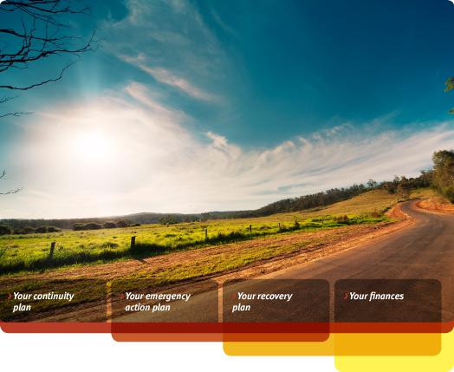

business.gov.au

Emergency management & recovery plan template

A good emergency management plan protects your livelihood by preparing you for unexpected disruptions to your business. The business.gov.au emergency management & recovery plan template steps you through the process of creating a solid, well-structured plan tailored to your business.

New! Create your emergency management & recovery plan on your iPad by downloading our free MyBizShieldApp. Search ‘MyBizShield’ in the App Store now!

Copies of the latest version of this template and the guide can be downloaded from www.business.gov.au/plans.

If you need further information, assistance or referral about a small business issue, please contact the Small Business Support Line on 1800 777 275.
[Business Name] Emergency Management & Recovery Plan [YEAR]

How to use this template

Before you complete the Emergency management & recovery plan template and start using it, consider the following:

- Use the [italicised text]. The italicised text is there to help guide you by providing some more detailed questions you may like to answer when preparing your response. Please note: If a question does not apply to your circumstances it can be ignored.

- Download the Emergency management & recovery plan guide. This guide, available from www.business.gov.au/plans, contains general advice on planning for emergencies and a complete overview with details on each question asked in the Emergency management & recovery plan template.

- Get some help. If you aren’t confident in completing the plan yourself, you can enlist the help of a professional (such as a Business Enterprise Centre, Enterprise Connect Centre, business adviser or accountant) to look through your plan and provide you with advice.

- Review. Review. Review. Ask a number of impartial people to proofread your final plan.

- Print. Before you print a copy of your completed Emergency management & recovery plan and store it in a safe location, ensure you delete the first section containing the guide as well as the [italicised text]. To print a copy, select the Printer icon on the toolbar, or select File then Print on the main menu.

For advice and examples on how to complete this template, please download the business.gov.au Emergency management & recovery plan guide from www.business.gov.au/plans.

[Business Name] Emergency Management & Recovery Plan [YEAR]

[INSERT YOUR BUSINESS LOGO]

[Your name] [Your title] [Business name]

[Main business address]

ABN: [ABN]

ACN: [ACN]

[Business name]

Emergency management & recovery plan

Prepared: [Date prepared]

Revision history
Version Number | Changes made | Person | Date updated
 |  | responsible
[e.g. Version 1.0] | [Description of changes made | [e.g. C. Jones] | [Day/Month/Year]
 | and what prompted the
 | changes]

Communication strategy
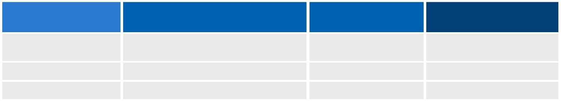
Manager/staff | Type of communication | Person | Frequency
 |  | responsible
[e.g. CEO] | [E.g. Presentation, email] | [e.g. C. Jones] | [e.g. Monthly and
 |  |  | after each change]

[Business Name] Emergency Management & Recovery Plan [YEAR]

Table of Contents

Revision history 1

Communication strategy 1
The Continuity Plan 3
Risk management 3

Critical business area analysis 3

Scenario planning 4
Insurance 5
Property & infrastructure 5

'Business as usual' planning 5
Key personnel training 6
Skill retention strategies 6

Data security & backup strategy 6
Environmental resilience 6
The Emergency Action Plan 7

Emergency contacts 7

Emergency procedures 7
Evacuation drill schedule 8
Emergency kit 8

Emergency team roles & responsibilities 9

The Recovery 10
Business impact assessment 10
Recovery contacts 10

Insurance claims 11
Market assessment 11
Marketing strategy 11

The Finances 12

Current creditors 12
Current debtors 12
Government funding 12

Expected cash flow 13

Supporting documentation 14

Page 2

[Business Name] Emergency Management & Recovery Plan [YEAR]

The Continuity Plan

Risk management

[List the potential risks to your business (in order of likelihood) and any mitigation/contingency strategies.]
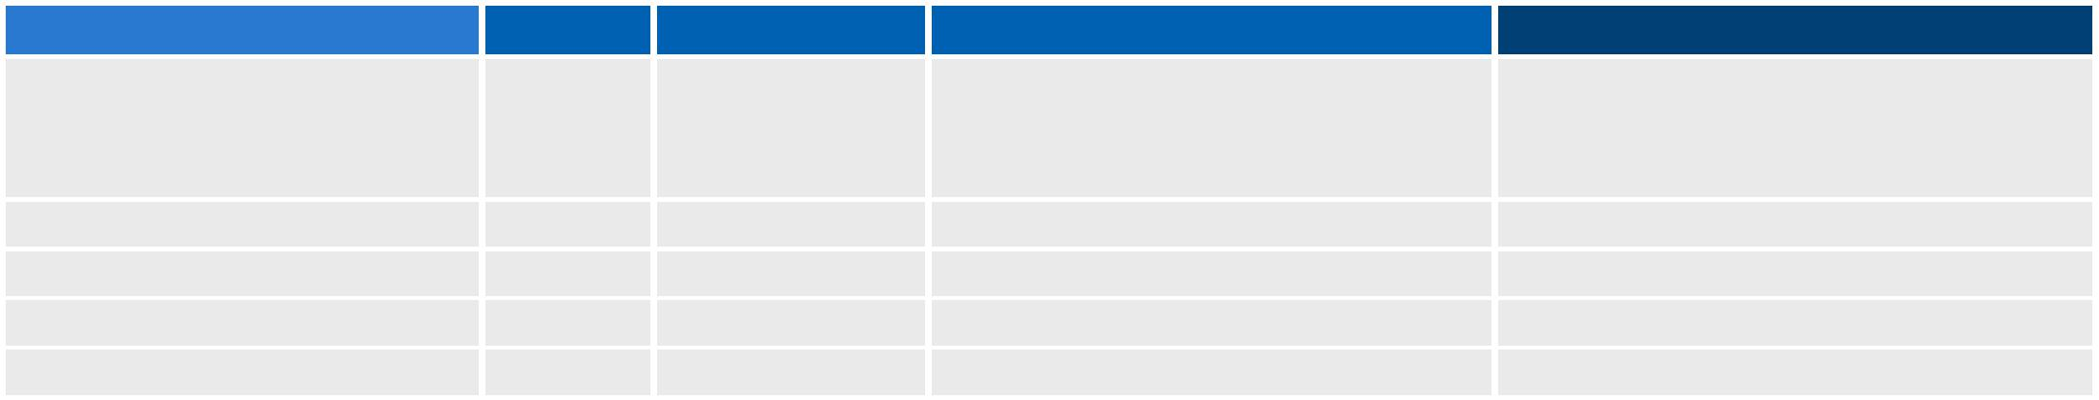
Business risk | Impact | Likelihood | Mitigation strategy | Contingency plan
[Description of the risk and | [High, | [Highly Unlikely, | [What actions will you take to | [What is your contingency plan in the
the potential impact to your | Medium, | Unlikely, | minimise/mitigate the potential risk | event that this risk happens?]
business.] | Low.] | Likely, | to your business?]
 |  | Highly Likely.]

Critical business area analysis

[Identify the critical areas of your business (e.g. product refrigeration process) and any protection strategies.]
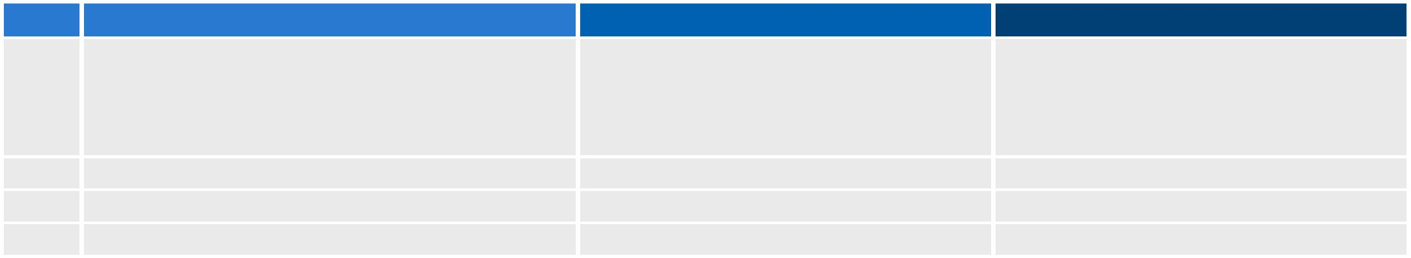
Rank | Critical business areas | Impact if failed | Current protection strategies
1 | [Description of what you can't do without: | [Describe the potential impact on your | [What strategies do you have that
 | people, suppliers, documents, systems or even | business if this critical area fails.] | minimise the impact to your business?
 | procedures.] |  | e.g. Training employees in multiple
 |  |  | areas of the business will reduce key
 |  |  | person risk.]
2
3
4

Page 3

[Business Name] Emergency Management & Recovery Plan [YEAR]

Scenario planning

[Once you have completed your critical business areas table and ranked them, complete a more detailed scenario based on each of your top three critical business areas.]

Scenario 1: [Name of scenario]
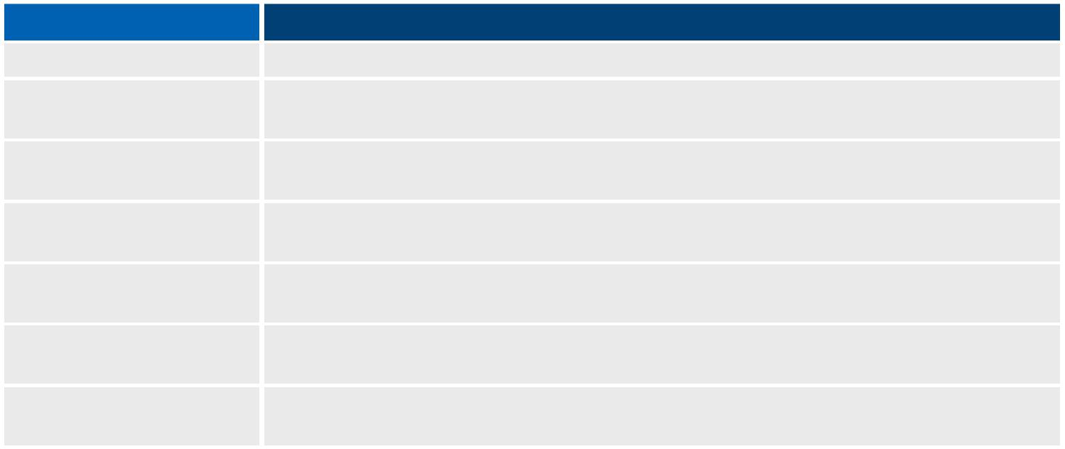
Question Details

Critical failure [Provide a short description of a critical area that could be interrupted.]

Background [Provide any relevant background information that is essential to

restoring the critical area.]

Impact to business [Provide an estimate of the impact to your business. This can be in

terms of percentage of sales or a dollar figure.]

Immediate actions Secondary actions

Responsibilities
Resources needed

[List what needs to be completed immediately to ensure loss is kept to a minimum.]

[Once immediate actions have been completed, what secondary actions can be completed until your business has recovered completely?]

[List the people who are responsible and for what during this critical business scenario.]

[What resources will you need to ensure you recover well in this sort of scenario? For example: cash flow, staff, service providers]

Scenario 2: [Name of scenario]
Question Details

Critical failure [Provide a short description of a critical area that could be interrupted.]

Background [Provide any relevant background information that is essential to

restoring the critical area.]

Impact to business [Provide an estimate of the impact to your business. This can be in

terms of percentage of sales or a dollar figure.]

Immediate actions [List what needs to be completed immediately to ensure loss is kept to

a minimum.]

Secondary actions [Once immediate actions have been completed, what secondary actions

can be completed until your business has recovered completely?]

Responsibilities
Resources needed

[List the people who are responsible and for what during this critical business scenario.]

[What resources will you need to ensure you recover well in this sort of scenario? For example: cash flow, staff, service providers]

Scenario 3: [Name of scenario]
Question Details

Critical failure [Provide a short description of a critical area that could be interrupted.]

Background [Provide any relevant background information that is essential to

restoring the critical area.]

Impact to business [Provide an estimate of the impact to your business. This can be in

terms of percentage of sales or a dollar figure.]

Immediate actions [List what needs to be completed immediately to ensure loss is kept to

a minimum.]

Secondary actions [Once immediate actions have been completed, what secondary actions

can be completed until your business has recovered completely?]

Responsibilities
Resources needed

[List the people who are responsible and for what during this critical business scenario.]

[What resources will you need to ensure you recover well in this sort of scenario? For example: cash flow, staff, service providers]

Page 4

[Business Name] Emergency Management & Recovery Plan [YEAR]

Insurance

[What insurance policies do you currently hold to cover your business risks?]
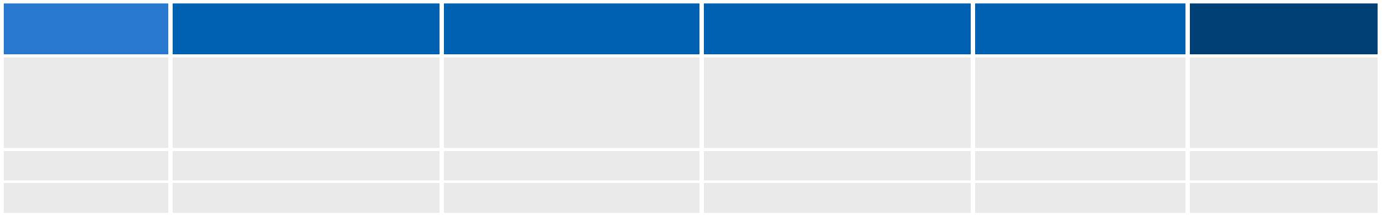
Insurance | Policy coverage | Policy exclusions | Insurance company | Last review date | Payments due
type |  |  | and contact
[e.g. Building, | [e.g. Damage from fire, | [e.g. Fraud, terrorism, | [e.g. XYZ Insurance, | [Day/Month/Year] | [Amount you pay
Contents, Car, | flood, theft, Cyclone] | tsunami, landslide] | D.Higgins (Area code) |  | and frequency.
Business |  |  | Number] |  | e.g. Monthly,
Interruption] |  |  |  |  | yearly]

Property & infrastructure

[What have you done to make your property and infrastructure less vulnerable to damage? Is your property secured with alarms, security personnel or video surveillance from unlawful entry? Do you have fire retardant or flood resistant building materials? Is leaf litter grass and gutters maintained regularly to minimise fire risk?]

'Business as usual' planning

Temporary office accommodation

[Identify temporary office accommodation you can quickly access in an emergency situation. Consider attaching a map of your accommodation to the back of your plan]
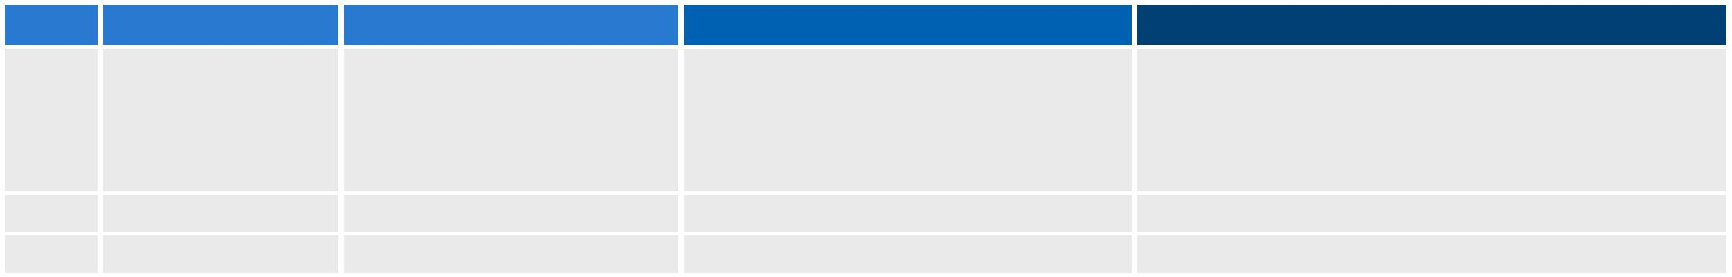

Rank | Type | Address | Equipment available
1 | [e.g. Private | [Enter the address of | [List all the equipment available at
 | residence, hotel, | your temporary office | the site. e.g. Computers, furniture,
 | temporary | site.] | photocopiers, phones, paper]
 | business centre.]

2

3

Resources needed

[List all the resources you will need in order to use this site as a temporary office. e.g. Software, backups, staff, and any other equipment not already available at the location.]

Business continuity strategies

[What other strategies will you consider to help maintain business as usual practices? Have you considered a virtual office service, e-commerce website or an online auction or e-marketplace shopfront?]

Page 5

[Business Name] Emergency Management & Recovery Plan [YEAR]

Key personnel training

[List your current staff in the table below and any cross-training requirements.]
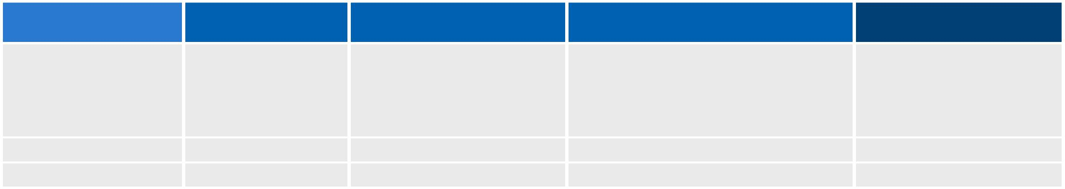
Job title | Name | Expected staff turnover | Skills or strengths | Cross-training
 |  |  |  | requirements
[e.g. Marketing/ Sales | [e.g. J. Smith] | [e.g. 12-18 months] | [e.g. Relevant qualifications in | [e.g. Requires training in
Manager] |  |  | Sales/Marketing. At least 5 years | finance system]
 |  |  | experience in the industry. Award in
 |  |  | marketing excellence 2007. Fully
 |  |  | qualified in first aid 2006.]

Skill retention strategies

[What procedural documentation will you provide to ensure the skills of staff are maintained? Do you have an appropriate allocation of responsibilities? How are responsibilities documented and communicated to staff? What internal processes will you implement to regularly check that the current skills of staff members are still appropriate for the business?]

Data security & backup strategy

[How have you protected your data and your network (e.g. virus protection, secure networks and firewalls, secure passwords and data backup procedures)? Detail your backup procedures in the table below.]
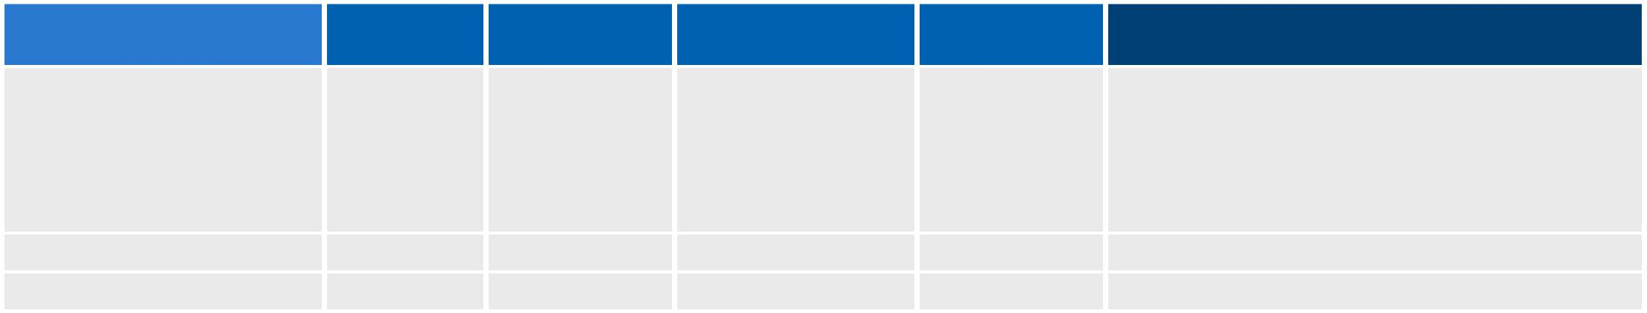
Data for backup | Type of | Frequency | Backup media/ | Person | Backup procedure steps
 | data | of backup | service | responsible
[List all the essential data | [e.g. Email, | [e.g. Daily, | [e.g. Magnetic | [e.g. C. | [List the steps required to perform the
that your business cannot | spreadsheet, | weekly, | tape, CD ROM, | Jones] | backup or attach a procedure document to
recreate from other | payroll | monthly] | external hard disk |  | the back of this plan]
sources. If this list is | system data, |  | drive,
substantial, consider a | website.] |  | remote/online
full system backup] |  |  | backup service.]

Environmental resilience

[What environmental choices have you made to help you achieve climate change adaptability?]

Page 6

[Business Name] Emergency Management & Recovery Plan [YEAR]

The Emergency Action Plan

Emergency contacts

[List your local emergency services numbers and any additional contacts you will need to phone in an emergency (e.g. Employee's next of kin).]
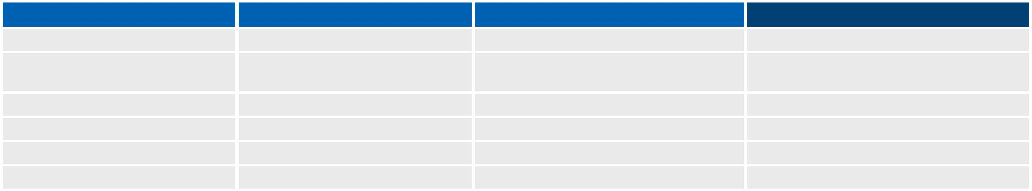
Organisation Name | Contact | Title | Phone number
ALL | - | - | 000
State Emergency Services | - | - | [(Area code) Number]
(SES)
Police | - | - | [(Area code) Number]
Fire | - | - | [(Area code) Number]
Ambulance | - | - | [(Area code) Number]

Emergency procedures

[List your emergency/evacuation procedures. It may be useful to attach a copy of your detailed emergency procedures and floor plan with the location of emergency exits, emergency kit and safety equipment clearly marked. Your emergency procedures should also include a map of evacuation locations for all emergencies.]

Procedures | Brief outline of procedures |  | Evacuation point/ | Reference to full
 |  |  | address | procedure document
[e.g. Fire | [e.g. 1. Alarm raised and relevant |  | [e.g. Corner of Safe | [e.g. The Fire and
Evacuation | emergency services authorities |  | Street and Sound | emergency procedures.doc
Procedure] | contacted. |  | Lane, City.] | can be found on the shared
 | 2. | Wait for evacuation signal. |  | drive under the 'Emergency'
 | 3. | Follow fire warden instructions. |  | folder. A printed copy is
 |  |  |  | also located in the main
 | 4. | Calmly evacuate the premises
 |  |  |  | filing cabinet.]
 | from nearest emergency exit.
 | 5. | Arrive at evacuation location.
 | 6. | Locate and account for all staff.]

Supporting documentation

[e.g. Office floor plan,

map of evacuation locations.]

Page 7

[Business Name] Emergency Management & Recovery Plan [YEAR]

Evacuation drill schedule

[Use this table to schedule your emergency evacuation drills.]
Evacuation procedure type | Drill frequency | Position/person responsible | Next drill dates
[e.g. Fire, flood, cyclone] | [Monthly] | [e.g. S. Jones] | [Day/Month/Year]

Emergency kit

Location

[Where is your emergency kit located/stored?]

Contents

[List the contents of your emergency kit and the date each item was last checked/reviewed.]
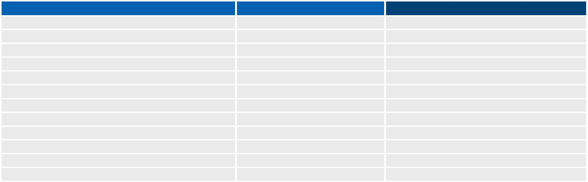
Object | Checked/Reviewed Date | Person responsible
Emergency management & recovery plan | [Day/Month/Year] | [e.g. J. Smith]
Emergency and recovery contacts
Insurance documents
Financial documents
Torch
First-aid kit
Portable radio
Plastic bags
Spare batteries
Adhesive tape
Pen/pencil and notepad]

Page 8

[Business Name] Emergency Management & Recovery Plan [YEAR]

Emergency team roles & responsibilities

Role
First Aid

Officer

Chief Fire

Warden

Fire

Warden

Details of responsibilities |  | Person | Email | Phone/Mobile numbers
 |  | responsible
[e.g. |  | [e.g. M. Smith] | [e.g. ms@example.com] | [(Area code) Number]
▪▪ | Attend regular first aid training courses. |  |  | [Mobile number]
▪▪  Administer first aid support in an
 | emergency situation.
▪▪  Contact ambulance services when
 | necessary.]
[e.g. |  | [e.g. S. Jones] | [e.g. sj@example.com] | [(Area code) Number]
▪▪ | Attend relevant training courses. |  |  | [Mobile number]
▪▪  Communicate procedures to all staff.
▪▪  Supervise and action emergency
 | evacuation procedures (including
 | contacting emergency services,
 | accounting for staff).
▪▪ | Conduct regular drills.
▪▪ | Update procedures regularly.]
[e.g. |  | [e.g. J. Silos] | [e.g. js@example.com] | [(Area code) Number]
▪▪ | Attend relevant training courses. |  |  | [Mobile number]
▪▪ | Assist in evacuating staff according to
 | evacuation procedures (including collecting
 | emergency kit and resilience and recovery
 | documentation).
▪▪ | Assist with regular drills.
▪▪ | Assume Chief Fire Warden duties when
 | required.]

Page 9

[Business Name] Emergency Management & Recovery Plan [YEAR]

The Recovery

Business impact assessment

[Based on your assessment of the damage to your business, complete the table below (in order of severity) or attach your own impact assessment to the back of your plan.]
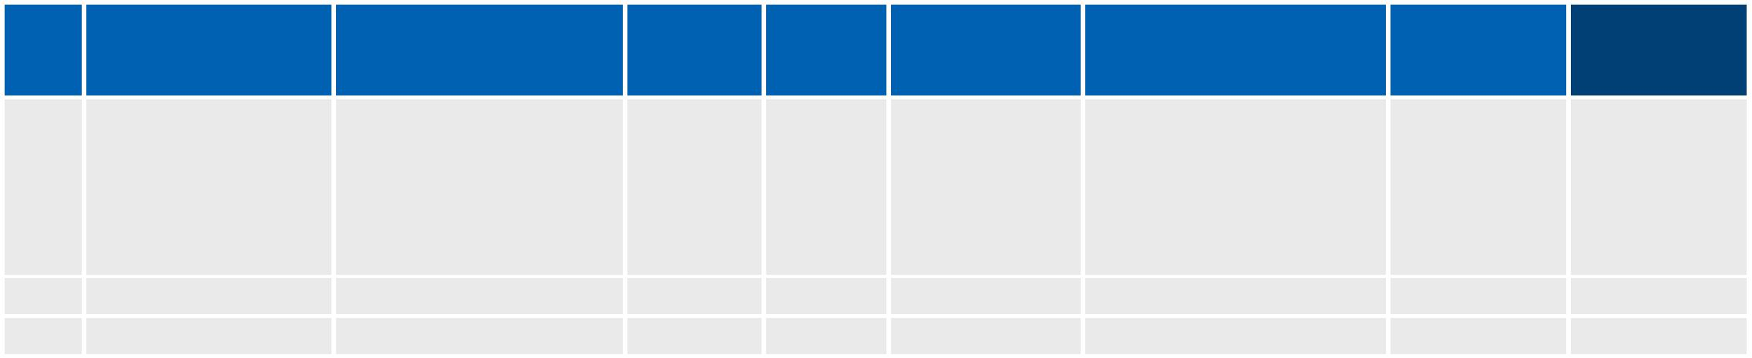  Rank | Damage | Impact to business | Severity | Action | Recovery | Resources needed | Actioned | Estimated
 |  |  |  |  | steps |  | by | date of
 |  |  |  |  |  |  |  | completion
1 | [List any damage | [Describe any direct | [High, | [Repair, | [List the | [List the resources | [Assign | [Due date
 | to buildings, | or indirect impacts | Medium, | replace, | steps needed | needed to recover | someone to | for
 | assets, stock, | the damage will have | Low.] | rebuild.] | to recover the | including any cost | each task.] | completion.]
 | documents or | on your business' |  |  | damage.] | estimates, service
 | surrounding | critical functions.] |  |  |  | providers, employees,
 | area/community.] |  |  |  |  | building materials.]
2
3

Recovery contacts

[Include all of the organisations/people that will be essential to the recovery of your business. See also Emergency contacts above.]
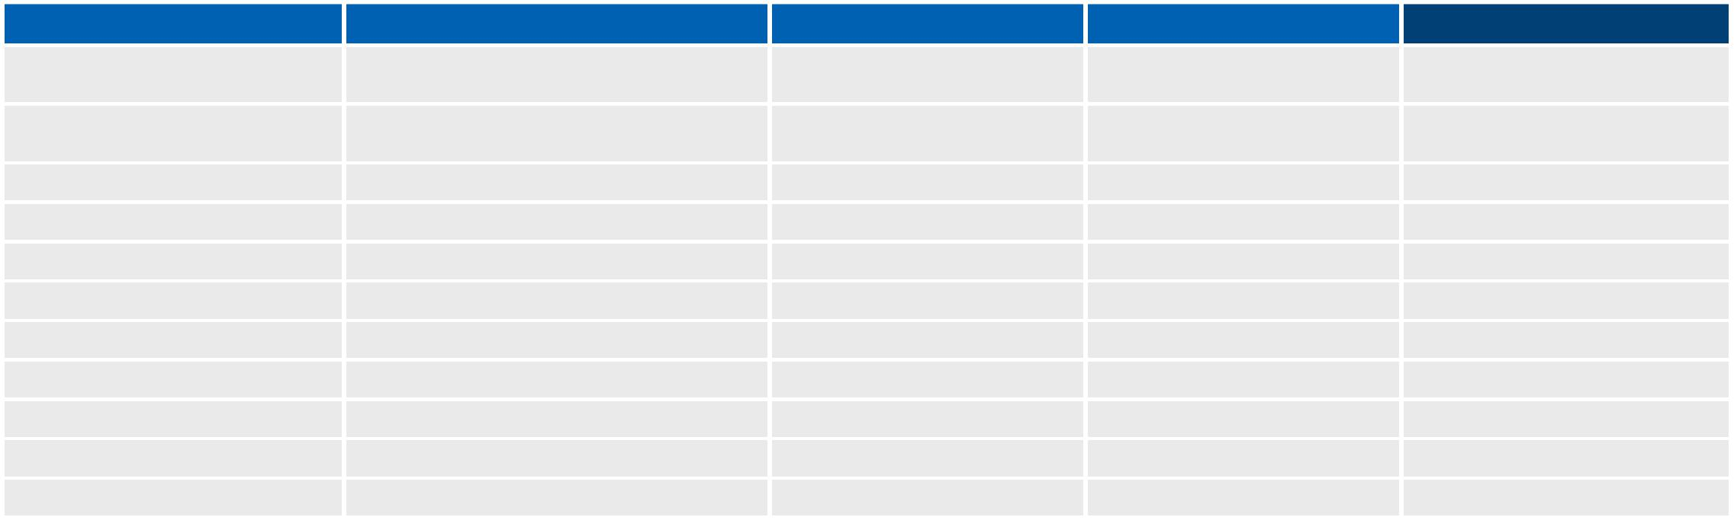
Contact Type | Organisation Name | Contact | Title | Phone/Mobile number
Insurance | [e.g. XYZ Insurance] | [e.g. G. Jones] | [e.g. Claims Advisor] | [(Area code) Number]
 |  |  |  | [Mobile number]
Telephone/internet
services provider
Bank/building society
Employee
Supplier (Main)
Supplier (Backup)
Customer
Business advisor
Accountant
Lawyer

Page 10

[Business Name] Emergency Management & Recovery Plan [YEAR]

Insurance claims

[What insurance policies have you claimed for? Use the table below to record any discussions you have had with an insurer about your claim]
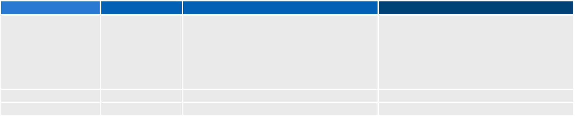

Insurance company | Date of contact | Details of conversation/claim
[e.g. XYZ Insurance, | [Day/Month/Year] | [Enter any relevant details discussed with your
D.Higgins |  | insurer about your claim. e.g. When will the
(Area code) Number] |  | assessor visit? Did you receive an estimated
 |  | claim amount?].

Follow up actions
[Is there anything you or the insurer need to complete to continue processing the claim? Is there any information the insurer requires to process the claim (e.g. estimate of the damage, serial numbers for stolen equipment, photos)? Are there any special instructions the insurer has asked you to do/not do in regards to the cleanup effort or property?]

Market assessment

[Based on your assessment of the damage to your business and/or surrounding area, list any areas of your market that have changed below. Alternatively, attach a complete market assessment to the back of this plan. Download our Marketing plan template for further guidance.]
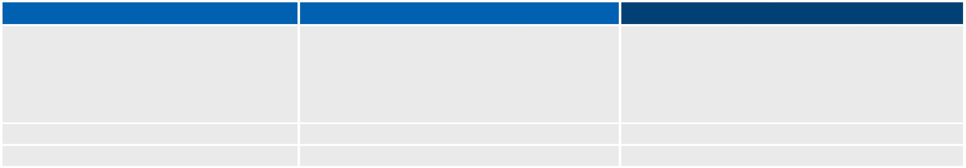
Market changes | Impact to business | Business options
[What has changed in the market since the | [What part of your business will be affected by | [How can your business adapt or change to suit
emergency?] | these market changes and how?] | these new market conditions? e.g. Can you move
 |  | location, trade online, change key products or
 |  | services or just re-evaluate the way you run your
 |  | business to make sure you are still meeting
 |  | market needs?]

Marketing strategy

[Detail your marketing strategy after the emergency. If your business is reopening its doors after the disaster, how will you get the message out? What channels will you use to target customers? How does this strategy differ in light of any changes in the market? e.g. You may consider a targeted marketing effort (such as a social media campaign) to communicate your business reopening.]

Page 11

[Business Name] Emergency Management & Recovery Plan [YEAR]

The Finances

Current creditors

[List all current creditors and any arrangements you have made during the recovery period]
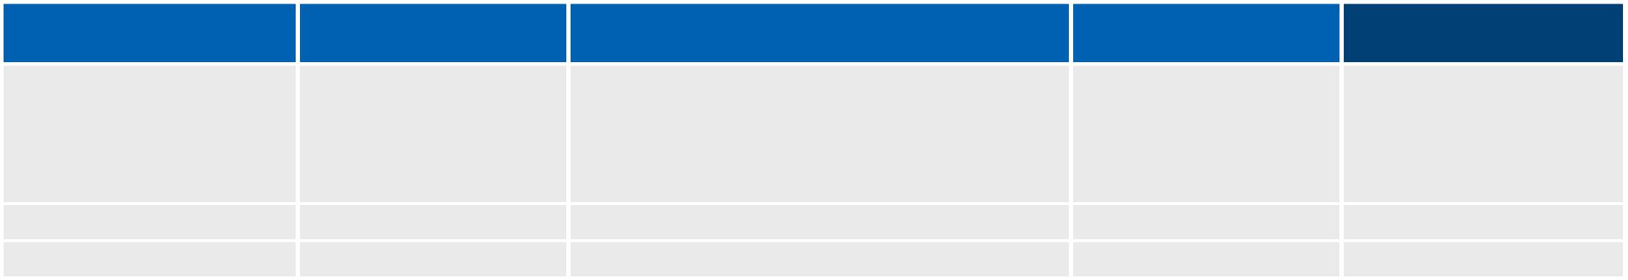

Creditor name | Contact details | Special arrangement details
[e.g. Example Banking | [J. Harmer, Business | [List the conditions of your arrangement.
Corp.] | Loan Advisor, | e.g. Loan temporarily changed to interest
 | (Area code) Number] | only arrangement for the period of
 | [Mobile number] | recovery.]

Period of special Amount to pay

arrangement

[Enter the period the [Detail the amounts

arrangement will be you are required to pay
valid until. e.g. Period within the arrangement

of 6 months ending period.]

on 1 July 2011]

Current debtors

[List all current debtors you have contacted and their agreed payment amount and date.]
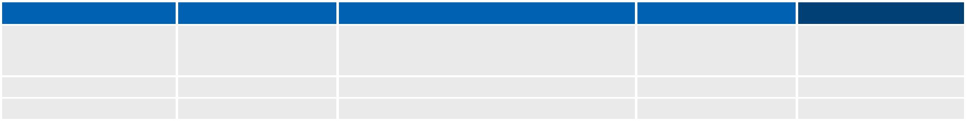
Debtor name | Contact details | Details | Agreed payment date | Amount to receive
[Example Business] | [P. Fred, | [Briefly list what the payment was for.] | [Day/Month/Year] | [$$$]
 | (Area code) Number]
 | [Mobile number]

Government funding

[List all government funding you have applied for and the expected amount.]
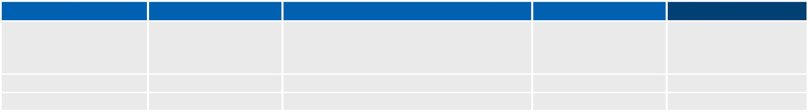
Program Name | Contact details | Funding details | Date of application | Amount to receive
[e.g. Flood relief | [R. Smith], | [Briefly mention the terms of the funding.] | [Day/Month/Year] | [$$$]
package] | [Agency name]
 | (Area code) Number]
 | [Mobile number]

Page 12

[Business Name] Emergency Management & Recovery Plan [YEAR]

Expected cash flow

[Double- click the table below to enter your details or attach your own Expected cash flow sheet at the back of this plan]
EXPECTED | Jan | Feb | Mar | Apr | May |  | Jun
CASHFLOW [YEAR]
OPENING BALANCE | $0 | $0 | $0 |  | $0 | $0 | $0
Cash incoming
Sales
Asset sales
Debtor receipts
Insurance payout
Government funding
Other income
Total incoming | $0 | $0 | $0 |  | $0 | $0 | $0
Cash outgoing
Bank fees & charges
Interest paid
Credit card fees
Utilities (electricity, gas,
water)
Telephone
Fuel
Lease/loan payments
Rent & rates
Motor vehicle expenses
Stationery & printing
Membership & affiliation
fees
Licensing
Insurance
Superannuation
Income tax
Wages (including PAYG)
More…
Recovery costs
Purchases (Stock,
equipment, supplies)
Cleanup costs
Rebuilding/repairs
Security fees
Accountant fees
Solicitor fees
Data recovery fees
Advertising & marketing
More…
Total outgoing | $0 | $0 | $0 |  | $0 | $0 | $0
Monthly cash balance | $0 | $0 | $0 |  | $0 | $0 | $0
CLOSING BALANCE | $0 | $0 | $0 |  | $0 | $0 | $0

Page 13

[Business Name] Emergency Management & Recovery Plan [YEAR]

Supporting documentation

Attached is my supporting documentation in relation to this Emergency management & recovery plan. The attached documents include:

▪▪ [List all of your attachments here. These may include copies of your floor plan, detailed emergency procedures, impact and market assessments and financial documents.]

Page 14

