Modern Roundabouts | A LIVABILITY FACT SHEET

Every day in the U.S. more than 20 people are killed at traffic intersections, and many more are seriously injured.¹

Roundabouts — circular intersections that move traffic counterclockwise around a central island — can help reduce these deaths and injuries. Modern roundabouts are calmer and safer than conventional intersections and have been deemed a “proven safety counter-measure” by the U.S. Department of Transportation.²

Roughly the size of a baseball diamond or infield, modern roundabouts differ from rotaries or traffic circles, which can be as big as the entire outfield. Roundabouts feature lower, safer vehicle speeds. They can be 80 feet across with single lanes carrying 25,000 vehicles a day or larger at 200 feet, with double lanes and 45,000 vehicles a day.³

Personal injuries and fatalities plummet as much as 90 percent in modern roundabouts when compared to conventional intersections.⁴ Roundabouts cause drivers to slow down, ideally to less than 20 mph, which reduces the risks to both pedestrians and drivers.

Because roundabouts can handle 30 to 50 percent more traffic than conventional intersections, they reduce travel delays.⁵ Since roundabouts can be designed to be aesthetically pleasing, they help create a sense of place.

By January 2014, roundabouts graced more than 2,000 intersections in the U.S., with more planned.⁶ Given their safety and placemaking benefits, roundabouts should be considered for many more of the three million intersections in the U.S.

Modern roundabouts are calmer and safer than conventional intersections and have been deemed a “proven safety counter-measure” by the U.S. Department of Transportation.
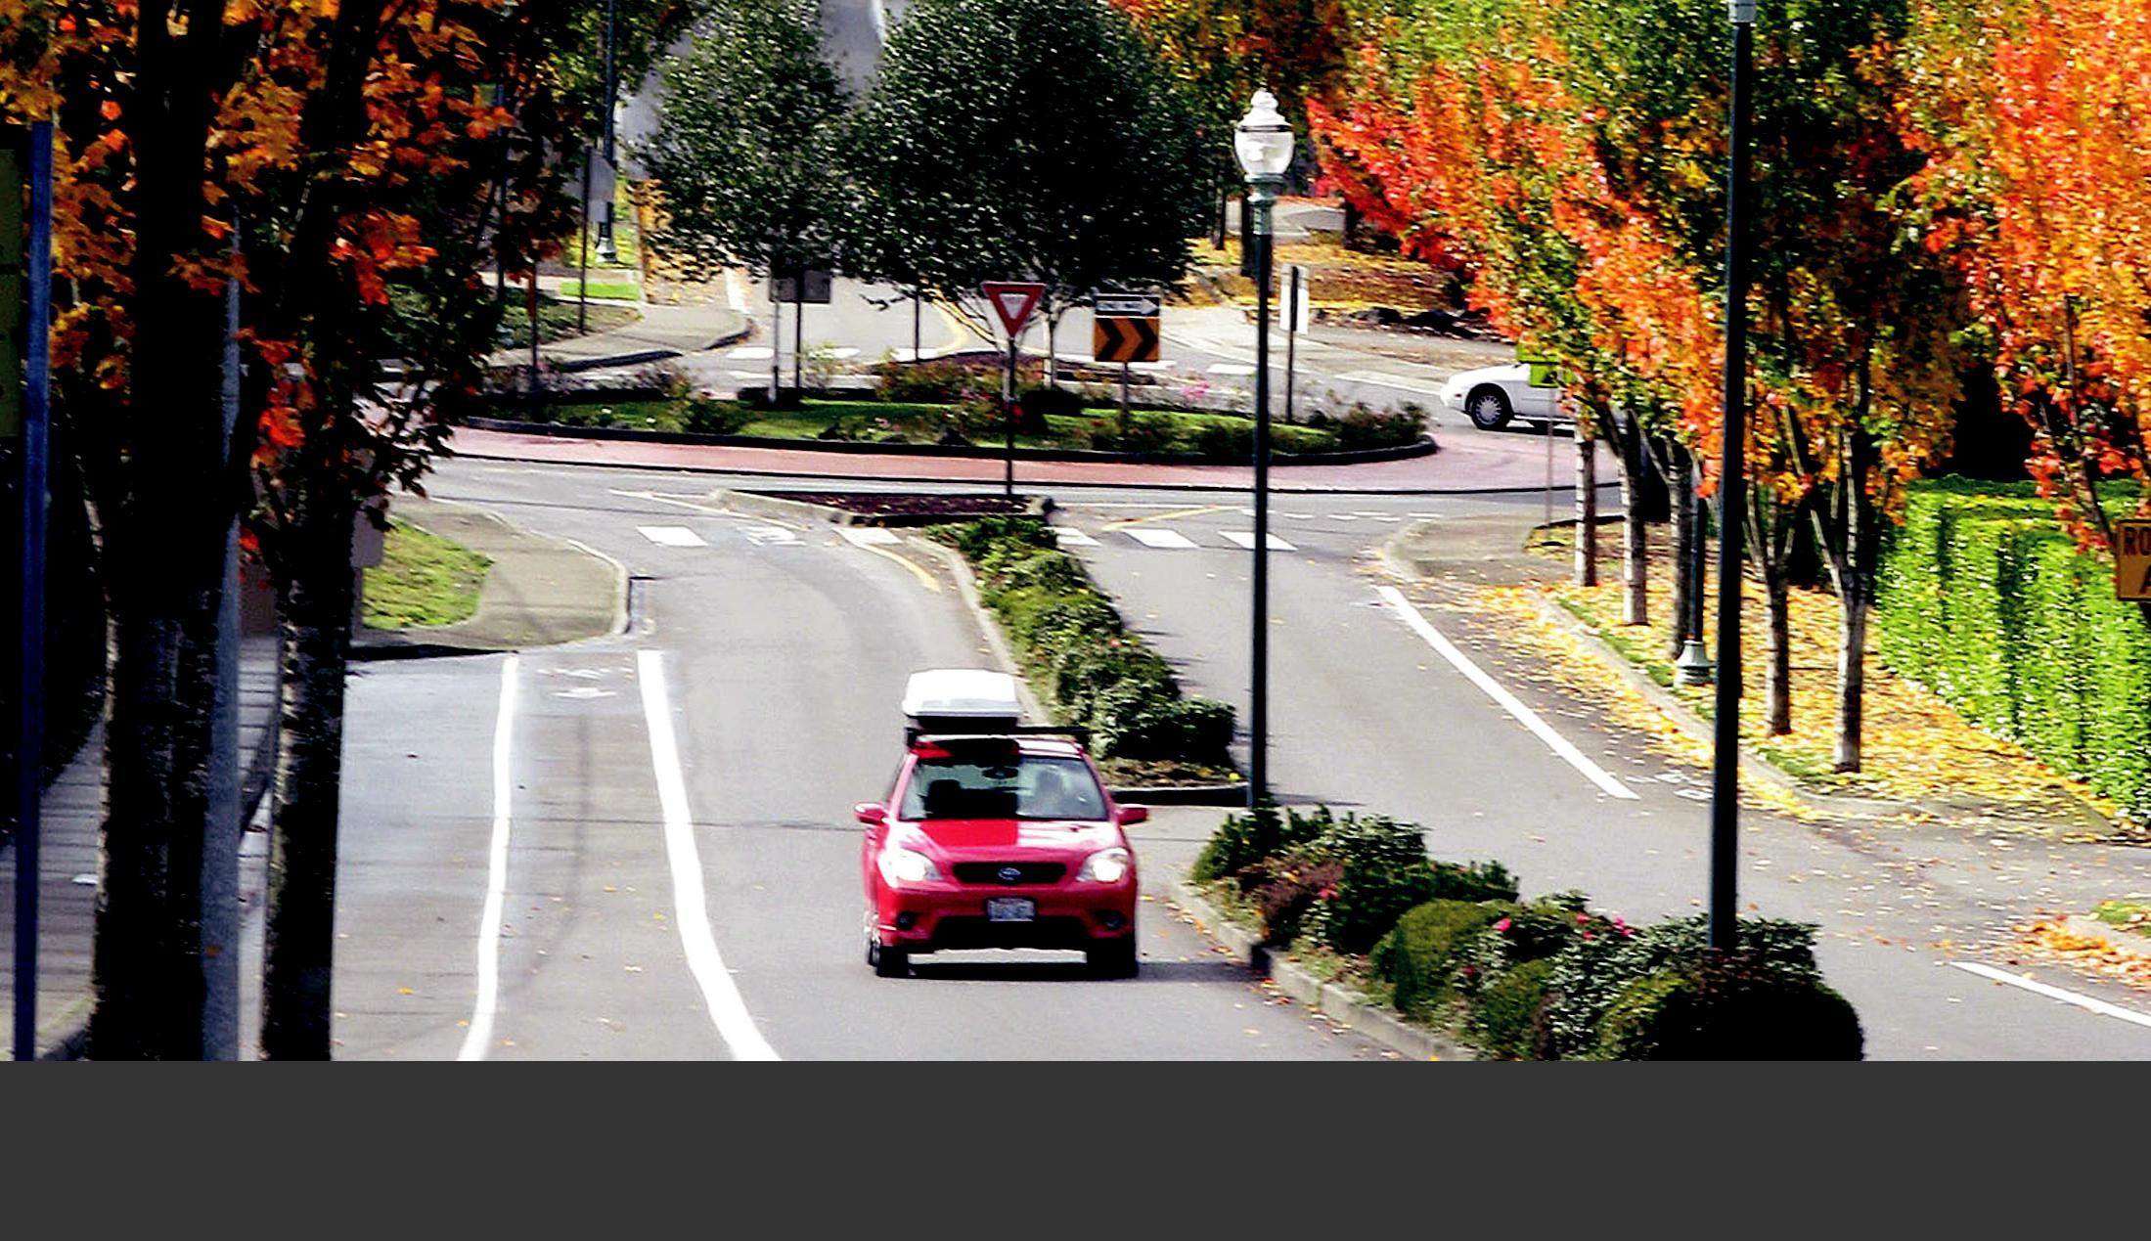

Vehicle speeds on Grandview Drive in University Place, Wash., often reached or exceeded 50 mph. After the installation of modern roundabouts, vehicle crashes dropped from one every nine months to zero in 14 years.

Myth-Busting!

 “Roundabouts require too much land.”

Roundabouts, which can be installed on virtually any size street, range from single-lane mini-roundabouts to two lanes or more.⁷ A single-lane roundabout can be as narrow as 80 feet in diameter, measuring across the circle from the outside edges of the vehicle lanes.

Also, a well-placed roundabout can keep a road from needing to be widened, saving up to 10 million dollars per mile in land and construction costs.⁸

 “The public will object to using a roundabout.”

Before several two-lane modern roundabouts were installed in Bellingham, Wash., only one in three people surveyed by the Insurance Institute for Highway Safety supported the creation of a roundabout.

Once the roundabout was built, the numbers reversed, and 70 percent of respondents became supportive.⁹ In another study conducted by the Institute, support for six different roundabouts went from a low of 22 percent to a high of 87 percent five years after installation.¹⁰ Building one roundabout in a community is usually all it takes to convince most people of their benefits.

 “Fire trucks, snowplows, buses and semis can’t use roundabouts.”

A “truck apron” in the center of a roundabout can accommodate emergency vehicles, buses, snow equipment and large trucks, including those with wheel-base lengths of 50 or more feet.

 “Roundabouts aren’t safe for bicyclists and pedestrians.”

By using space to pause on the “splitter island,” pedestrians need to watch only one direction of traffic at a time, which simplifies the task of crossing the street. The low vehicle speeds through a roundabout — which can be

as low as 15 mph — also allow more time for drivers and pedestrians to react to one another, which reduces the chance and consequences of error. A bicyclist can be given the option of riding in the lane of slow-moving cars or crossing as a pedestrian.¹¹

 “Roundabouts hurt business.”

The lower the speed of traffic through an area, the easier it is to park a car, walk, bicycle and locate and approach a business. Since roundabouts are also quieter than conventional intersections, any outdoor seating nearby is more enjoyable.

In Golden, Colo., retail sales increased 60 percent after the addition of a string of roundabouts — and that was during the 1989 recession. Sales in Golden outpaced those of all other cities in the state.¹²

 “Roundabouts aren’t good for older adults.”

By 2025, about 25 percent of all drivers in the United States will be over the age of 65. Forty percent of all car crashes that involve drivers over the age of 65 occur at intersections.¹³

As we age, we lose our ability as drivers to judge left-turn gaps.¹⁴ Roundabouts don’t require those decisions, and they eliminate head-on and right-angle crashes. When collisions do occur, they are generally at lower speeds and less harmful.

 “Pedestrians with limited vision can’t cross roundabouts.”

A known issue with roundabouts and other street crossings — such as mid-block crossings and right-turn slip lanes — is that it’s difficult for pedestrians with limited vision to determine when traffic has stopped and it is safe to cross. Solutions are being sought to address this problem.^{15, 16}

- U.S. Department of Transportation’s Federal Highway Administration (FHWA) (n.d.), safety.fhwa.dot.gov. Modern Roundabouts: A Safer Choice. http://safety.fhwa. dot.gov/intersection/roundabouts/fhwasa10023/transcript/audio_no_speaker/

- U.S. DOT FHWA (n.d.), safety.fhwa.dot.gov. Proven Safety Countermeasures. http://safety.fhwa.dot.gov/provencountermeasures/fhwa_sa_12_005.htm

- U.S. DOT FHWA (n.d.), fhwa.dot.gov. Roundabouts: An Informational Guide. http://www.fhwa.dot.gov/publications/research/safety/00067/000674.pdf

- U.S. DOT FHWA (n.d.), safety.fhwa.dot.gov. http://www.fhwa.dot.gov/resourcecenter/teams/safety/teamsafe_rndabout.pdf

- Kittelson & Associates, Inc. (August 2000), roundabout.kittelson.com. Modern Roundabouts. Retrieved Feb. 3, 2014, http://roundabout.kittelson.com/Roundabouts/ Search

- U.S. DOT FHWA (February 2010). Technical Summary: Mini Roundabouts. http://safety.fhwa.dot.gov/intersection/roundabouts/fhwasa10007/fhwasa10007.pdf

- American Road and Transportation Builders Association (n.d.), ARTBA.org: electronic references. http://www.artba.org/faqs/#20

- Insurance Institute for Highway Safety (February 2013). Public Opinion, Traffic Performance, the Environment, and Safety after the Construction of Double-Lane Roundabouts. Retrieved Feb. 3, 2014, http://www.iihs.org/frontend/iihs/documents/masterfiledocs.ashx?id=2033

- Transportation Research Record: Journal of the Transportation Research Board (2007). Long-Term Trends in Public Opinion Following Construction of Roundabouts. http://trb.metapress.com/content/1162251045856345/?genre=article&id=doi%3a10.3141%2f2019-26

- City of Golden and LSC Transportation Consultants, Inc. (April 2006). Development Opportunities: Golden, Colorado Case Study. http://lscdenver.com/Papers/ Minnesota%20Revised%202006.pdf

- U.S. FHWA. (n.d.) Modern Roundabouts: A Safer Choice. http://safety.fhwa.dot.gov/intersection/roundabouts/fhwasa10023/transcript/audio_no_speaker/

- National Cooperative Highway Research, Transportation Research Board, National Academies of Science. Roundabouts in the United States, Program Report 572. http://onlinepubs.trb.org/onlinepubs/nchrp/nchrp_rpt_572.pdf

How To Get It Right
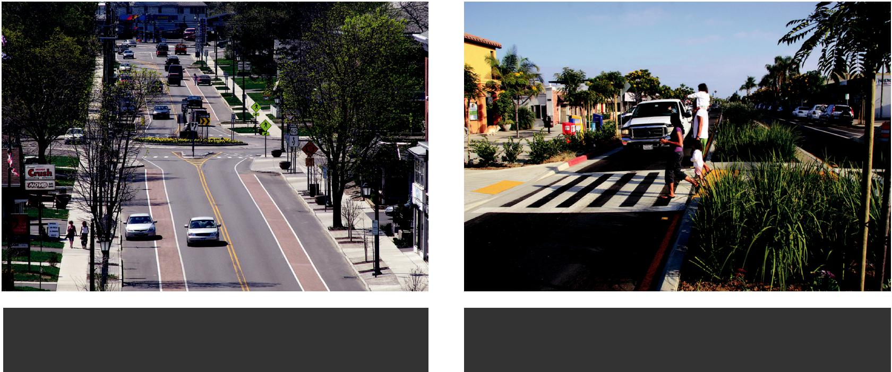

In Hamburg, N.Y., a series of roundabouts on Route 62 helps calm traffic and create a sense of place.

This roadway approaching a roundabout in San Diego, Calif., reduces the distance people must cross.

For modern traffic roundabouts to be effective, it’s important they’re done right:

 Adopt a roundabout-first policy

Whenever a roadway project includes reconstructing or constructing an intersection, analyze the feasibility of using a roundabout instead. This approach is

recommended by the U.S. Department of Transportation’s Federal Highway Administration and backed by the Insurance Institute for Highway Safety.¹⁷

 Embrace a public process and build support

Since roundabouts can be a new idea, elected leaders and agency staff may need to seek public support first, to inspire approval and navigate implementation.

For example, community advocates can print this fact sheet, talk to neighbors, build community support and then meet with decision makers, news outlets, experts and others to discuss the benefits of roundabouts. Agency staff can engage the public in a meaningful process, hosting interactive design workshops to build public acceptance and understanding.

 Design for speeds lower than 20 mph

Fast-moving vehicles kill people and divide places. A pedestrian hit by a vehicle at 20 mph has a 90 percent chance of survival while the odds of surviving a 40 mph impact are only 10 percent.¹⁸

Good roundabout design ensures that drivers slow down to 15 or 20 mph. This protects pedestrians, reduces pollution and noise and creates a more pleasant neighborhood.

 Keep dimensions tight

To keep traffic calm and therefore safe for all roadway users, roundabouts should feature context-appropriate design elements that reduce speed. Examples include tight entry and exit turn radii, narrow entry and circulatory lanes, appealing but non-distracting landscaping, a

truck apron for large vehicles and splitter lanes to help pedestrians cross two or more traffic lanes.

 Make it beautiful

An aesthetically pleasing roundabout can create a sense of place, frame a neighborhood, establish an entry point into a business district or neighborhood and serve as a canvas for public art or a garden.

- Owsley, C. (2004). Driver Capabilities in Transportation in an Aging Society: A Decade of Experience. Technical Papers and Reports from a Conference: Bethesda, MD.; November 7-9, 1999. Washington, D.C.: Transportation Research Board

- Pedestrian Access to Roundabouts: Assessment of Motorists’ Yielding to Visually Impaired Pedestrians and Potential Treatments to Improve Access, FHWA. http:// www.fhwa.dot.gov/publications/research/safety/pedbike/05080/

- Skene, M., Jacobson, M., Havercroft, D., Boan, J. (n.d.). Considerations for Accommodating Visually Impaired Pedestrians at Roundabouts, Institute for Transportation Engineers. http://www.ite.org/Membersonly/annualmeeting/2010/AB10H1002.pdf

- Smart Transportation Guide, Planning and Designing Highways and Streets that Support Sustainable and Livable Communities. Chapter 6. http://www.state.nj.us/ transportation/community/mobility/pdf/smarttransportationguidebook2008.pdf

- Ibid

- Federal Highway Administration (FHWA). Proven Safety Countermeasures. http://safety.fhwa.dot.gov/provencountermeasures/fhwa_sa_12_0

Success Stories

 San Diego, California: La Jolla Boulevard

A string of five roundabouts has allowed the city to reduce the road from five vehicle lanes to two, while also cutting travel time, adding on-street parking, attracting new businesses and still moving 23,000 vehicles a day.

The number of people walking went up, noise pollution plummeted and the increase in walking, bicycling and street life is bringing new business to retailers.

HOW IT WORKS

As these illustrations demonstrate, roundabouts harbor far fewer potential conflict points than conventional intersections, making streets safer for all users.
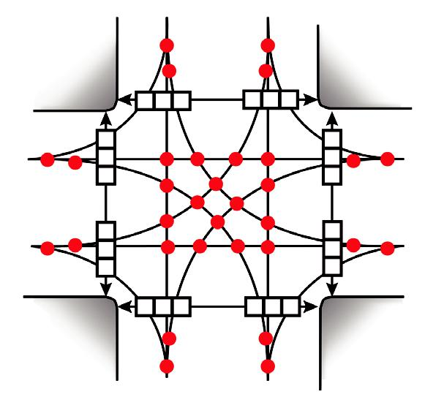

 Hamburg, New York: Route 62

By the 1990s, business had declined along the Route 62 commercial district. Empty storefronts pushed shoppers away to malls and big box stores. The road was generally congested and hazardous for cyclists and pedestrians.

A state plan emphasized wider roads and signalized intersections. But a group of residents banded together as the “Route 62 Committee” and created a new vision for Route 62 based on walkability and calmer traffic. Roundabouts have reduced the number and severity of crashes, congestion has been eased and emissions from idling cars have been reduced.

●

□

32 vehicle-to-vehicle conflict points

24 vehicle-to-person conflict points

 Bradenton Beach, Florida: Bridge Street

One pedestrian was being killed every year at the intersection of Bridge Street and North Gulf Drive. With 18,000 cars and trucks moving daily, the traffic separated residents and visitors from the beach. People could see the beach, but they could not walk to it without taking severe risks.

A roundabout was built and the police chief reports there hasn’t been a recorded crash of any type since. With many more people walking to the beach, parking eased, and the roundabout became one of the nation’s first to kick-start downtown reinvestment, which is now bustling with pedestrians, new homes and retail activity.

●
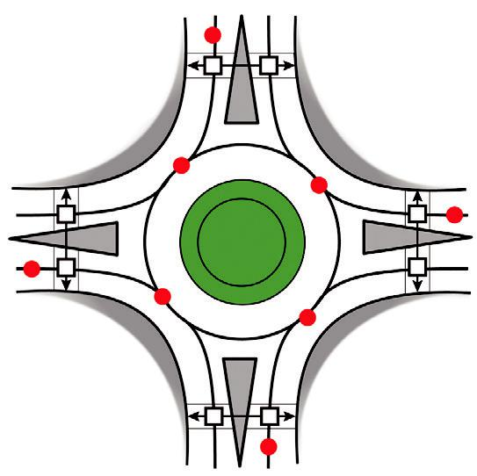

□

8 vehicle-to-vehicle conflict points

8 vehicle-to-person conflict points

RESOURCES

1. | Roundabouts, FHWA. http://safety.fhwa.dot.gov/intersection/roundabouts/ | 5. | Geocoded National Roundabout Database. http://roundabouts.kittelson.
2. | Technical Summary: Roundabouts, FHWA. http://safety.fhwa.dot.gov/ |  | com/
 | intersection/roundabouts/fhwasa10006/fhwasa10006.pdf | 6. | Roundabout Benefits, Washington State Department of Transportation.
3. | Technical Summary: Mini Roundabouts, FHWA. http://safety.fhwa.dot. |  | http://www.wsdot.wa.gov/safety/roundabouts/
 | gov/intersection/roundabouts/fhwasa10007/fhwasa10007.pdf | 7. | Insurance Institute for Highway Safety. http://www.iihs.org/
4. | Roundabouts: An Informational Guide, FHWA, Lee August Rodegerdts, | 8. | Proven Safety Countermeasures, FHWA. http://safety.fhwa.dot.gov/
 | National Research Council (U.S.). Transportation Research Board, National |  | provencountermeasures/fhwa_sa_12_0
 | Cooperative Highway Research Program, American Association of State
 | Highway and Transportation Officials, 2010
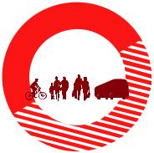

 | AARP LIVABLE COMMUNITIES |  | WALKABLE AND LIVABLE COMMUNITIES INSTITUTE
 | Mail: | 601 E Street NW, Washington, DC 20049 | Mail: | 2023 E. Sims Way #121, Port Townsend, WA 98368
 | Email: | livable@aarp.org | Email: | community@walklive.org
 | Online: | aarp.org/livable | Online: | walklive.org

