Information is only valuable...
If you can use it!

Managing information and creating bibliographies for research papers has always been a time-consuming, complex task, often involving the use of different systems and applications. RefWorks makes this a problem of the past by providing solutions for research management, wirting and collaboration.

RefWorks is a powerful web-based service, providing for the integration of the newest technologies to support researchers with effective tools. Users can easily organize, access, and disseminate information within seconds --- offering global portability to today’s modern researcher.

www.refworks.com
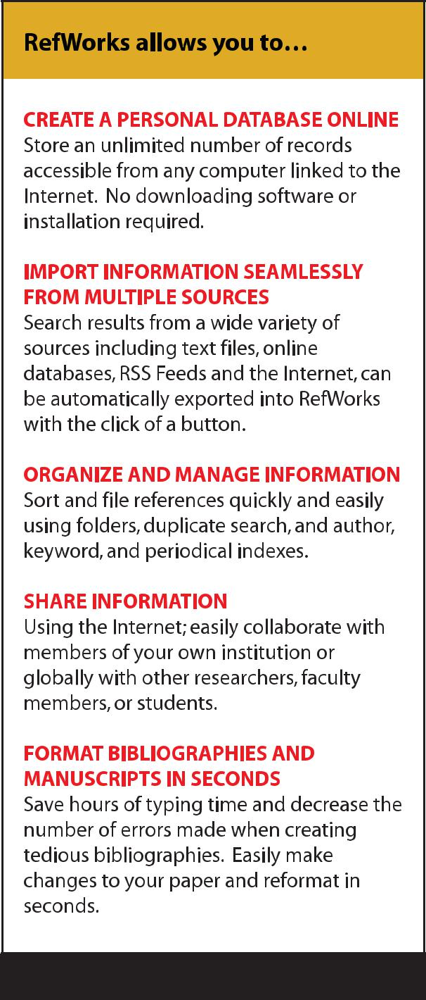

RefWorks allows users to create personal databases and use them for a variety of research activities. References are quickly and easily imported from text files, online databases, through RSS feeds or via the web. Users can automatically insert references from their database into their papers and generate formatted bibliographies and manu-scripts in instantly. In addition, RefWorks provides users with a quick and easy way to share their information amongst colleagues at their own institution or with other researchers globally.

Who Uses RefWorks?

From researchers to faculty to students, RefWorks supports all types of users throughout their careers. Only RefWorks provides immediate access to a research management system that combines the high performance features of a desk-top product with the full range of Web-based functionality! If you could learn just ONE powerful, yet easy to use research management, writing and collaboration tool, wouldn’t you? With hundreds of thousands of users in over 700 organizations globally, RefWorks supports the needs of your organizations ever demanding, diversified user population.

Users | Types of Organizations
Researchers | Academia, Government Agencies & Corporations
Graduate Students | Academia, Hospitals
Teaching Faculty | Academia, Hospitals
Undergraduate Students | Academia
Librarians | All of the above!

“I have used reference database software for many years. RefWorks is the most intuitive and least problematic of any software that I have used. It permits me to capture the reference information for the online resources more effectively than other tools. I have found RefWorks invaluable!”

Jeff Olsen

Associate Vice President of Online Learning & Services

Director of Library and Information Sciences

St John's University, USA

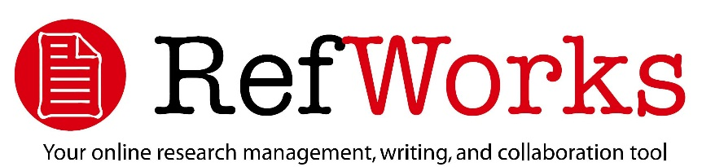

1. NO SPECIAL SOFTWARE REQUIRED

RefWorks is a Web-based service that can be used with any major Web browser on any platform. No need to load program software on individual machines.

- PORTABILITY ---- ACCESSIBLE ANYTIME, NEARLY

ANYWHERE

Users can access RefWorks any time of the day from any Internet-connected computer. No need to limit access to a specific desk-top, at a specific location.

- MACHINE INDEPENDENCE

RefWorks is compatible with multiple platforms including Windows, Mac, UNIX and Linux.

4. SHARE INFORMATION

RefWorks makes it easy to disseminate information online, or collaborate with geographically disparate colleagues further enhancing the research process.

5. COMPATIBLE WITH NUMEROUS RESOURCES

Users can import references quickly and easily from most major online database services, other bibliographic software packages, RSS Feeds, webpages, as well as library catalogs.

6. UPGRADED AUTOMATICALLY

All upgrades are automatically made available to the user without the need to re-load software. The upgrades are provided at no extra fee.

7. USAGE STATISTICS AND CUSTOMIZATION

RefWorks offers extensive usage reporting and local customiza-tion.

8. TRAINING AND TECHNICAL SUPPORT

RefWorks provides both on-site and web-based training, specifi-cally customized to the needs of the organization. In addition, end-user support via the web or by phone is also provided. Both training and technical support is included as part of the annual service fee.

7200 Wisconsin Avenue, Suite 601 Bethesda, MD 20814

USA

(t) +1 301.961.6700 (f)+1 301.961.6708 www.refworks.com

CHANGE FORMATS QUICKLY AND EASILY!
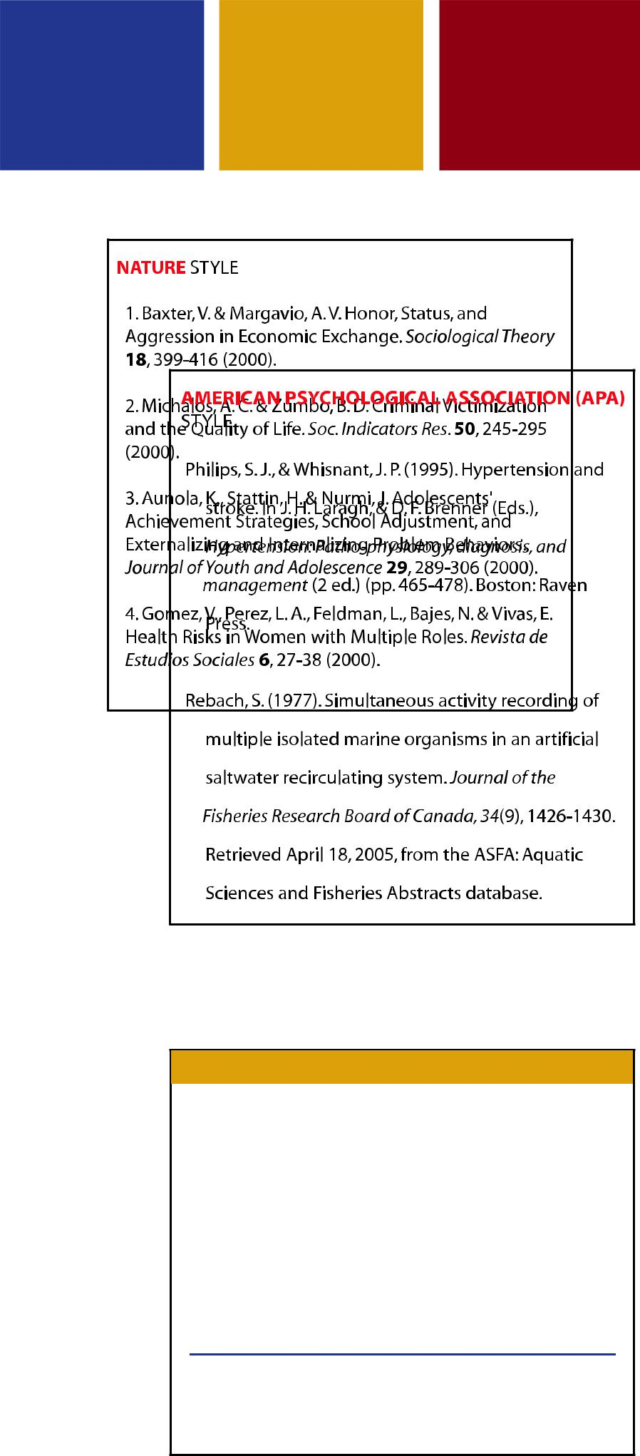

"RefWorks is the most comprehensive and versatile reference program I have ever used! I used RefWorks at Northern Arizona University while conducting research for my Master's Thesis. I think RefWorks is an invaluable tool. Thanks for a great product!"

Patti Jo King

Doctoral Student

University of Oklahoma, USA

ACCESS REFWORKS AT: www.refworks.com

FOR A COMPLIMENTARY TRIAL: info@refworks.com

