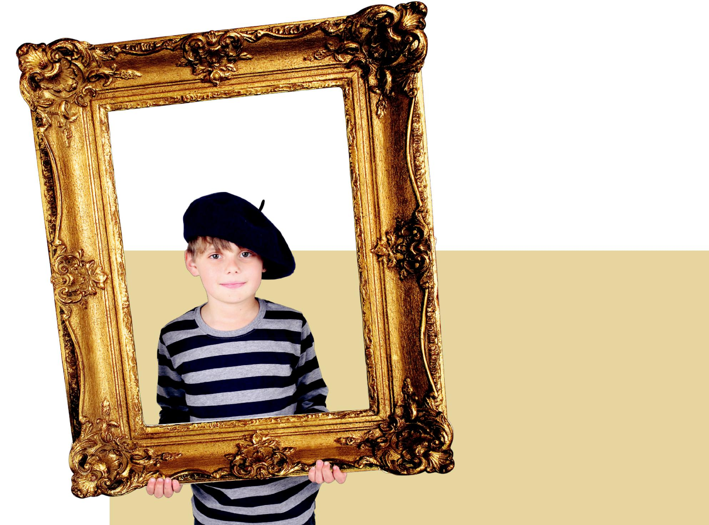
Lotta

lottamagazine.com

Pablo
Picasso

Fact Sheet

Pablo Picasso was born on 25th October 1881 in Spain. His whole name is 23 words long and is Pablo Diego José Francisco de Paula Juan Nepomuceno María de los Remedios Cipriano de la Santísima Trinidad Martyr Patricio Clito Ruíz y Picasso.

Picasso was born an artist — his first word was ‘piz’ short for lápiz the Spanish word for pencil. His father Ruiz, an artist and art professor, gave him a formal education in art from the age of 7. By 13, Ruiz gave up his own art to support, instruct, and encourage his son’s abilities as an artist.

After learning and mastering traditional forms of painting, Picasso began to experiment with other ways of expressing the way he saw the world. He is most famous for being one of the inventors of the art movement called Cubism.
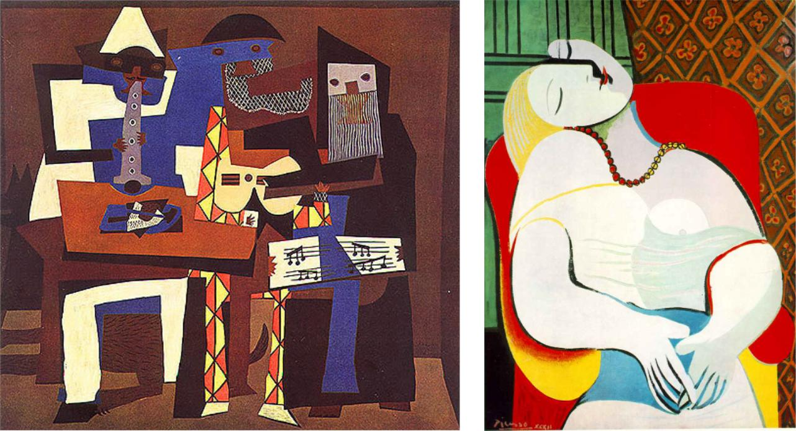
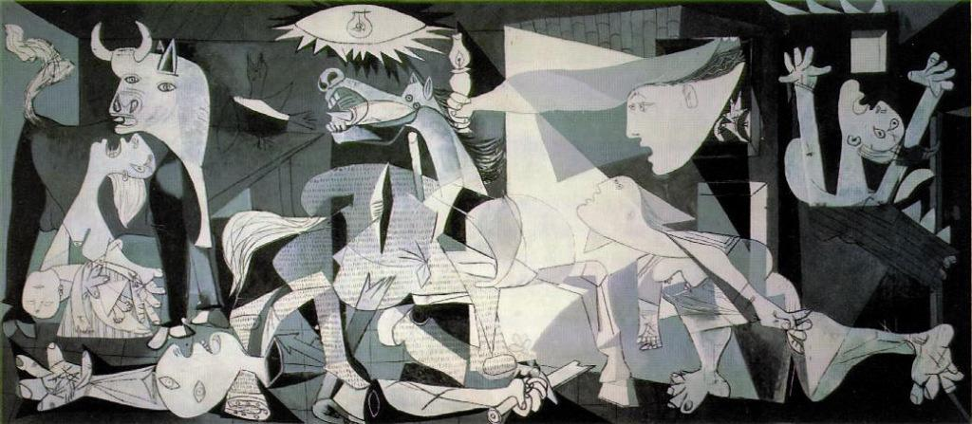

The Cubists tried to create a new way of seeing things in art — an abstract way. Many of their subjects, be they people or landscapes, were represented as combinations of basic geometric shapes, sometimes showing multiple viewpoints at the same time. This approach was related more to the way we see images in our imagination rather than in real life. For instance if you try to imagine your friend, you won’t remember all the exact details of their face but parts of them that stand out in your mind.

Picasso was a prolific artist for all of his 91 years creating over 20,000 works of art. He always tried to explore daring and unpredictable new directions in art. A well as paintings and drawings, he worked in sculpture, graphic arts, ceramics, mosaics and stage design.

Unlike many great artists before him who died poor and unknown, Pablo Picasso became rich and famous during his lifetime. No artist has affected modern art more — the thousands of artworks he created forever changed the way people thought about art.
