[](https://templatelab.com/)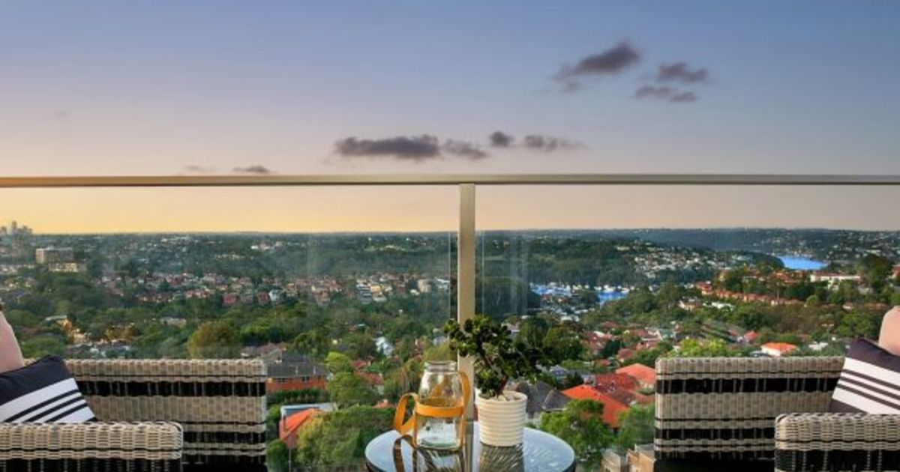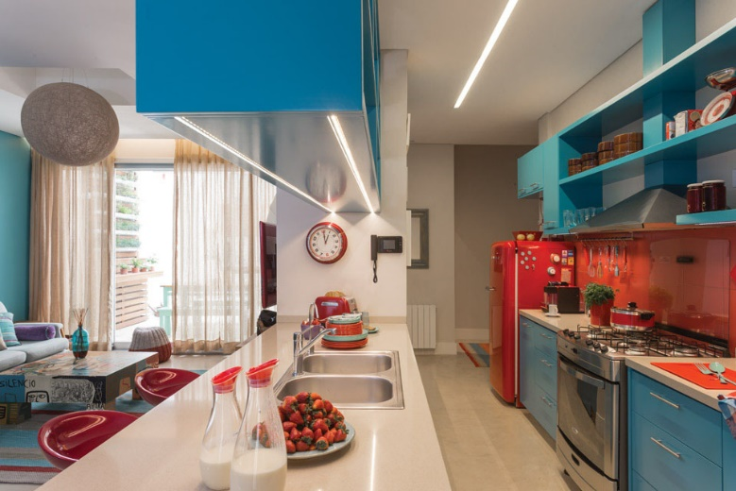

[© TemplateLab.com](https://templatelab.com/)

4 BEDS

2 BATHS

2 FLOORS

5,000 SQ.FT

SPECTACULAR PROPERTY

THE FABULOUS HOME WITH A CITY VIEW

Offered at:

$ 265,000

PROPERTY FEATURES



Air Conditioning



Marble Floors



Remodeled kitchen



Zoned small animal overlay



Separate laundry area



New interior paint



Calm street

Vanessa Doe

Cell: 348.256.2555

Office: 125.555.3333

KING estates, 217 Broadway Avenue,

NY 10455, USA

info@kingestatesoffice.com

Lorem ipsum dolor sit amet, consectetuer adipiscing elit. Maecenas porttitor congue massa. Fusce posuere, magna sed pulvinar ultricies, purus lectus malesuada libero, sit amet commodo magna eros quis urna. Nunc viverra imperdiet enim. Fusce est. Vivamus a tellus. Pellentesque habitant morbi tristique senectus et netus et malesuada fames ac turpis egestas.

Ut nonummy. Fusce aliquet pede non pede. Suspendisse dapibus lorem pellentesque magna. Integer nulla. Donec blandit feugiat ligula. Donec hendrerit, felis et imperdiet euismod, purus ipsum pretium metus, in lacinia nulla.