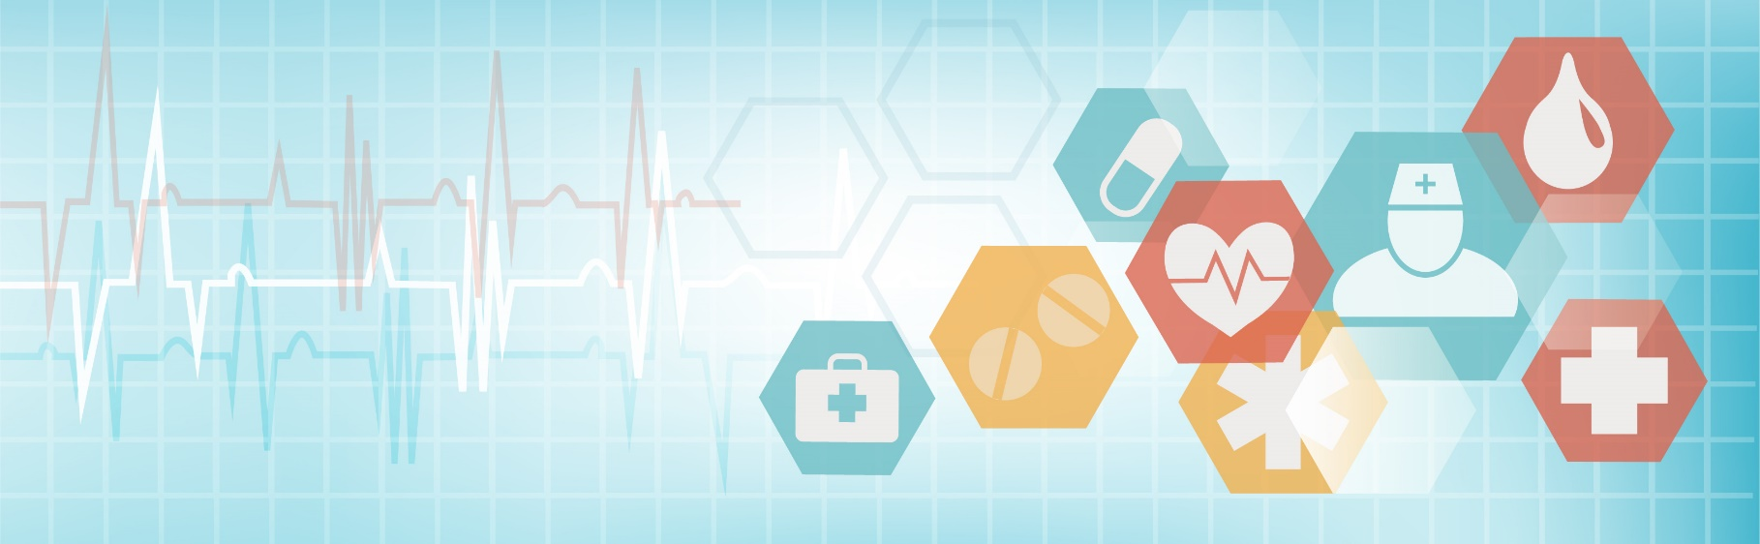[](https://templatelab.com/)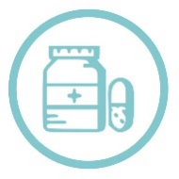

* Eat three healthy meals a day (breakfast, lunch, and dinner); it is important to remember that dinner does not have to be the largest meal.
* The bulk of food consumption should consist of healthy foods, such as fruits, vegetables, whole grains, and fat-free or low-fat milk products.
* Incorporate lean meats, poultry, fish, beans, eggs, and nuts (with emphasis on beans and nuts) into a healthy diet.
* Choose foods that are low in saturated fats, trans fats, cholesterol, salt (sodium), and added sugars; look at the labels because the first listed items on the labels comprise the highest concentrations of ingredients.
* Control portion sizes; eat the smallest portion that can satisfy hunger and then stop eating.
* Healthy snacks are OK in moderation and should consist of items like fruit, whole grains, or nuts to satisfy hunger and not cause excessive weight gain.

[**©** TemplateLab.com](https://templatelab.com/)

Health Tips for Healthy Life

"Healthy living" to most people means both physical and mental health are in balance or functioning well together in a person

Lorem ipsum dolor sit amet, consectetuer adipiscing elit. Maecenas porttitor congue massa. Fusce posuere, magna sed pulvinar ultricies, purus lectus malesuada libero, sit amet commodo magna eros quis urna. Nunc viverra imperdiet enim. Fusce est. Vivamus a tellus. Pellentesque habitant morbi tristique senectus et netus et malesuada fames ac turpis egestas. Proin pharetra nonummy pede. Mauris et orci. Aenean nec lorem. In porttitor. Donec laoreet nonummy augue. Suspendisse dui purus, scelerisque at, vulputate vitae, pretium mattis, nunc.

Fusce aliquet pede non pede. Suspendisse dapibus lorem pellentesque magna. Integer nulla. Donec blandit feugiat ligula. Donec hendrerit, felis et imperdiet euismod, purus ipsum pretium metus, in lacinia nulla nisl eget sapien. Donec ut est in lectus.

Lorem ipsum dolor sit amet, consectetuer adipiscing elit. Maecenas porttitor congue massa. Fusce posuere, magna sed pulvinar ultricies, purus lectus malesuada libero, sit amet commodo magna eros quis urna. Nunc viverra imperdiet enim.

Fusce est. Vivamus a tellus. Pellentesque habitant morbi tristique senectus et netus et malesuada fames ac turpis egestas. Proin pharetra nonummy pede. Mauris et orci. Aenean nec lorem. In porttitor. Donec laoreet nonummy augue. Suspendisse dui purus, scelerisque at, vulputate vitae, pretium mattis, nunc.

Physical activity and exercise

Lorem ipsum Icon 1

Lorem ipsum Icon 2

Lorem ipsum Icon 3