[](https://templatelab.com/)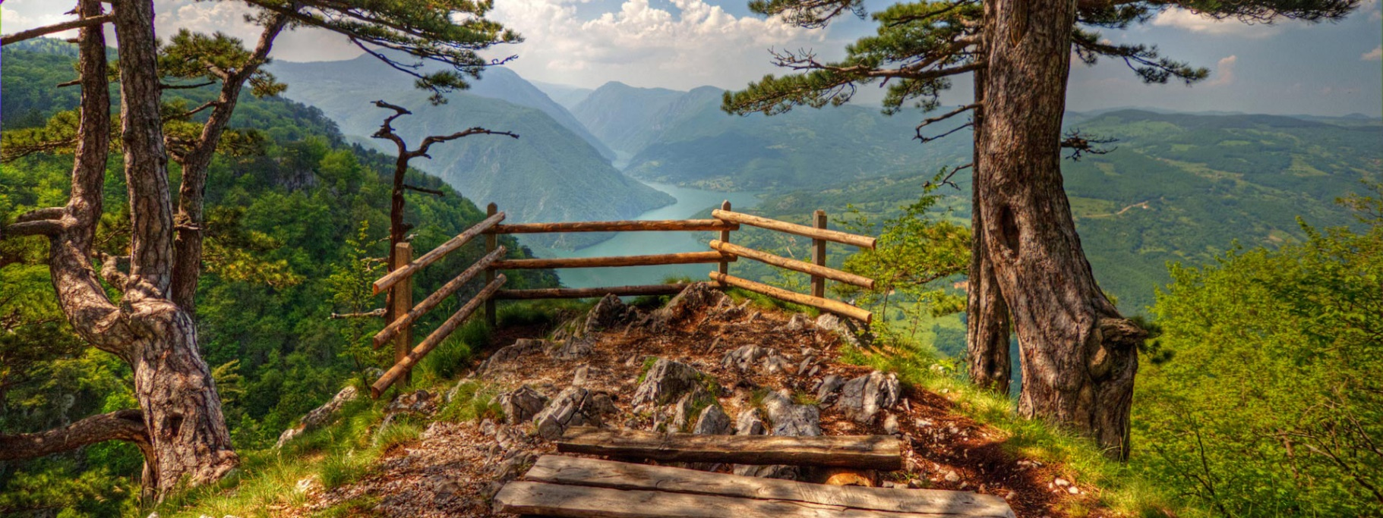

SERBIA

LANDMARKS

From Subotica all the way down to Niš, and from Tara to Đerdap, Serbia is full to breaking point with majestic attractions waiting to be discovered, photographed, adored and then photographed again.

Our list looks like this: Kalemegdan, Church of St. Sava, House on the Drina, Studenica Monastery, Subotica City Hall, Josip Broz Tito’s Grave, Đerdap Gorge, Skull Tower, Uvac Canyon, Đavolja Varoš, Knez Mihailova, Šargan Eight, Golubac Fortress, Drvengrad.

POLITICS

Serbia is a parliamentary republic, with the government divided into legislative, executive, and judiciary branches.

FOOD

Serbian cuisine consists of the culinary methods and traditions of the Republic of Serbia. Its roots lie in Serbian history, including centuries of cultural contact and influence with the Byzantines, the Ottomans, the defunct state of Yugoslavia, and Serbia's Balkan neighbours.

National dishes of Serbia include gibanica (an egg and cheese pie made with filo dough), pljeskavica (a ground beef or pork patty), ćevapi (grilled meat), and Karađorđeva šnicla (a schnitzel). The national drink is rakia (various traditional fruit brandies).

CLIMATE

The climate of Serbia is under the influences of the landmass of Eurasia and the Atlantic Ocean and Mediterranean Sea. With mean January temperatures around 0 °C, and mean July temperatures of 22 °C, it can be classified as a warm-humid continental or humid subtropical climate.

CULTURE

Positioned on the crossroads of the main Balkan routes, Serbia has inherited a considerable cultural wealth. Among the remains of the tens of centuries old civilizations, there are traces of people who lived in this region 40,000 years ago, impressive Roman heritage, as well as medieval material and immaterial cultural wealth.

All of the people who inhabited or still inhabit Serbian soil have included something of their own into Serbian cultural heritage, thus making it more valuable and interesting.

[**©** TemplateLab.com](https://templatelab.com/)

CALLING CODE

+381

RELIGION

Christian (Eastern Orthodox)

CAPITAL

Belgrade

CURRENCY

Serbian dinar (RSD)

POPULATION

6,963,764

TIME ZONE

UTC+1 (CET)

OFFICIAL LANGUAGES

Serbian

CAPITAL

Belgrade

Welcome to the land of great cultural wealth, where nature is just as bit tame as it is wild, and where beautiful cities irrevocably entwine the East and the West for centuries.

