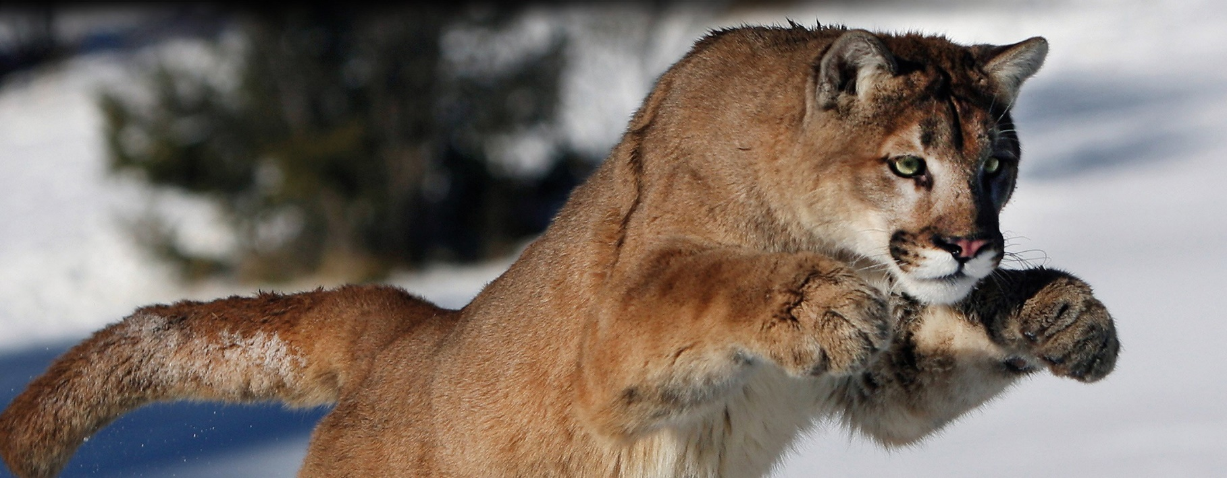[](https://templatelab.com/)

The cubs drink their mother’s milk for around 3 months, but have begun to eat meat after 6 weeks. Their mother teaches them to hunt, and at six months they begin to prey on small animals.

PUMA

FACT SHEET

WORLD ANIMALS SERIES

Discover One of America’s Top Predators!

The puma is a large wild cat found in both North and South America. It is extremely adaptable and able to live in a wide range of habitats, from forests to deserts. It is an expert ambush predator, an amazing jumper, and the second largest cat in the Americas.

OTHER NAMES

Mountain lion, cougar

SCIENTIFIC NAME

Puma concolor

ANIMAL FAMILY

Felidae (the cat family)

FOUND WHERE

North & South America

LENGTH (INCLUDING TAIL)

male: 2.4 m , female: 2.05 m

HEIGHT

60 – 90 cm

WEIGHT

M: 53-120 kg, F: 29-64 kg

TYPE OF ANIMAL

Mammal

CONSERVATION STATUS

Least Concern

FACTS AT A GLANCE

Pumas are able to live in a wide variety of habitats, including forests, prairies, deserts and rocky mountainsides. The puma holds the record for being the cat found at the highest elevation: an individual was seen at 5,800 m in the Andes. The cat family Felidae is split into two subfamilies: Pantherinae (the big cats) and Felinae (the small cats). The puma is a member of the subfamily Felinae, despite being bigger on average than both the leopard and the snow leopard (both of which are ‘big cats’). In fact, the puma is the world’s fourth-largest cat; only the tiger, lion and jaguar are larger.

HABITAT

Like most cats, the puma lives and hunts alone, and only actively seeks out other pumas in order to breed. The puma is nocturnal, and is also likely to be active at dawn and at dusk. Although it usually moves under cover of darkness, it’s not all that unusual for a puma to be seen during the day. Both male and female pumas are territorial. The territory of a male puma is substantially larger than that of a female, and may be as large as 1,300 km2. The puma is a carnivore (meat eater) and cannot survive on anything other than meat. It will prey on most animals, large and small, from insects to moose.

BEHAVIOUR

[**©** TemplateLab.com](https://templatelab.com/)