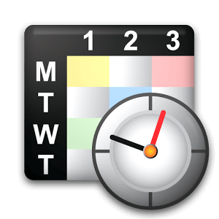 | WEEKLY CONSTRUCTION SCHEDULE TEMPLATE
 | <Project Name> |  | <Owner> |  | mm/dd/yyyy |  | mm/dd/yyyy
 | PROJECT NAME |  | OWNER |  | START DATE |  | END DATE
Project Description |  | Task ID | Task Name | Start | End | % Completed | WK07 | WK08 | WK09 | WK10 | WK11 | WK12 | WK13 | WK14 | WK15 | WK16 | WK17 | WK18 | WK19 | WK20 | WK21 | WK22 | WK23
 |  |  |  | Week | Week
<Project description> |  | 01 | <TITLE>
 |  | 01.01 | Task 01 | WK07 | WK08 | 100%
 |  | 01.02 | Task 02 | WK09 | WK09 | 100%
 |  | 01.03 | Task 03 | WK09 | WK11 | 100%
 |  | 02 | <TITLE>
 |  | 02.01 | Task 04 | WK12 | WK13 | 100%
 |  | 02.02 | Task 05 | WK12 | WK14 | 100%
 |  | 02.03 | Task 06 | WK15 | WK17 | 100%
 |  | 02.04 | Task 07 | WK16 | WK17 | 85%
 |  | 02.05 | Task 08 | WK17 | WK17 | 90%
 |  | 02.06 | Task 09 | WK18 | WK18 | 10%
 |  | 03 | <TITLE>
Remarks |  | 03.01 | Task 10 | WK19 | WK20 | 0%
 |  | 03.02 | Task 11 | WK20 | WK20 | 0%
<Remarks> |  | 03.03 | Task 12 | WK19 | WK20 | 0%
 |  | 03.04 | Task 13 | WK20 | WK22 | 0%
 |  | 03.05 | Task 14 | WK20 | WK22 | 0%
 |  | 04 | <TITLE>
 |  | 04.1 | Task 15 | WK23 | WK23 | 0%

