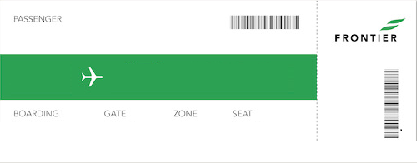

Name of Passenger

To Destination

From