Concept Mapping
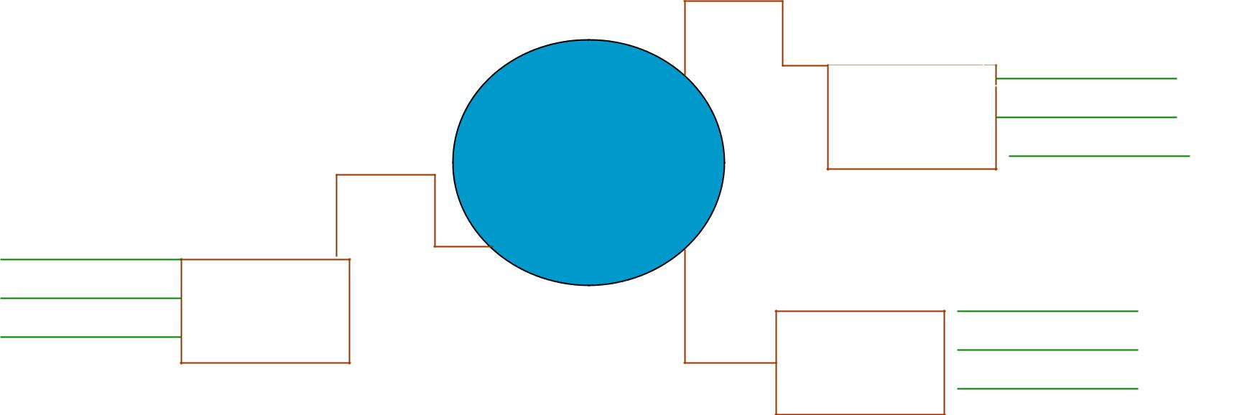

Topic:

Party
Related Items

Who to invite

Related Items

Date &
Time

Related Items

Where to go

