 | #
 |  |  |  |  | # |  |  |  |  | #
Key Problem |  |  |  | Key Problem |  |  |  | Key Problem
Data |  |  |  | Data |  |  |  | Data
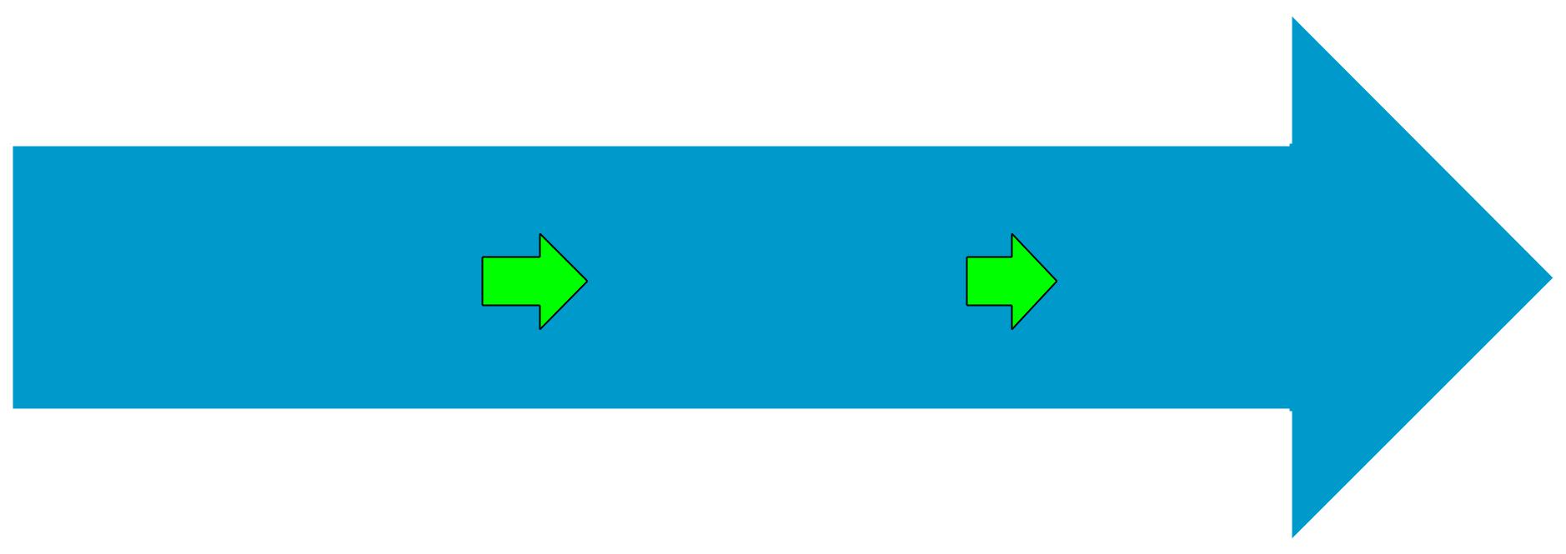
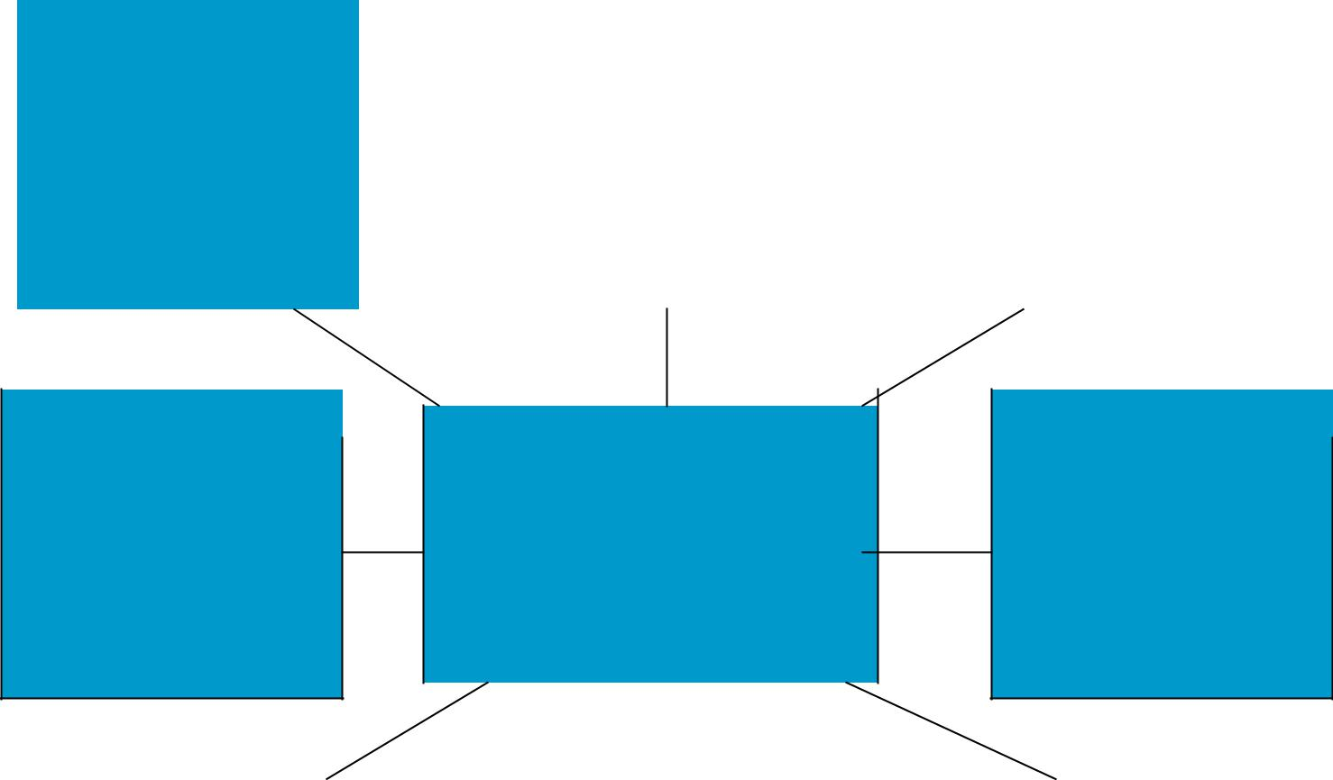

 | # |  |  |  |  |  |  | #
Key Problem |  |  |  |  | # |  | Key Problem
 |  |  | Reason for
 |  |  | Hospitalization
Data |  |  |  |  |  |  | Data

CONCEPT MAP
 |  | # |  |  |  |  | # |  |  |  | #
Key Problem |  |  |  |  | Key Problem |  |  |  |  | Key Problem
Data |  |  |  |  | Data |  |  |  |  | Data

