Medical Dx:

Femur Fracture

Impaired Mobility

Risk for Impaired

Skin Integrity

Medical Dx:

Type 2 Diabetes
Mellitus

PC: ANEMIA Fatigue
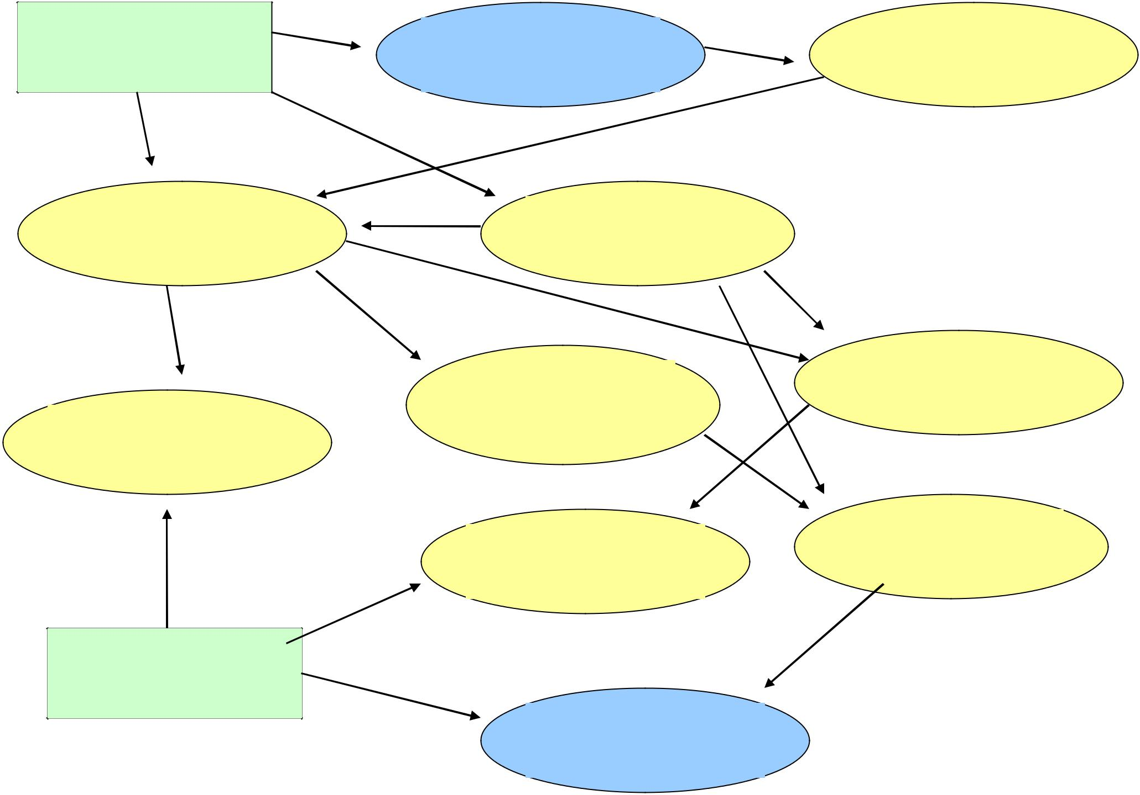

Pain

Ineffective Role | Constipation
Performance

Risk for Imbalanced | Anxiety
Nutrition

PC: Hyperglycemia

